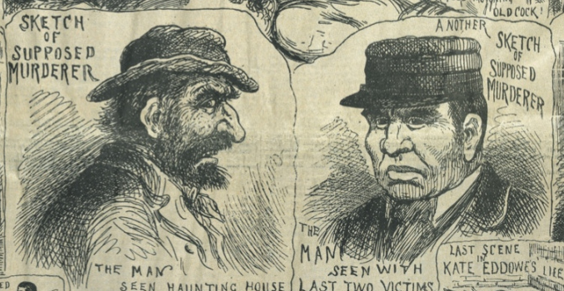
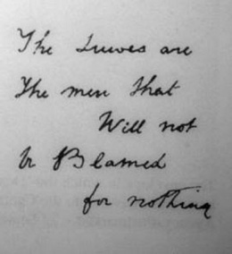
Source A- Two different impressions of the possible murderer from the Illustrated Police News (a newspaper available to the general public), 20 October 1888.
Source B- Taken from a modern school textbook.

The police took photographs of the victim’s eyes because they believed they would see an image of the last person the victim saw- the Whitechapel Murderer. This was one of the very few forensic techniques they could use to investigate crimes.
Source C- a witness statement from 1888.

“it was very dark. The man was of average height, may have been left- or right- handed and was wearing a hat. He had his back to me but seemed to be a foreigner. I did not hear him speak and he seemed to disappear into the dark night…”
Source D- this writing was found above the body of Catherine Eddowes, murdered on the 30th September 1888. It says: “the Jews are not the men that will be blamed for nothing.” The police officer in charge of the case ordered the writing to be scrubbed off the wall. He was afraid that Whitechapel residents would attack Jewish residents.
Ripper Profile:
- He was a white male.
- He was average height or below average height.
- He was between 20 and 40 years old.
- He did not dress as a labourer or a homeless person.
- He lived in the East end of London.
- He could be a doctor.
- He might have been a foreigner.
- He was right- handed.
- He probably had a regular job, as murders took place at the weekend.
- He was probably single so that he could commit the murders.
Source E- The police did not have any suspects for the Ripper murders in 1888 but they did come up with a profile of what the murderer could look like based on various witness statements.

