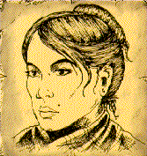
MARY JANE KELLY

"Black Mary" was unlike the other victims. Aged just 25, she was young and attractive and as a prostitute, she would have better served the rich West End clients as opposed to working the grim streets of the East End. Mary was born in Limerick in Ireland and later moved to Wales where she married a miner who was tragically killed in a coal mining disaster. After turning to prostitution in Cardiff, she moved south to London where she worked in a West End brothel.
On Friday 9th November 1888, Mary Kelly was found by a rent collector inside the room she rented two hours after she had been murdered. She was the only Jack the Ripper victim to be found indoors and the only one to be photographed at the scene by police. Police found Mary’s clothes folded neatly on a chair and her books in front of the fire. She had been cut open, her organs placed around the room and her face hacked to pieces. She was buried at Walthamstow Roman Catholic cemetery on 19th November.

ANNIE CHAPMAN 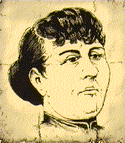
Prostitute "Dark Annie" met her death on a foggy night, alone, undernourished and suffering from brain and lung diseases which soon would have claimed her if Jack's knife hadn't. Annie wandered the East End Streets penniless following the death of her husband in 1886. Cruelly treated by life, Annie had two daughters, one of which died in 1882, and a son who was disabled. Living off poor earnings and selling matches and flowers, Annie was a rogue who had become hardened by life on the streets.
On Saturday 8th September 1888 she was found dead in a backyard only a few hundred metres away from where Mary Ann Nichols had been murdered. A doctor called to the scene wrote that ‘the body was terribly mutilated and the throat deeply severed.’ The killer had removed some of Annie’s internal organs, too, and placed them over her shoulder. Other body parts were also missing. She was buried in secret, at Manor Park on September 14th 1888, by her family. She was 47 years old.
ELIZABETH STRIDE 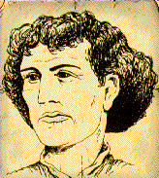
“Long Liz" was born in Gothenburg, Sweden in November 1843, named Elizabeth Gustafsdotter. After becoming a registered prostitute and giving birth to a still- born baby girl, she moved to London in 1866 and married John Thomas Stride, a carpenter, supposedly living in Gower Street, London. The Strides allegedly kept a coffee shop prior to the breakdown of their marriage in 1882. “Long Liz” was to have had eight convictions for drunkenness before her fatal appointment with Jack the Ripper.
On 30th September 1888, “Long- Liz” was one of two prostitutes found murdered in a backyard in the east end of London. The post- mortem concluded that she ‘had a silk handkerchief round her neck, and it appeared to be slightly torn… the throat was also deeply gashed.’ Unlike the other Ripper victims, Stride had not been mutilated following her murder. Stride was buried in a pauper’s grave in the East London cemetery aged 44 years.
CATHERINE EDDOWES 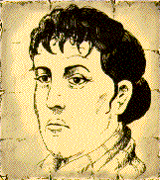
Born in 1842, the daughter of a tin- plate worker, Catherine Eddowes came to London's Bermondsey district at the age of two. She returned to her native Wolverhampton, with Thomas Conway, a pensioner, who was to father her three children. The couple separated in 1880, both victims of regular drinking. "Katie" left for London once more, where she lived in Flower and Dean Street.
On 30th September 1888, “Katie” was one of two victims found in a backyard in East London; and it is believed the two were killed within minutes of each other. Police found graffiti near her body saying ‘The Jews did it’ but they washed it off. Bits of her blood- soaked clothing were nearby. Later, doctors found that one of her ears, her nose and one of her kidneys had been removed. A Police Surgeon at the scene wrote that ‘the throat had been cut. Across below the throat was a neckerchief. ... The intestines were drawn out to a large extent and placed over the right shoulder.’ She was buried in an unmarked grave in Ilford on 8th October 1888, witnessed by hoards of onlookers, aged 44.

MARY ANN NICHOLS 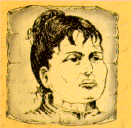
"Polly" Nichols as she was known to many, was aged 42 when Jack the Ripper's icy hand took her life. The estranged wife of a printer, Polly had borne five children before husband William ran away with one of her friends in 1877. It was then that she became trapped in the downward spiral of drink and prostitution; her final days spent living in the squalid conditions of the "White House" doss-house on Flower and Dean Street.
She was described as being ‘very drunk and staggering against walls’ on the night of her murder. At 4 am, 31st August 1888, Mary Anne was found murdered, lying in a gateway in Whitechapel. Her throat had been slashed with a long bladed knife and her stomach had been cut open.

