Investigating muscle fatigue
Aims
In this practical students will:
- investigate the effects of the contraction of the biceps and triceps in moving the arm
- investigate the effects of resting muscles on fatigue.
Students will be working scientifically to:
- use appropriate techniques, apparatus, and materials during fieldwork and laboratory work, paying attention to health and safety
- make and record observations and measurements using a range of methods for different investigations
- present observations and data using appropriate methods, including tables and graphs
- interpret observations and data, including identifying patterns and using observations, measurements, and data to draw conclusions.
Teacher notes
- It might be useful for students to look at an arm, or a skeleton of the arm, to familiarise themselves with the muscles and bones being studied in this experiment.
- Ensure that the students are advised about possible damage to knuckles and elbows during the lifting. Use paper under the elbow, and a towel or soft material on the desk where the hand will touch.
- Choose students carefully so as not to cause undue stress or anxiety.
- Make sure that students record data for each minute of lifting. This will be especially important in the no-rest test as they may simply record a total for three minutes.
- The plotting of the graph is quite advanced, so it would be advisable to show the class how to plot such data and only consider the graph as an extending activity.
Answers
Prediction
The longer the rest period, the less fatigue in the antagonistic muscles of the arm.
Questions
1 biceps
2 triceps
3 The two muscles work together (but in opposite ways) to bend and straighten the arm.
4 no rest (normally)
5 The number of lifts should decrease.
6 The number of lifts does not decrease as much.
Extension
1 The bar chart should show that when no rest is taken, there is a large decrease in the number of contractions from one minute to the next. When a minute's rest is given, the number of contractions remains consistently high.
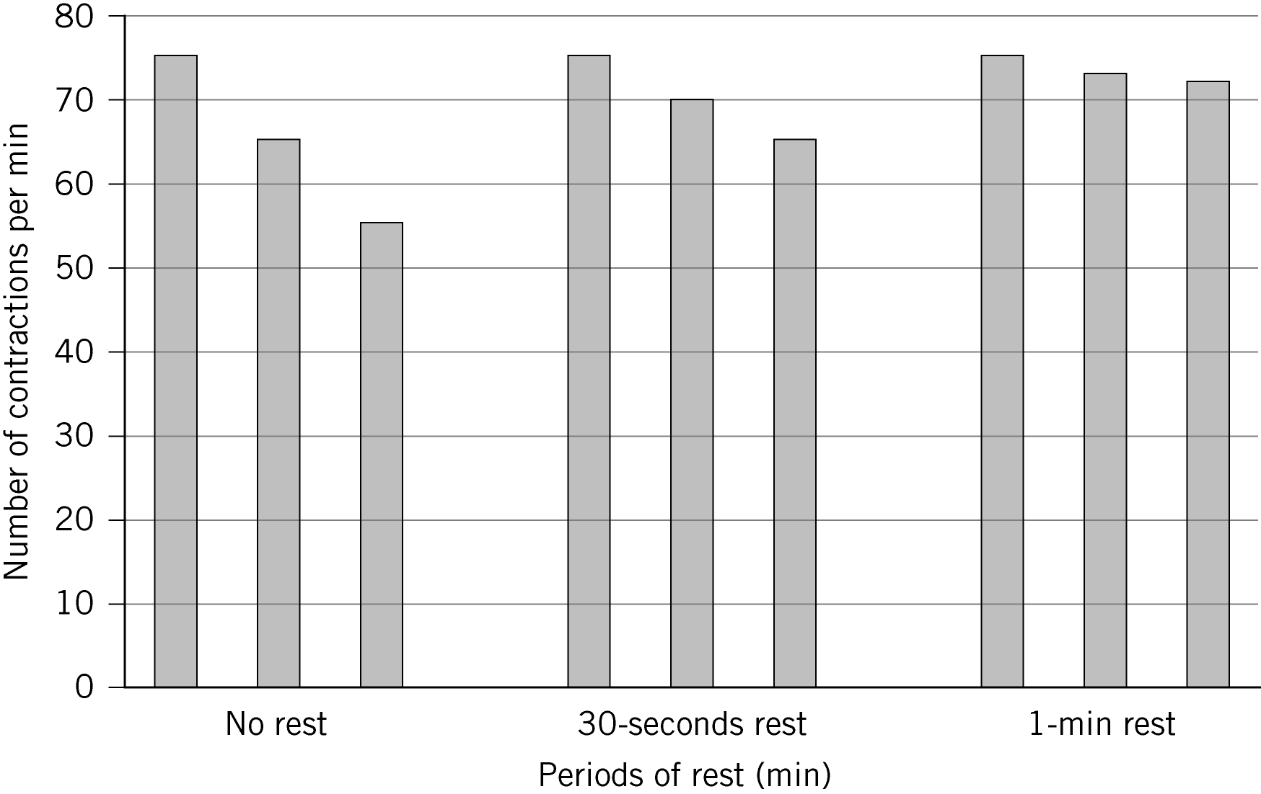

2 The muscle becomes fatigued.
3 The muscle does not fatigue as much.
4 The biceps will contract and cause flexing (bending) of the arm, while the triceps relax.
The triceps are required to contract to extend (straighten) the arm, while the biceps relax.
Without the triceps, the arm could not straighten.
Access sheet
An access sheet is available with a results table, a shorter experiment, and no extension questions.
Technician notes
Safety
- Students need to rest their elbow on a smooth surface such as paper, and have something to protect their hand during the practical such as a towel on the desk.
Equipment and materials
- 1 kg mass
- stop watch
- protective material

