Build your own skeleton
Aims
In this activity students will:
- build a large card skeleton in groups
- learn the names of the major bones in the skeleton to complete the activity sheet.
Students will be using the following literacy skills:
- use scientific terms confidently and correctly in discussions and writing
- retrieve and collate information from a range of different sources.
Teacher notes
- If available, it would be useful to have a model skeleton for students to refer to.
- In the first part of the main task, it may be advisable to encourage the class to work in small groups. Prepare your activity sheet with the cut out skeleton on by photocopying it onto A3 card, with sufficient number of skeletons for the number of groups planned.
- Define your rules for the cutting activity, including tidy-up time.
- Any cutting and sticking activity can take a surprisingly long time, so allow for this in your planning or preparation.
- You may wish to display the skeletons from the lesson but remember that they will be needed to complete the activity sheet first.
Answers
Labels for the skeleton are:
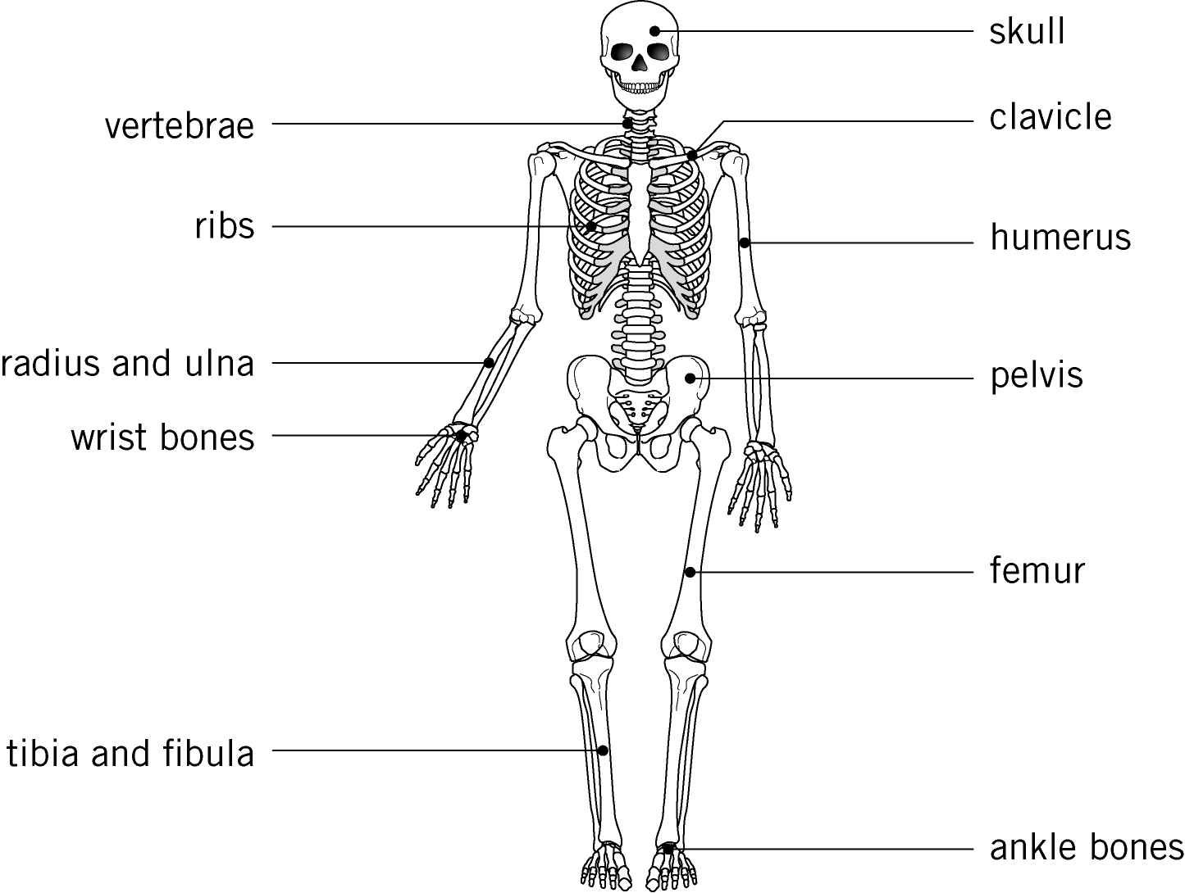

1 a ribs
b skull
c vertebrae
d ribs
2 Any two from: support, movement, or making blood.
3 calcium
Extension
1 A joint is a point where two bones meet, and allows movement. Any joint, for example, elbow, hip, knee, shoulder.
2 The skeleton protects the organs, for example, the ribs protect the heart. The joints allow movement of the skeleton, for example, a knee joint. The skeleton supports our body, for example, the vertebrae keep us upright.
3 The bones will need to be larger, as the animal will be bigger.
The bones will be thicker, to support the extra mass on land.
This would cause a problem as that the body of the animal would become more difficult to move due to the extra mass.
There will be extra mass of both bones needed to support the body, and the muscles to move this increased mass.
4 The mass of the animal would be too great for a skeleton to support on land.
The buoyancy of the water would support some of the extra mass.
Technician notes
Safety
- Students need to take care when using scissors.
Equipment and materials
- A3 card versions of activity sheet with cut out skeleton (one per group)
- scissors
- paper fasteners or staples
- activity sheet with questions (one per student)
- model skeleton (if available)

