Build your own skeleton
Setting the scene
Inside the human body is a strong framework of bones called the skeleton. It is made of a large number of bones which are linked together at the joints.
Aims
In this activity you will:
- build your skeleton model
- learn the names of the major bones in the skeleton.
Task
1 Cut out the human bones from the second activity sheet.
2 Attach the bones together at the joints by using either paper fasteners or staples. The result should be a human skeleton.
3 Use the model and the student book to label the diagram of the skeleton below.
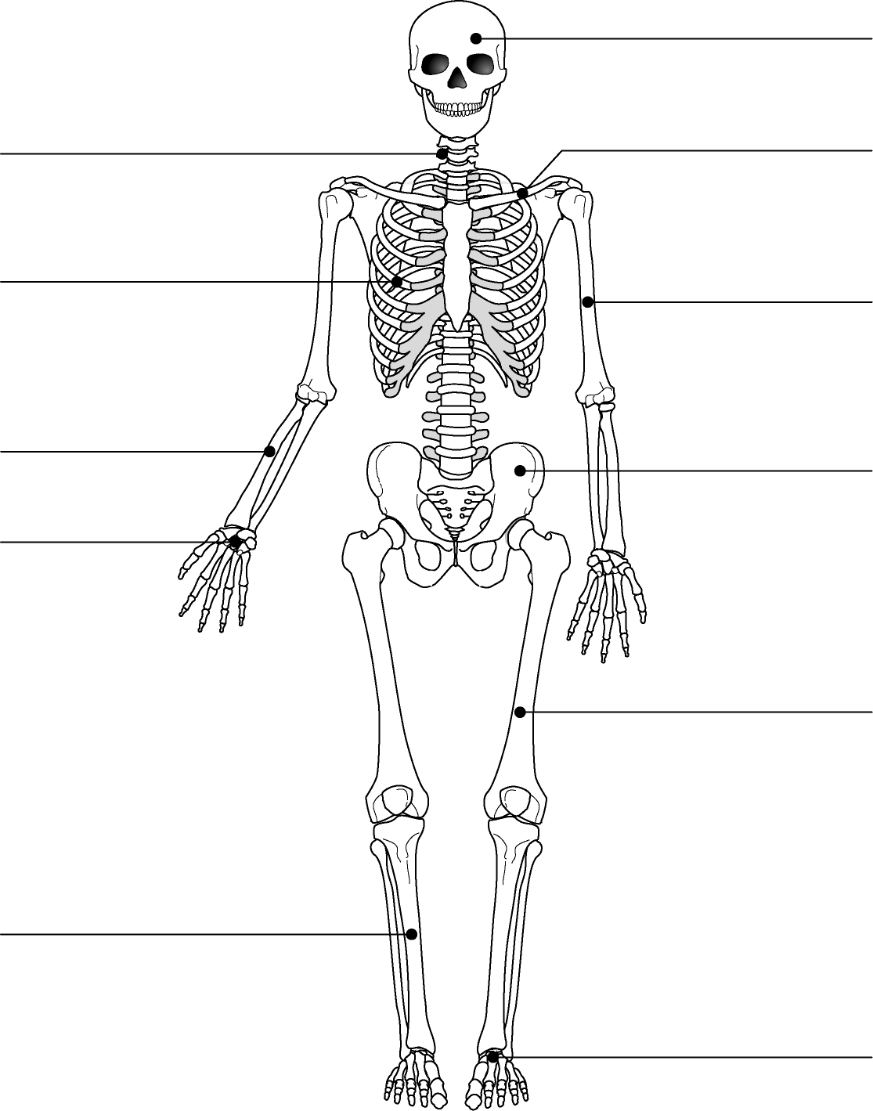
Questions
1 The skeleton protects organs. State the names of the bones that protect the following organs:
a lungs
b brain
c spinal cord
d heart
2 Name two other functions of the skeleton.

3 Name a mineral we need from our diet to help make our bones strong.

Extension
1 Describe what a joint is and give an example of a joint.

2 Describe the properties of the skeleton that make it good at its job.

3 Predict how the skeleton of a large land animal would be different from a human skeleton. Explain what problems this would cause for the animal.

4 Suggest reasons why the largest animals, like whales, are only found in water.

