Measuring the volume of the lungs
Setting the scene
When humans exchange gases they breathe in a volume of air. Are all lungs the same size? How can we measure the volume of our lungs?
Aims
In this practical you will:
- design a system for measuring the volume of your lungs
- make accurate measurements
- find out the volume of your lungs.
You will be working scientifically to:
- consider health and safety
- take measurements and suggest improvements to the method
- present observations.
Safety
- Make sure you always use a clean or sterile mouthpiece.
- If you have any breathing problems such as asthma, you may wish to not take part in the measurement of lung volume.
- Take care when handling large volumes of water as they will be heavy.
Equipment and materials
- 2.5 litre drinks bottle
- waterproof marker pens
- 500 cm³ measuring cylinders
- rubber tubing
- large bowl or trough
- antiseptic wipes or disposable mouthpiece
- funnel (optional)
Prediction
Will all students in the class have the same lung volume? Suggest why.

Method
Calibrating a bottle
1 Fill a measuring cylinder to 500 cm³ with tap water.
2 Carefully pour the water into the drinks bottle, taking care not to spill any. You may wish to use a funnel.
3 Mark the level of the water on the outside of the bottle with a waterproof marker pen.
4 Repeat the process, adding 500 cm³ at a time and marking the bottle each time until it is full.
Measuring your own lung volume
1 Half-fill a large bowl or trough (or sink) with tap water.
2 Place your hand over the end of the full drinks bottle to create a seal. Carefully turn it upside down and place the neck of the bottle in the bowl of water.
3 Carefully remove your hand, making sure that the neck of the bottle stays under the water. This is so that water does not escape from your calibrated bottle.
4 Take a length of rubber tube and feed one end into the neck of the bottle.
5 Wipe the other end of the rubber tubing with an antiseptic wipe, or fit a disposable mouthpiece.
6 You now need to take a deep breath in.
7 Breathe out into the rubber tubing for as long as possible. (Do not make
yourself ill!)
8 Record the volume to the nearest 500 cm³ from the marker scale on the outside of the bottle.
9 Refill the bottle with water and repeat for each member of your group.
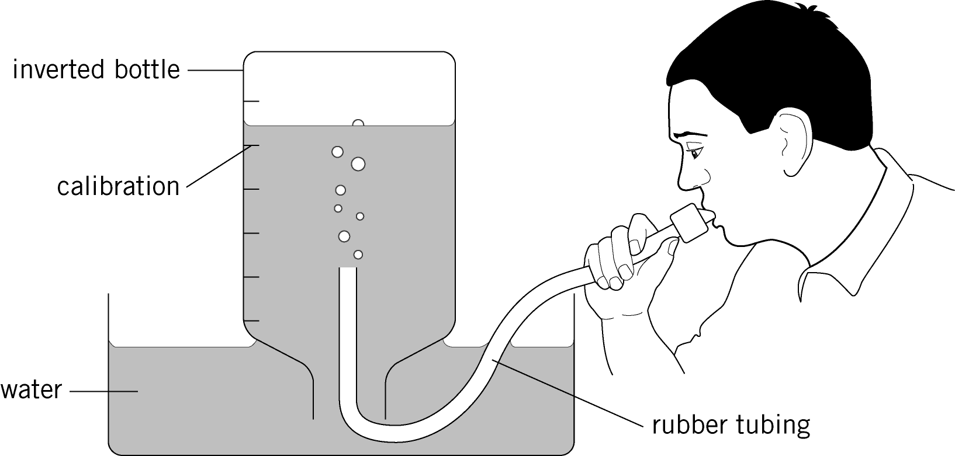

Results
Name | Breaths per minute (from starter) | Maximum volume of lung (cm³) | Total possible air breathed per minute (cm³)
Questions
1 Do all the students tested have the same lung volume?

2 State if there is a relationship between the lung volumes and any characteristics of people.

3 Suggest a reason for this relationship.

Extension
1 Suggest a reason why precise values of lung volume cannot be obtained using this method.

2 Suggest a way to obtain a more precise result for lung capacity.

3 Predict how your results may change after exercise.

