Organising a body
What are we made of?
All living things are made of cells. All cells have some common parts:
a nucleus, which controls what the cell does
cytoplasm, which is where all the chemical reactions occur
a cell membrane, which controls what goes in and out of the cell.
Organising cells in our body
The cell is the building block, for example, a single muscle cell.

A group of similar cells working together is called a tissue, for example, a muscle tissue.
Different tissues working together are called an organ, for example, the heart.
Organs work together in an organ system, for example, the circulatory system.
Specialised cells
Cells become specialised to do many functions in a plant or an animal. For example, nerve cells, red blood cells, sperm cells, muscle cells, ciliated epithelial cells, root hair cells, and fat cells.

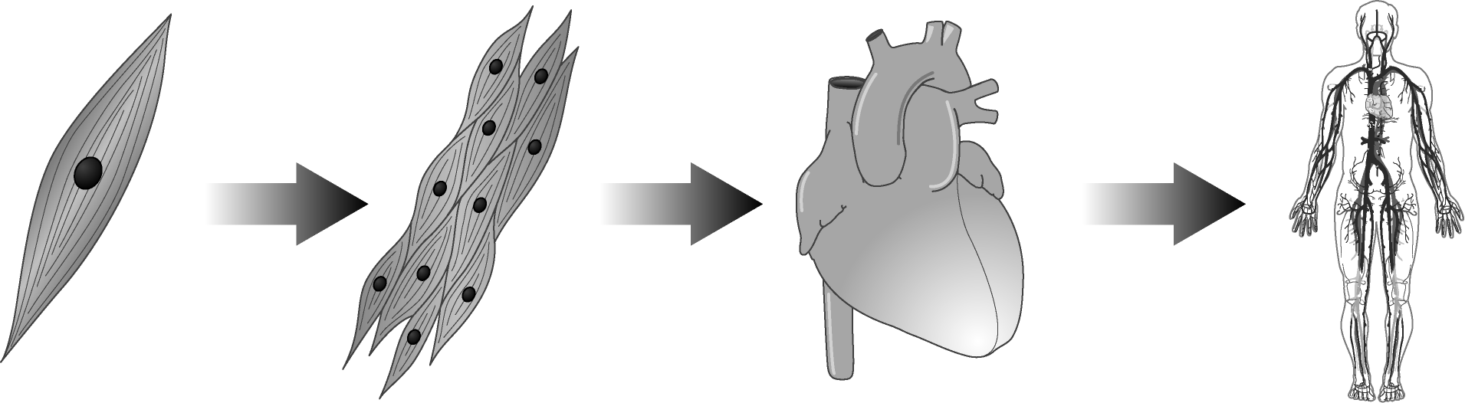
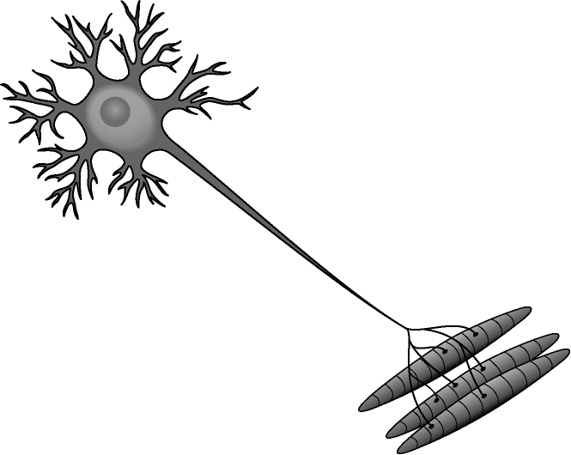
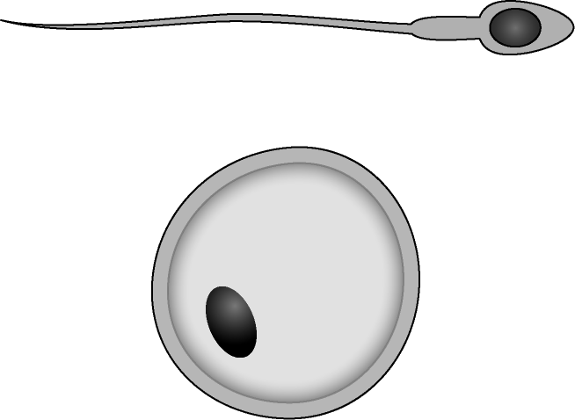
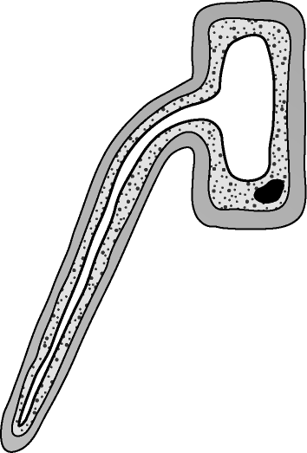

Organ systems
The human body has several organ systems to carry out major functions in our body. Each organ system has several organs and a particular function.

The skeletal system helps us in movement and support.
The respiratory system allows us to breathe.
The reproductive system allows us to reproduce.
The digestive system allows us to break down our food.
The circulatory system transports blood around the body. It includes:
the heart – to pump blood
arteries – to carry blood away from the heart
veins – to return blood to the heart.
