Organising a body
Setting the scene
Cells do not work alone in plants and animals. They work as tissues, organs, and organ systems.
Aims
In this activity you will:
- gather information on levels of organisation in organisms
- answer questions about a piece of text.
You will be working scientifically to:
- interpret information to draw conclusions.
Task
Read the information sheet, then answer the questions below.
Questions
1 State what all living things are made of.

2 Name three parts of all cells.

3 Name three specialised cells.

4 What is a tissue?

5 State the name of a group of tissues working together.

6 What is an organ system?

7 Give three examples of organ systems and their functions.

8 Complete the following table.
Organ | Function
heart
arteries
veins
9 Label the diagram of the digestive system.
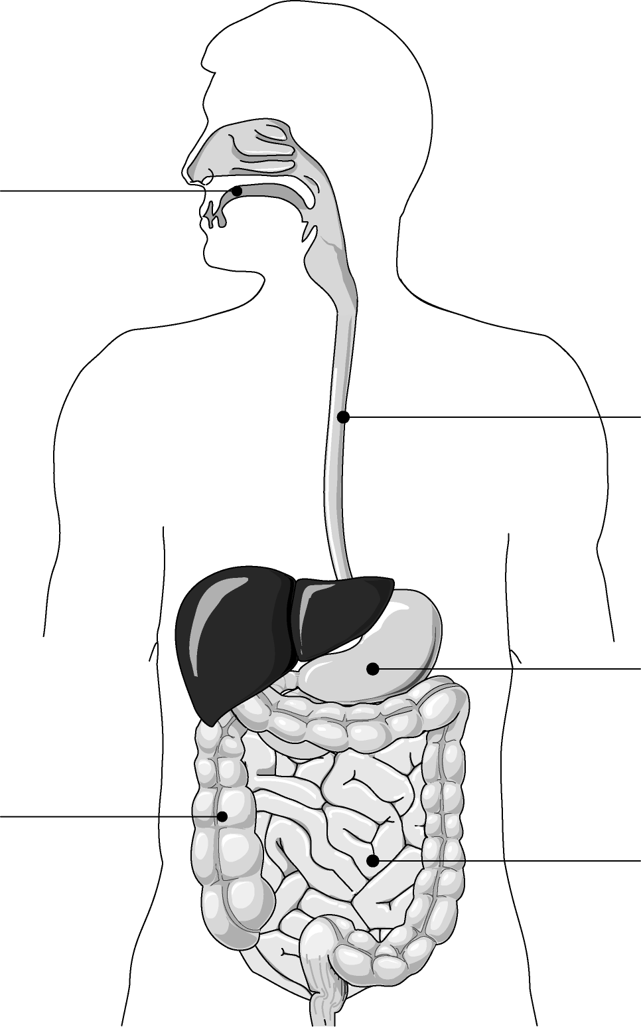

Extension
Explain how the organs of the digestive system function together to digest food.

