Aim
The aim of the revision activity is to provide support for students who need to progress from developing to secure for the core National Curriculum statements.
The aim of the extension activity is to provide extension for students who have already achieved secure. The activity is also suitable for higher ability or older students in need of further extension work.
Revision activity notes
In the revision activity, students will create a revision poster about space. Before completing their poster, they should work through the tasks in the revision activity. This will help ensure students have covered all the key points required.
Additional notes:
- The revision activity should be appropriate for students achieving less than 65 % in the Checkpoint assessment.
- You can review students’ answers to questions in the Checkpoint assessment in Kerboodle. You may decide not to cover all tasks in the revision activity, based on students’ performance on specific questions.
- An index of which task covers which outcome is given in the Teacher Handbook.
- This revision activity could also be used as a revision sheet for all students.
- Students should be given a chance to see some simple demonstration involving the Sun (a light source), the Moon (a tennis ball), and the Earth (a globe).
- You can demonstrate day and night using the spinning globe and the Moon using a ball orbiting the Earth. If one side of the ball is black and one side is white it is easier for students to spot when the lit and unlit side of the Moon faces Earth.
- Demonstrate that at the poles the Earth’s surface tilts away form the Sun, and any light spreads over a larger area compared to the equator. Be very careful to tilt the globe correctly to show the effect of seasonal changes at the poles.
Support activity answers
Task 1
1 The Sun is at the centre of the Solar System. It is a star giving out heat and light.
There are eight planets which orbit the Sun. The four closest planets are smaller and rocky,
and the four outer planets are much larger and gassy.
The Moon orbits the Earth. We see the Moon because it reflects the Sun’s light.
2 Students’ descriptions should use all the key words in the correct manner.
Task 2
1 The diagram shows the Sun in the centre with planets shown on four concentric circles, representing the orbits of Mercury, Venus, Earth and Mars.
2 The arrows show the planets orbiting in the same direction. The Moon orbits Earth.
3 The planet with the longest year is Mars and the shortest year is Mercury.
4 The coldest planet is Mars on this diagram
Task 3
It takes 8 minutes for light to travel from the Sun to Earth, and 4 hours for light to travel from the Sun to Neptune.
Light from our nearest star takes 4 years to reach us.
The Solar System is part of a galaxy. It takes light 100 million years to travel across the galaxy.
The Universe contains everything and is so big it takes light 14 billion years to reach us from the very edges.
The Solar System formed 5 billion years ago when dust and gas was pulled together by gravity from the Sun. The Universe formed 14 billion years ago.
Task 4
Statement | True or false
The Earth spins on an axis that is tilted. | True
The North Pole has summer when it tilts towards the Sun. | True
The North Pole has winter when it is tilted towards the Sun. | False
The South Pole and North Pole have summer at the same time. | False
It is warmer in summer because the Earth is closer to the Sun. | False
It is warmer at the equator because the Sun’s rays are more concentrated. | True
The time of daylight is less in summer. | False
The Sun rises as high in the sky in winter and in the summer. | False
The Sun and stars seem to move because Earth is spinning. | True
The Moon changes appearance because Earth is spinning. | False
The Moon orbits the Earth. It reflects the Sun’s light. | True

Task 5
- The Sun, Moon, and the Earth should be correctly labelled on the diagram.
- The Moon comes between the Sun and a small amount of the Earth’s surface, blocking the Sun’s light from the Earth.
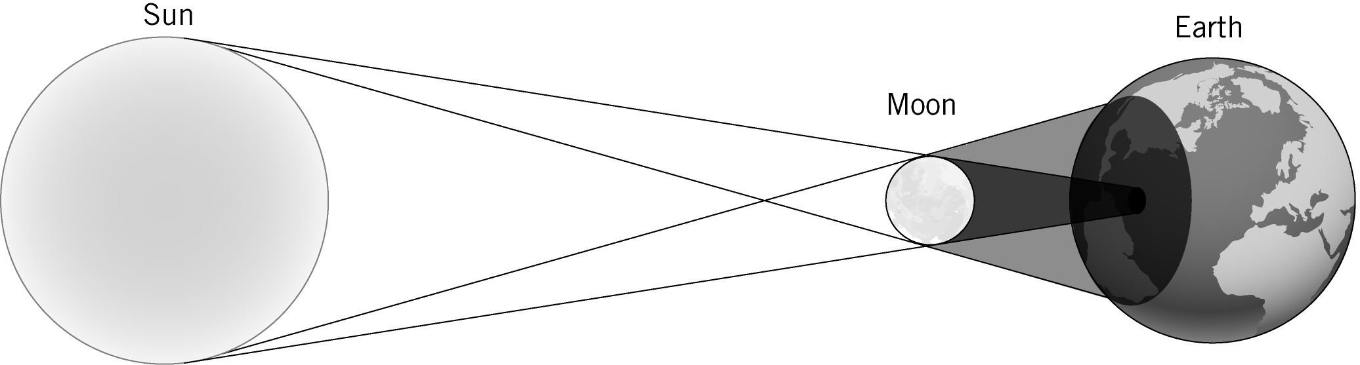

- The diagram shows the Earth between the Sun and the Moon with the Earth’s shadow falls on the Moon.
The Earth comes between the Moon and the Sun, blocking the Sun’s light from the Moon.
- The diagram for a new moon shows the Moon between the Earth and the Sun so the Moon’s unlit side faces Earth.
The diagram for a full moon shows the Earth between the Moon and the Sun so the Moon’s lit side faces the Earth.
The diagram for a quarter moon shows the Moon to one side of the Earth so half of the Moon’s lit side faces Earth.
As the Moon orbits around the Earth, different amounts of its lit side face the Earth causing the different shapes.
Extension activity notes
The activity is a written description of a journey through space. Students need to consider the information given and use it to discuss forces, effects of gravity, the types of planets, and other information they think is relevant in their accounts.
Additional notes:
- If there are other sources of information, for example books, access to the internet, or data sheets, this would make the activity more rewarding.
Extension activity marking guidance
- Aim to see imaginative writing but based on scientific fact. Students are unlikely to incorporate all aspects but should be able to write a clear account of their trip.
- The forces during take-off are weight and lift.
- Students should include reference to feeling pushed back in their seat by g-forces during take-off, with these forces gradually reducing as the rocket accelerates less. When they move at the same rate as the rocket they feel weightless but they are still experiencing the gravity of the nearest planet or moon.
- Students should be able to imagine what it feels like on different planets, for example, how dim and small the Sun is; how heavy or cold they feel; do they fall through the surface; how many moons they see; and how long it takes to reach the planet.

