Aims
You are going to create a poster about space. First work through the tasks on this page to make sure you know all the information you need to include. Once you have completed the tasks, think about how you want to present the information in your poster. If there is a diagram to draw in a task, draw a sketch for now. You can add a neater diagram on your poster.
Task 1: The Solar System
1 Complete these sentences about objects seen in the Solar System.
The is at the centre of the Solar System. It is a star giving out
and light. There are eight which orbit the Sun.
The four closest planets are smaller and , and the four outer planets
are much and gassy.
The orbits the Earth. We see the moon because it
the Sun’s light
2 Use these key words to write a description about the structure of the Universe. Include this in your poster.
star planet Solar System galaxy Universe Sun
Earth Moon Milky Way
Task 2: Orbits of the planets and the Moon
On your poster you will need to draw the following diagrams. Draw a sketch on a scrap piece of paper before drawing them on your poster.
1 Draw a diagram showing the Sun, Mercury, Venus, Earth, the Moon, and Mars and the orbit for each planet and the Moon.
2 Add an arrow to show which way the planets orbit the Sun.
3 Label the planet with the longest year and the planet with the shortest year.
4 Label the coldest planet.

Task 3: The age of the Universe
Fill in the missing numbers
14 billion years 4 hours 100 million years 4 years
8 minutes 5 billion years 14 billion years
It takes for light to travel from the Sun to Earth, and
for light to travel from the Sun to Neptune.
Light from our nearest star takes to reach us.
The Solar System is part of a galaxy. It takes light to travel
across the galaxy.
The Universe contains everything and is so big it takes light to reach
us from the very edges.
The Solar System formed ago when dust and gas was pulled together
by gravity from the Sun. The Universe formed years ago.
Task 4: The seasons
Are these statements true or false? You should include the true statements in your poster. Think about diagrams you could draw to go with them.
Statement | True or false
The Earth spins on an axis that is tilted.
The North Pole has summer when it is tilted towards the Sun.
The North Pole has winter when it is tilted towards the Sun.
The South Pole and North Pole have summer at the same time.
It is warmer in summer because the earth is closer to the Sun.
It is warmer at the equator because the Sun’s rays are more concentrated.
The time of daylight is less in summer.
The Sun rises as high in the sky in winter and in the summer.
The Sun and stars seem to move because Earth is spinning.
The Moon changes appearance because Earth is spinning.
The Moon orbits the Earth. It reflects the Sun’s light.
Task 5: The Moon
The Moon orbits the Earth. It reflects the Sun’s light. In your poster you should include labelled diagrams to show what is happening. Try sketching them first on scrap paper.
- Label the diagram showing the Sun, Earth, and Moon when there is a solar eclipse. Write a sentence explaining what happens.

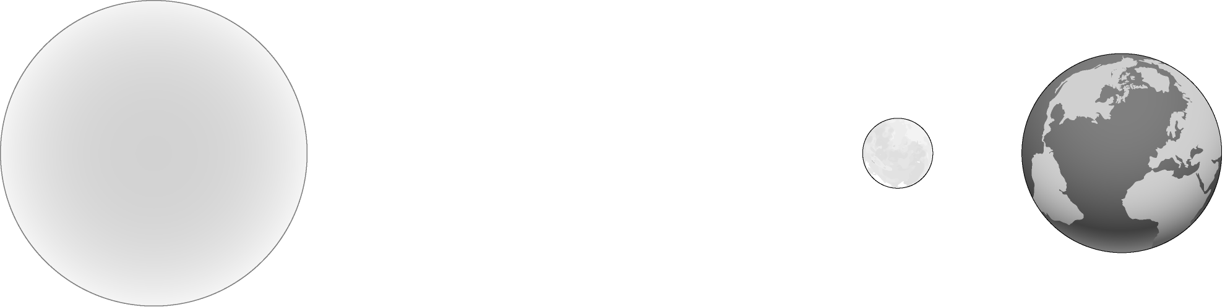

- Sketch a diagram showing the Sun, Earth, and Moon when there is a lunar eclipse. Write a sentence explaining what happens.
- Sketch a diagram showing the Sun, Earth, and Moon when there is a new moon (it is not visible), a full moon, and a quarter moon. Write a sentence explaining what happens.

