The Moon and eclipses
Setting the scene
The Moon constantly orbits the Earth. Its appearance changes because different amounts of the lit side face the Earth. The changing appearance is called the phases of the Moon. Total eclipses of the Sun happen when the Moon blocks our view of the Sun. Total lunar eclipses happen when the Earth’s shadow falls on the Moon.
Aims
In this practical you will:
- describe how the appearance of the Moon changes during the month
- explain why we see phases of the Moon
- explain why we see total lunar eclipses and total solar eclipses.
You will be working scientifically to:
- make predictions using scientific knowledge
- Present observations as diagrams.
Safety
- Do not look directly into the light from the lamp.
- Take care when lifting lamps. These may get hot.
- Take care if using mains electricity.
Equipment and materials
- lamp (Sun)
- tennis ball (Earth)
- table tennis ball coloured black on one half, white on the other half (Moon)
Method: phases of the Moon
1 The light represents the Sun. Turn the light on.
2 The tennis ball represents Earth. Hold it in the ‘Sun’s’ light. The side facing the Sun
has daytime, and the side facing away from the Sun has nighttime.
3 The table tennis ball represents the Moon. Always hold it so the white side faces the light and the black side faces away from the light.
4 The Moon orbits the Earth once each month. Move the table tennis ball around the
tennis ball.
5 Watch how the appearance of the side of the Moon facing the Earth changes as the Moon travels around the Earth. This is how phases of the Moon happen.
6 Complete the diagram in the results section using the instructions provided.
Results
Draw a diagram showing the position and appearance of the Moon (in relation to the Earth and the Sun) for three phases:
- When the dark side faces Earth. Label this ‘new moon’.
- When the light side faces Earth. Label this ‘full moon’.
- When we see a half light and half dark moon. Label this ‘quarter moon’.

Method: eclipses
1 To see why we have total solar eclipses, move the Moon between the Sun and Earth.
2 The Moon can block out our view of the Sun: this is a total solar eclipse.
3 To see why we have total lunar eclipses, move the Moon so Earth is between the Sun and Moon.
4 Move the Earth so its shadow falls onto the Moon: this is a total lunar eclipse.
5 Complete the diagram in the results section, showing why we have total solar eclipses and total lunar eclipses.

Results: eclipses
Complete this diagram to show where the Moon is during a total solar eclipse. Use shading to show how the Moon blocks our view of the Sun.
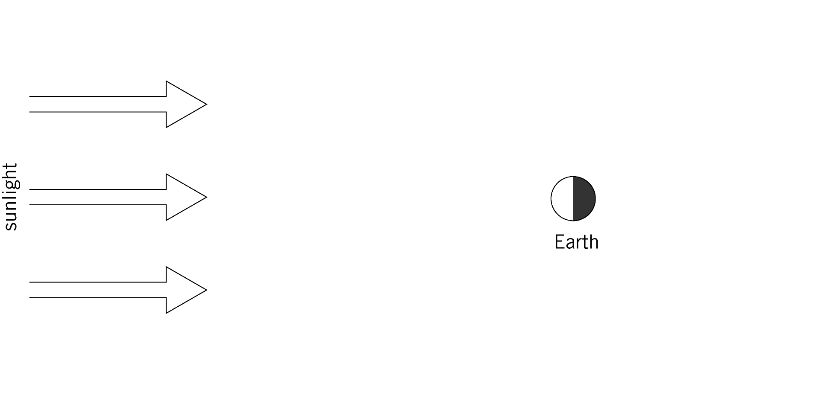

Total solar eclipse
Complete this diagram to show where the Moon is during a total lunar eclipse. Use shading to show the Earth’s shadow on the Moon.

Total lunar eclipse
Questions
1 State how we see the Moon. (Where does its light come from?)

2 Describe, using your model, why the appearance of the Moon changes.

3 Explain why we have total lunar eclipses.

4 Explain why we have total solar eclipses.

Extension
1 Explain why we can only have total lunar eclipses when there is a full moon.

2 Explain why we can only have total solar eclipses during the middle of the day.

3 Explain why we can only have total solar eclipses when the Moon is a new moon.

