1: 5: 6
Draw these circuits using symbols

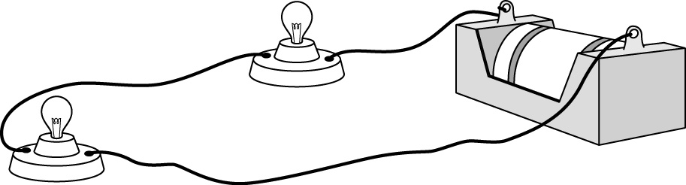

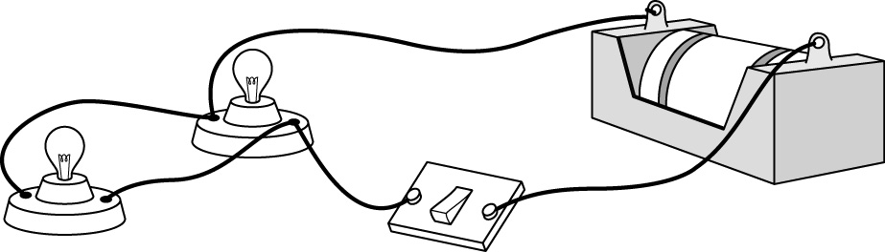
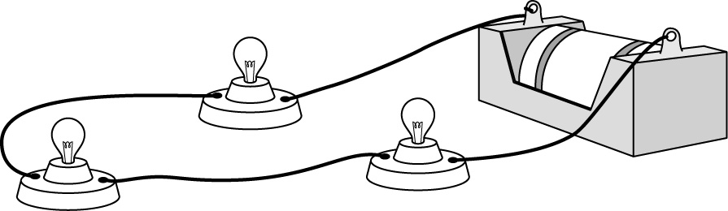
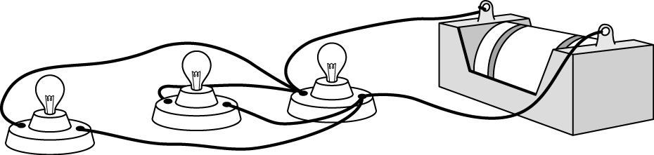
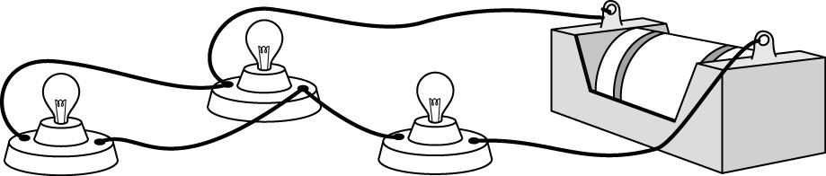
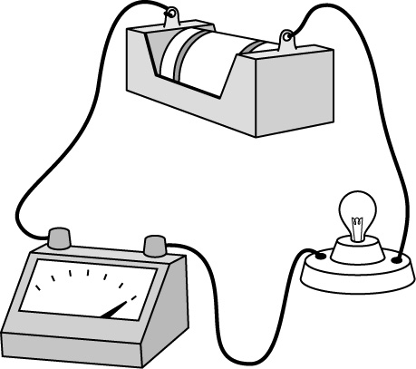

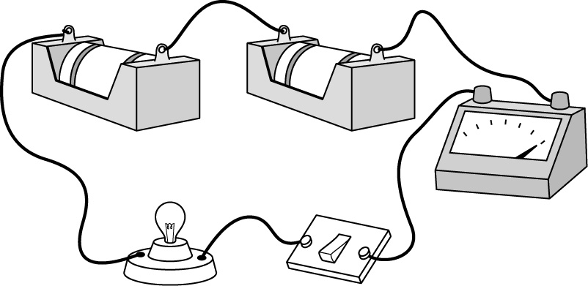

1: 5: 6
Draw these circuits using symbols

