The Earth
Task 1: Structure of the Earth
1 Label the diagram below, which shows the structure of the Earth.

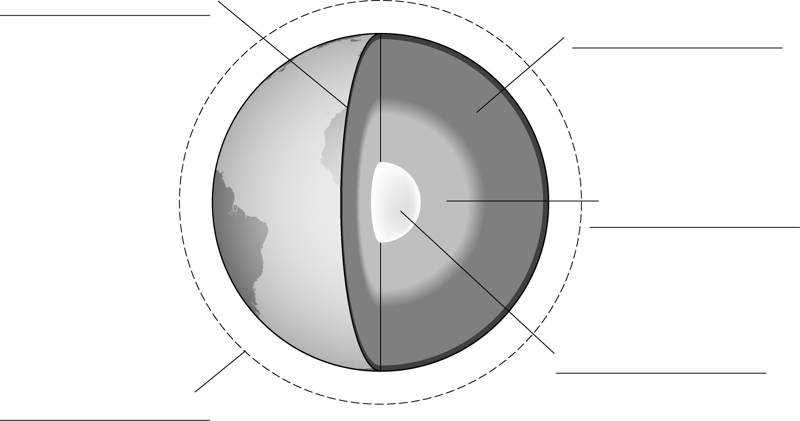

2 Complete the following sentences to describe the properties of the different layers of the Earth’s structure. Use the words given below.
oxygen inner live solid crust outer mantle four atmosphere
core gas solid flow iron troposphere liquid carbon
The Earth is split into ____________ layers. The top layer is called the
______________. This is made from _____________ rock. The next layer is
called the ______________. This is mostly made from _____________ rock that
can ____________. The centre of the Earth is called the _____________, and
this has two parts. The ______________ core, which is solid and contains mainly
______________ and nickel, and the ________________ core which is
_________________.
A layer of ______________ surrounds the Earth. This is called the
___________________ . The part nearest the Earth is called the
___________________. This is mostly made up of _________________ and
nitrogen but contains other gases such as argon and _________________
dioxide. Without this layer we would not be able to ______________ on the
Earth.
3 Label the following pie chart to describe the composition of the Earth’s atmosphere.

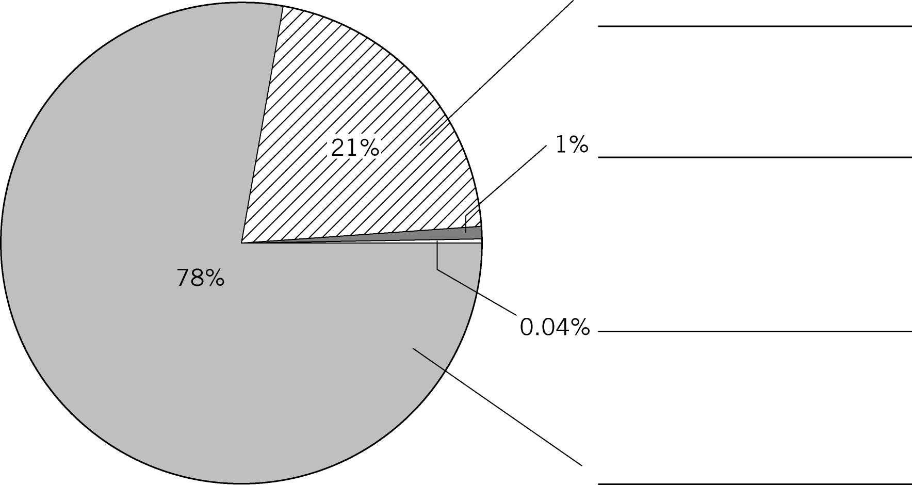

Task 2: The rock cycle
1 The following table shows properties of rocks and information about how they form. Write the type of rock each statement is describing in the right hand column.
Be careful: Some statements may describe more than one rock type.
Description | Rock type(s)
an example is granite
soft and easily scratched
contains layers
sometimes contains layers
non-porous
hard and durable
made up of separate grains
made when existing rocks are placed under heat and pressure
an example is marble
porous
made when liquid rock cools and freezes
contains crystals
an example is sandstone
reacts with acids
formed when sediments settle on top of each other

2 Complete the simplified rock cycle below to explain how material in rocks is recycled.
Use the words provided to annotate the arrows in the diagram. Words can be used
more than once.
uplift compaction deposition erosion cementation weathering
melting pressure cooling heat transportation
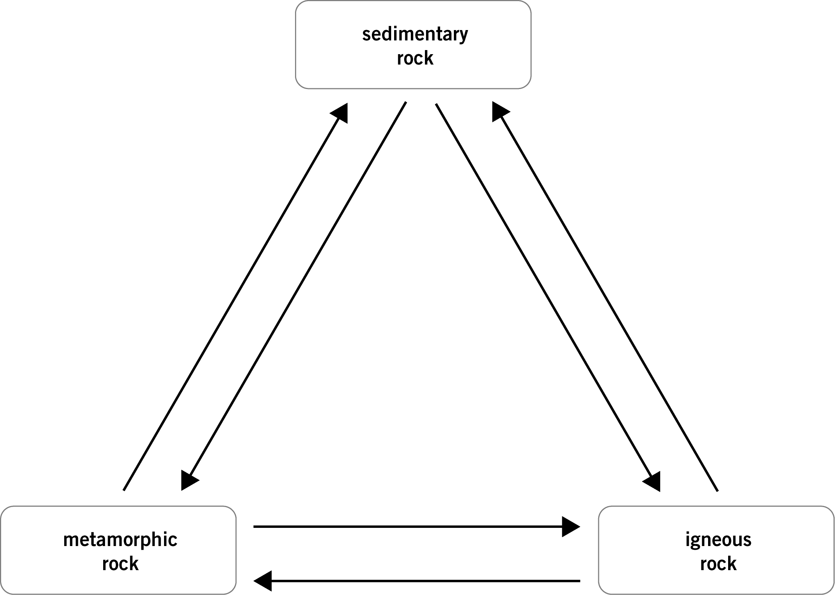

Task 3: The carbon cycle
Use the diagram of the carbon cycle below to answer the following questions.
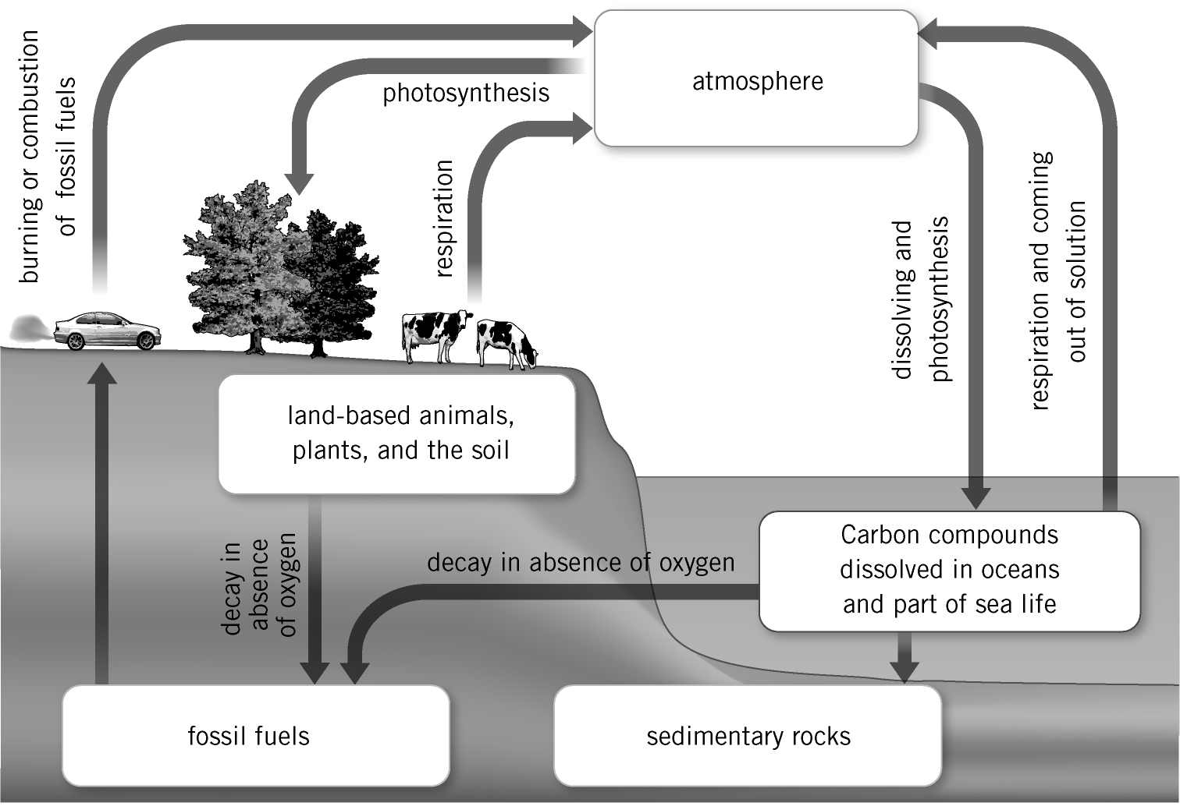

1 Identify the five carbon stores in the carbon cycle.

2 Complete the table below to describe whether the following processes transfer carbon dioxide into or out of the atmosphere.
 | Into the atmosphere | Out of the atmosphere
combustion of fossil fuels
respiration of plants and animals
photosynthesis by plants
formation of sedimentary rocks
the dissolving of carbon dioxide
on oceans
decay in absence of oxygen
deforestation

3 The concentration of carbon dioxide in the atmosphere stayed the same for many years but since 1800 levels of carbon dioxide have been increasing. Explain in detail why this has happened. Use your answer to Question 2 to help you.

Task 4: Climate change
Decide if the following statements are true or false. Correct those that are false
a Global warming describes how energy from the Sun is trapped by gases in the atmosphere.

b We would not be able to live on the Earth without the greenhouse effect.

c Global warming is the term given to an increase in global average air temperature
due to increased carbon dioxide in the atmosphere.

d Scientists predict that the global average air temperature could decrease by up to
5 °C by 2100.

e The greenhouse effect is the term given to changes in weather patterns due to
global warming.

f Global warming is causing the melting of polar ice, leading to flooding on low-lying coasts.

Task 5: Recycling
1 Reorder the following sentences to explain how aluminium is recycled.
Order
Machines shred the objects and remove their decorations.
It is then rolled into thin sheets, and made into new objects.
The liquid aluminium cools and freezes in a mould.
Old aluminium objects are collected and taken to a factory.
A furnace melts the shreds.
The ingot is then heated to 600 °C to soften.
This is known as an aluminium ingot.
2 The following table gives information about the number of hours a TV can be
switched on for given different items that are recycled.
 | Equivalent time a TV can be used for (h)
fizzy drinks can | 2.5
wine bottle | 3.0
magazine | 8.0
food tin | 1.5
egg box | 0.6
Use the data given to discuss the advantages and disadvantages of recycling these materials.

