Interpreting the carbon cycle
Setting the scene
Carbon dioxide in the Earth’s atmosphere keeps it warm. It is constantly added and removed by various processes. Carbon is stored in many places on the Earth, and can leave these stores in the same way that carbon dioxide enters and leaves the atmosphere. The movement of carbon and its compounds is shown by the carbon cycle.
Aims
In this activity you will:
- label a diagram of the carbon cycle
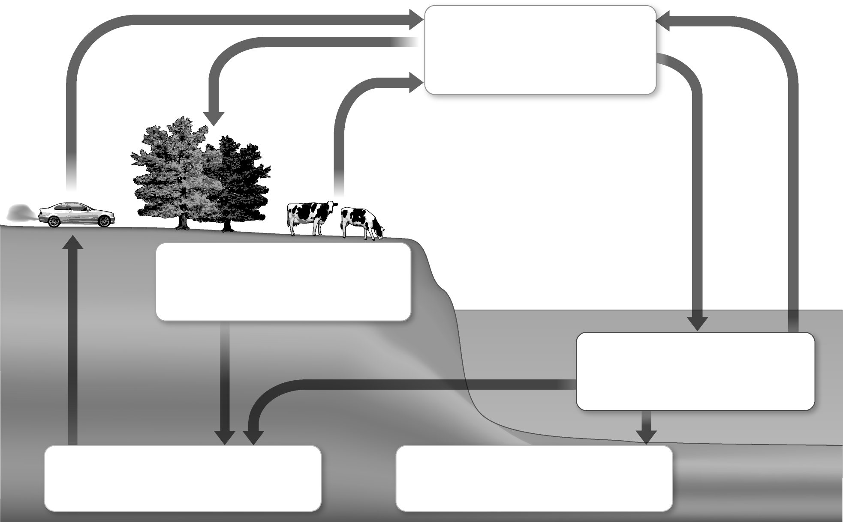
- draw a storyboard showing a carbon particle travelling through the carbon cycle
- explain the processes that occur and give equations for some of the processes.
You will be working scientifically to:
- interpret observations, identify patterns, and draw conclusions.
Task
1 Complete the following diagram by identifying the carbon stores to fill in the missing labels.
Also identify the processes that occur between the stores (as shown by the arrows) and write the name of each process next to each arrow.
2 Choose one journey around the carbon cycle and draw a storyboard of a particle
moving through the carbon cycle in the space below.
Your storyboard should include:
- where the particle starts from
- how it gets to its destination
- how long it spends at each stage
- descriptions or equations to describe each process.
You should identify whether the particle is elemental carbon or carbon in a compound at each stage. You should include the names of the carbon compounds used in your storyboard.
Extension
1 Explain why one particle could travel through the carbon cycle relatively quickly, whereas another could take hundreds of thousands of years. Use examples of
routes in the carbon cycle to help explain your answer. Give chemical equations to describe processes where possible.

2 Annabelle was explaining the carbon cycle to her friend. She said that all the carbon in the carbon dioxide we breathe out came from the same place originally. Is Annabelle correct? Explain your answer using equations to describe the different processes in the
carbon cycle.

