Modelling Earth’s structure
Setting the scene
The Earth contains different layers that all behave in different ways. Because it is impossible to see the different layers, models are an excellent way to show people what the inside of the Earth looks like.
Aims
In this activity you will:
- evaluate a simple model of the Earth
- design your own model of the Earth that can be used in a science exhibition for students and their parents.
You will be working scientifically to:
- present explanations
- interpret observations.
Task
Ben has made a model of the Earth by cutting a tennis ball in half and filling the middle with scrunched-up red tissue paper. Answer the questions below.
1 Label the following diagram of the structure of the Earth. Include a brief description of each layer that must include its state and one other property (e.g., thickness).
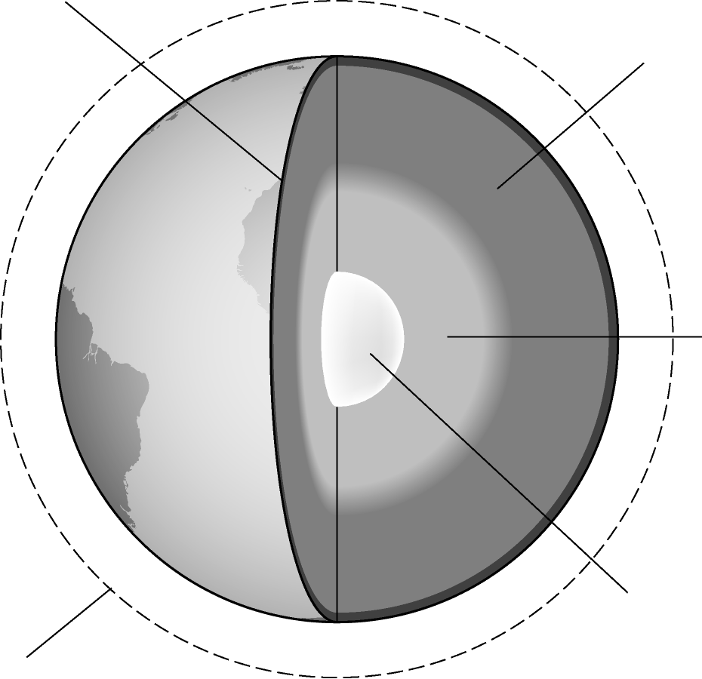

2 State what is represented by the tennis ball and the tissue paper in Ben’s model.

3 List two good points about the model of the Earth’s structure that Ben has made.
Explain your answer.

4 List two ways Ben’s model can be improved. Explain your answer.

5 Ben has forgotten about the air that surrounds the Earth in his model. Give the name
of this layer and the name of the first sublayer within this structure.

6 Imagine you are to make you own model to show the structure of the Earth. Draw a plan of your model below. Remember to take into account the improvements suggested in Question 4.
In your diagram you should describe the materials you would use to make the model Earth to make it as realistic as possible and explain your choices.
Extension
The table below shows the composition of the troposphere (the air we breathe).
Component | % composition
nitrogen | 78
oxygen | 21
argon | 1
carbon dioxide | 0.04
1 Summarise the composition of the troposphere using the data above.

2 If you could use any material to demonstrate the atmosphere, and add this to your existing model, what material would you choose? Explain your answer.

3 Using the data provided, discuss the advantages and disadvantages of using your material as a model of the atmosphere.

