Interpreting the carbon cycle
Aims
In this activity students will:
- label a diagram of the carbon cycle
- draw a storyboard showing a carbon particle travelling through the carbon cycle
- explain the processes that occur and give equations for some of the processes.
Students will be working scientifically to:
- interpret observations and data, including identifying patterns and using observations, measurements, and data to draw conclusions.
Students will be using the following literacy skills:
- organisation of ideas and information.
Teacher notes
- Before beginning this task, it is important that students are familiar with the carbon cycle and have seen a diagrammatic representation of this. They should appreciate that carbon is discussed as being the element carbon when moving to and from some stores, and as carbon dioxide when moving from to and from the atmosphere. It is important that students realize that reactions will convert the carbon to carbon dioxide and vice versa, but that many of these reactions are beyond the scope of what they need to understand.
- Secure students should include equations to help describe what is occurring in their storyboards. They could use formula equations as well as word equations if they have been shown these, especially for respiration, photosynthesis, and combustion.
- You may wish to provide A3 paper for students to draw their storyboards onto.
- If time permits, you could ask students to produce their storyboards, peer-assess them, and then produce a larger neat version for a display.
Answers
Task
1
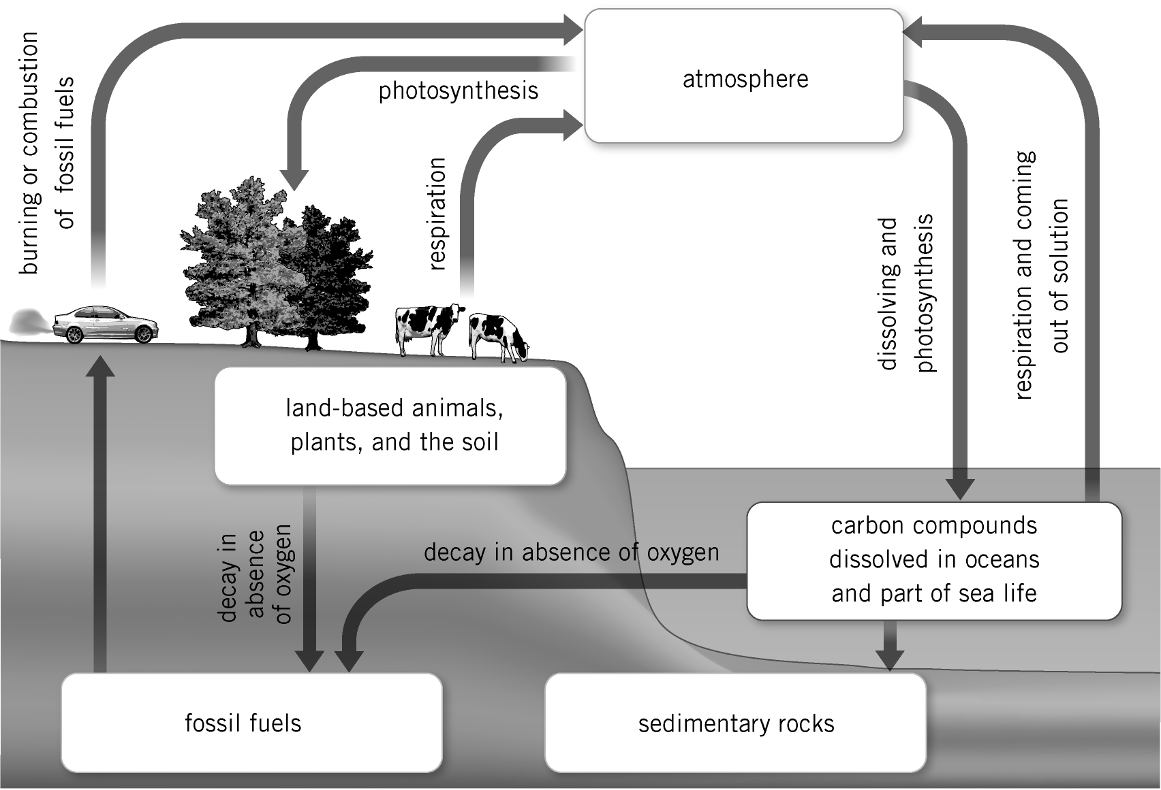

2 Individual storyboards should be checked to ensure that students have correctly:
- identified which store the particle is moving to and from
- identified whether the particle is carbon, carbon dioxide, or changing between the two
- identified the process occurring and given an accurate description of this process
- included word equations or formula equations if working at secure level.
Extension
1 Some processes within the carbon cycle can be very fast and so a particle may move through these stages very quickly. For example, a carbon dioxide particle could be taken in by a plant during photosynthesis and stored in the plant, and that plant could be cut down soon after and burnt. This would mean that the carbon dioxide has left and returned to the atmosphere very quickly. Carbon locked up in fossil fuels may remain undiscovered for thousands of years before it is burnt and released into the atmosphere. Carbon dioxide dissolved in seawater near the surface of the ocean may come into and out of solution quite rapidly, whereas carbon dioxide dissolved in water that is now deep in the ocean is likely to remain dissolved for a much longer time.

2 Annabelle is incorrect. There is no set route through the carbon cycle. Particles could continually move from the atmosphere into plants via photosynthesis and then be returned via respiration, without ever actually becoming dissolved in the sea. Another particle may be dissolved in the sea before returning to the ocean and then becoming part of a plant and not go back to being dissolved in the sea for a very long time. The routes through are varied and do not need to be the same. The random nature of particle behaviour would also suggest that for particles to follow the same route would be highly unlikely.
Equation for photosynthesis:
carbon dioxide + water light glucose + oxygen
Equation for respiration:
glucose + oxygen carbon dioxide + water
Support sheet
The accompanying support sheet contains an unlabelled carbon cycle diagram, but with prompts to support students with labelling the cycle.

