The composition of inhaled and exhaled air
Setting the scene
There are different amounts of gases in the air we breathe in (inhaled air) and the air we breathe out (exhaled air).
Aims
In this activity, you will be:
- analysing data obtained on the composition of inhaled and exhaled air.
You will be working scientifically to:
- present data using a graph
- identify patterns in data to draw conclusions.
Task
1 Label the diagram of our breathing system.
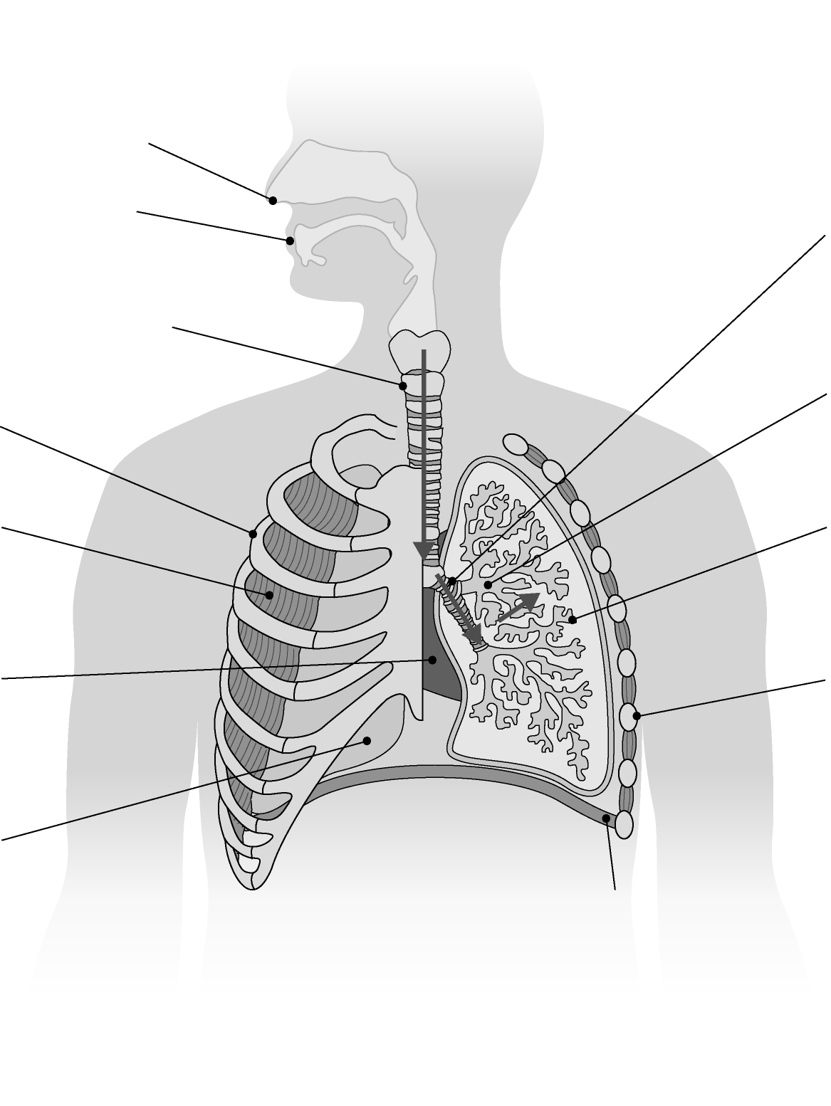

2 Choose the most appropriate graph or chart to display the data in the table. Draw two: one for inhaled air, and one for exhaled air.
Gas | Inhaled air (%) | Exhaled air (%)
nitrogen | 78 | 78
oxygen | 21 | 16
carbon dioxide | 0.04 | 5.04
other gases (e.g., argon) | 0.96 | 0.96
Questions
1 Name a gas whose percentage composition in the air remains unchanged during the breathing process.

2 Name a gas whose percentage composition increases in exhaled air.

3 Calculate by how much the composition of oxygen decreases between inhaled and exhaled air.

4 State where, in the breathing system, these changes in the gas content of air happen.

5 Explain what has happened to the oxygen which has been removed from inhaled air.

6 A student stated that ‘we breathe out carbon dioxide’. Is this statement correct? Use the data to help answer the question.

7 Explain why scientists use graphs or charts for their data.

Extension
1 Explain why you chose the graph or chart you did to show the data. Why would
other types of chart be less useful or incorrect?

2 The data does not show any values for water vapour, which is present in the air we breathe in and out. Suggest whether water vapour levels would increase or decrease
in exhaled air. Explain why this would happen.

