Information card 1: Development of the fetus
Image | Information |  | Information | Image
 | 2 days  The fertilised egg travels down the oviduct toward the uterus. As it does, it divides several times to form a ball of cells called an embryo. The embryo implants into the wall of the uterus. |  | 8 weeks  The embryo is now about 18 mm. The heart beat can be detected by doctors. Elbows and knees can be seen, together with fingers and toes. The embryo is now called a fetus. The fetus starts to move its arms and legs. Eyelids begin to form. | 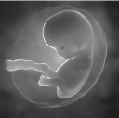
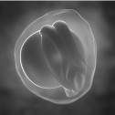 | 3 weeks  A groove forms along what will be the back of the embryo. This is the beginning of the brain and spine. An outgrowth forms from the front of the embryo, which will form the placenta. |  | 12 weeks  It can be up to 7 cm long. The skin is very thin, almost transparent. Muscles and bones develop. The fetus makes more movements. External reproductive organs begin to form. | 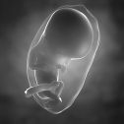
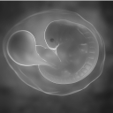 | 5 weeks  The embryo is about  9 mm long and forms a ‘C’ shaped structure. Simple arm and leg buds can be seen. There is a heart, which is quite large and makes the chest extend out. It starts beating. The spine has closed up. The umbilical cord is clear. |  | 22 weeks  The fetus is now about  28 cm long. Eyebrows and eyelashes have formed. Fingers now have nails and fingerprints. The last organs to form, the lungs, are now developing fast. | 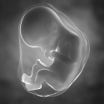
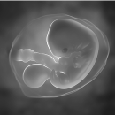 | 6 weeks  The embryo is about  13 mm long. The brain enlarges. The arms and legs extend, and hand and foot development begins, fingers and toes can just be seen. The eyes are now very clear. |  | 35 weeks  The embryo is now about 50 cm long; the brain develops. Eyelids open and close. Bones are now well developed, but soft and pliable. The head hair is well developed. | 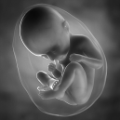

Information card 2: Birth of the baby
Childbirth can be divided into a series of stages called the stages of labour.
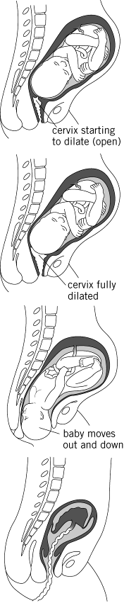
Pre-labour
Pre-labour is when the woman starts to feel regular contractions of the uterus. The cervix will start to open or dilate. This is due to the uterus contracting and pushing the baby’s head against the cervix.

First stage: Dilation
This starts when the cervix is about 3–4 cm dilated. The uterus continues to contract, causing a sac around the baby to break releasing amniotic fluid (known as a woman’s waters breaking). When the cervix has widened to around 10 cm it will allow the baby's head through. This stage may take several hours.

Second stage: Birth
This stage begins when the cervix is fully dilated (about 10 cm wide). As pressure on the cervix increases, the head of the baby is pushed out through the vaginal opening. This is helped by the mother pushing. This is the birth of the baby.

Third stage: Delivery of the placenta
This is the stage when the placenta is pushed out of the uterus and is called the ‘afterbirth’. The umbilical cord is clamped and cut in this stage
Information card 3: Placenta and umbilical cord
The placenta forms as an outgrowth of the early embryo. It has cells on the outside which allow it to sink into the inner lining of the mother’s uterus. The placenta is attached to the baby by the umbilical cord. In humans, the placenta can reach 22 cm in width and it can be 2 to 2.5 cm in thickness.
The umbilical cord connects the placenta to the baby itself at the ‘belly button’, or navel. It forms very early in the first few weeks. It reaches a length of about 20 cm and is about 2 cm thick. It contains blood vessels that carry blood from the placenta to the baby.
The baby has a blood vessel that runs down the umbilical cord into the placenta. Here it gets rid of unwanted substances and collects substances that it wants.
The placenta wears away the lining of the uterus. This means that the baby’s blood flows very close to the mother’s blood.
The placenta allows substances to be exchanged between the mother and baby.

