The Periodic Table
Aims
You have been asked to make a documentary about the Periodic Table and the elements and groups found within it.
Work through the tasks below. You teacher may ask you to use your answers to plan this documentary for homework.
Task 1: Metals and non-metals
1 Look at the Periodic Table below.
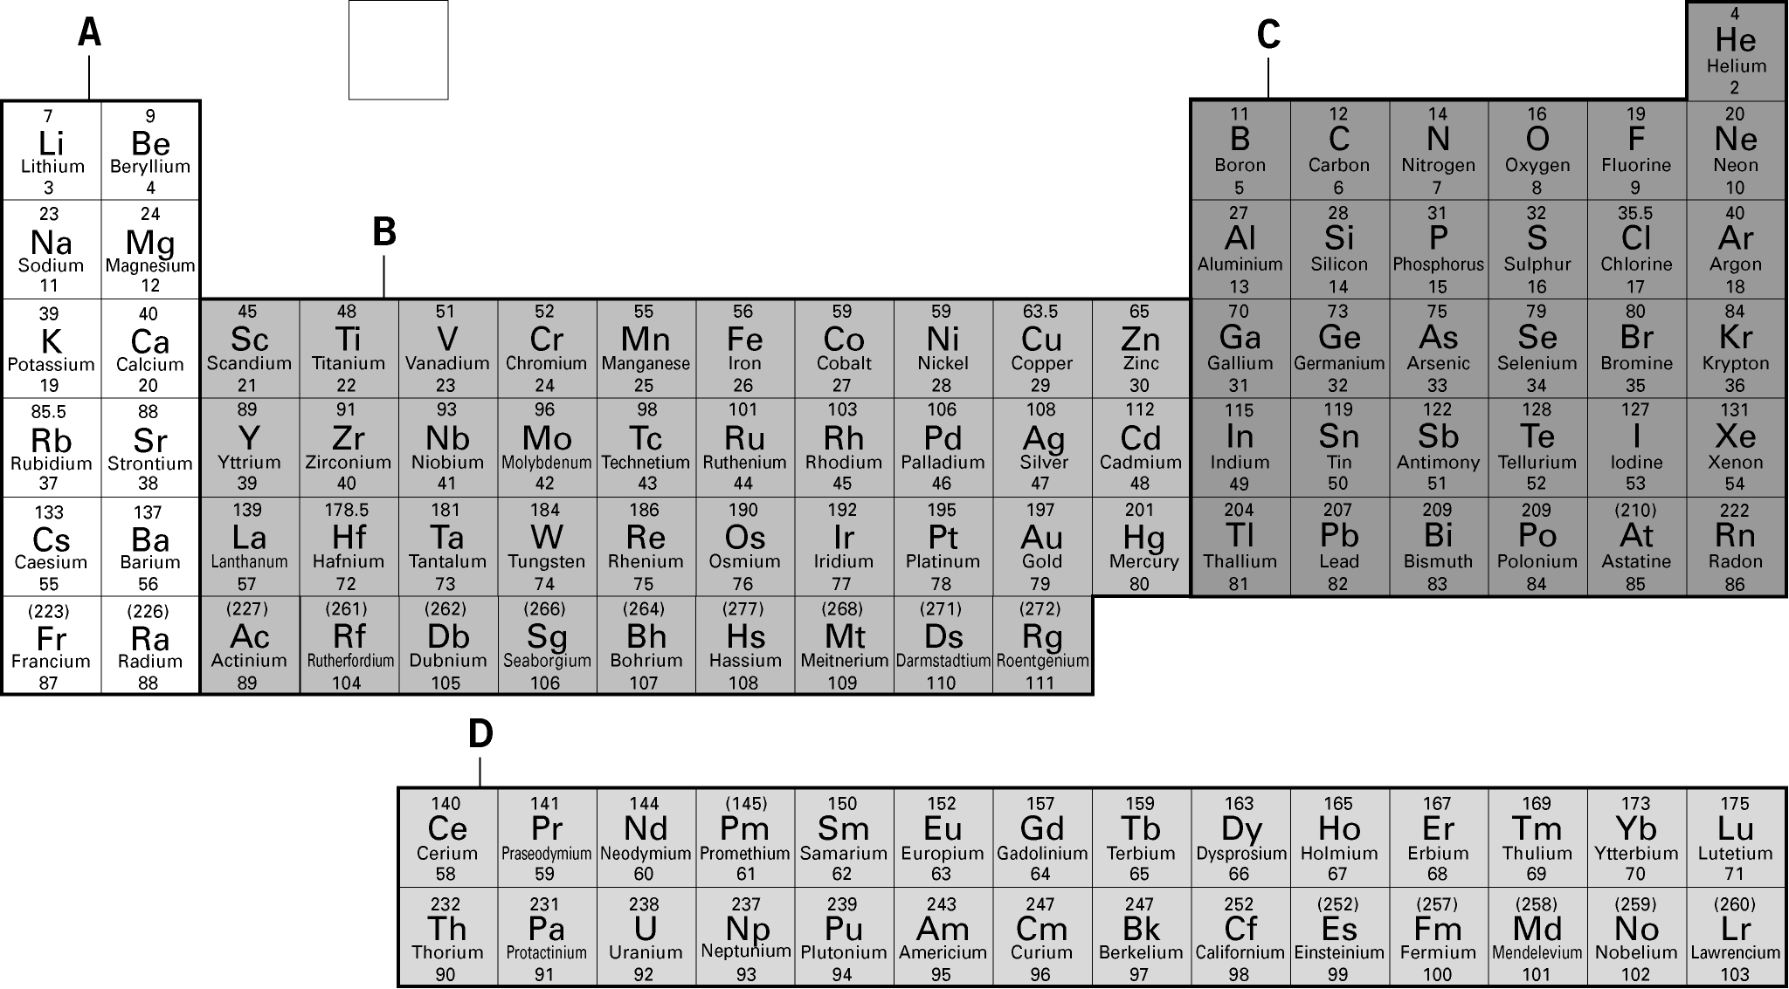

a State the section of the Periodic Table in which you can find non-metals.
b State whether Section A contains metals or non-metals.
2 a Categorise the following properties into those shown by metals, non-metals,
or both. Complete the table below by ticking in the column.
Property | Metal | Non-metal
conductor of heat and electricity
insulator of heat and electricity
shiny
low density
dull
sonorous (makes a ringing sound when hit)
brittle (breaks easily)
malleable (can be hammered into shape)
ductile (can be drawn into wires)
high density
not sonorous
b An unknown element is sonorous, conducts electricity, and can be drawn into wires. State whether this unknown element is a metal or a non-metal. Explain your answer.

3 An oxide is produced when an unknown substance dissolves in water. This solution
turns universal indicator orange. Explain whether the unknown substance is a metal
or non-metal, and describe how the observations will be different if the unknown substance is of the other category.

Task 2: Patterns in groups and periods
1 Complete the sentences below by crossing out the incorrect answer.
The rows of the Periodic Table are called groups/periods.
The columns of the Periodic Table are called groups/periods.
2 a Look at the data provided in the table. Describe the trend shown across a period.
Element | sodium | magnesium | aluminium | silicon
Melting point (°C) | 98 | 649 | 660 | 1410

b Here is another set of data for a different period. Compare the data provided for the two periods.
Element | lithium | beryllium | boron | carbon
Melting point (°C) | 181 | 1287 | 2076 | 3527

Task 3: Patterns in Group 1
The following table shows some of the trends in Group 1 elements.
 | Melting point (°C) | Boiling point (°C) | Reactivity with water
lithium |  | 1330 | fizzes steadily
sodium | 98 | 890
potassium | 64 |  | fizzes and burns with a lilac flame
rubidium | 39 | 688 | explodes with sparks
1 Describe the pattern shown in the data for Group 1 elements.

2 Predict the missing properties in the table above using the patterns described in Question 1. Fill in the missing entries in the table above.
Task 4: Patterns in Group 7
The table below shows whether reactions will occur between Group 7 elements (halogen water) and Group 7 compounds in solution (potassium halide).
 | potassium  fluoride | potassium  chloride | potassium  bromide | potassium  iodide
fluorine water |  | 
chlorine water
bromine water
iodine water
1 Complete the table above using patterns in Group 7 elements.
2 a State what is meant by a displacement reaction.

b Describe displacement reactions using examples from the table above.

3 Predict if the following pairs of reactants will undergo displacement reactions.
Write a word equation for reactions that occur. Explain your answer.
a chlorine water and sodium iodide

b bromine water and magnesium bromide

c iodine water and aluminium chloride

Task 5: Patterns in Group 0
1 The table below shows some of the properties shown by Group 0 elements.
Categorise them into chemical or physical properties by ticking the appropriate
column for each property stated.
 | Physical | Chemical
low melting points
low boiling points
colourless gas at room temperature
good insulator of heat
unreactive
2 Describe the differences between chemical and physical properties. Use examples
from the table above.

3 Predict if xenon will react with nitrogen. Explain your answer.

4 The boiling points of helium, neon, and argon are –269 °C, –246 °C, and –186 °C respectively. Predict the boiling point of krypton. Explain your answer.

