Male and female reproductive systems
Aims
In this activity students will:
- learn the names and locations of the main structures in both the male and female reproductive systems
- be able to describe the function of each of those parts.
Students will be working scientifically to:
- present observations and data using appropriate methods, including tables.
Students will be using the following literacy skills:
- retrieving and collating information from a range of sources.
Teacher notes
- Remind students of the expectations for a lesson on reproduction.
- Perhaps the best way to deliver this lesson is to see it as two half lessons. Run a starter and main for the male system, followed by a starter and main for the female system.
- If the starters here are not being used, some starter which describes and names the main reproductive structures would be helpful.
- Issue the student book and the activity sheet and allow students to work though the tasks.
Answers
Task 1: Male reproductive structures
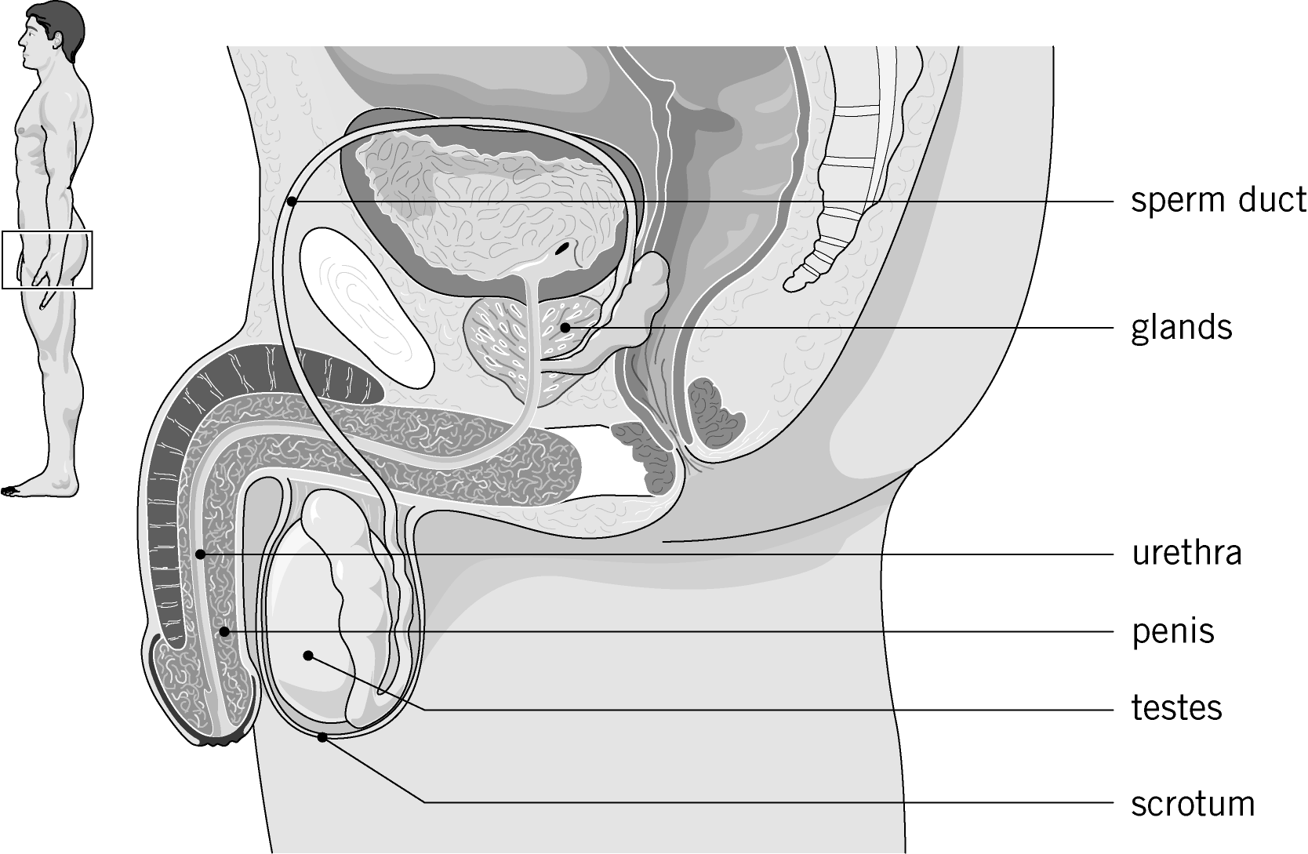

Male reproductive  structure | Description of  structure | Function
testes | oval organs in the scrotum | produce sperm and the male sex hormones
scrotum | bag of skin containing the testes | keeps the temperature of the testes slightly lower than the rest of the body
glands | small structures near the urethra | add fluid to the sperm to keep them alive
sperm ducts | muscular ducts about 30 cm long | carry sperm from the testes to the penis
urethra | tube in penis | carries urine or sperm out through the penis
penis | sex organ, cylindrical in shape | inserts sperm into the female
Task 2: Female reproductive structures
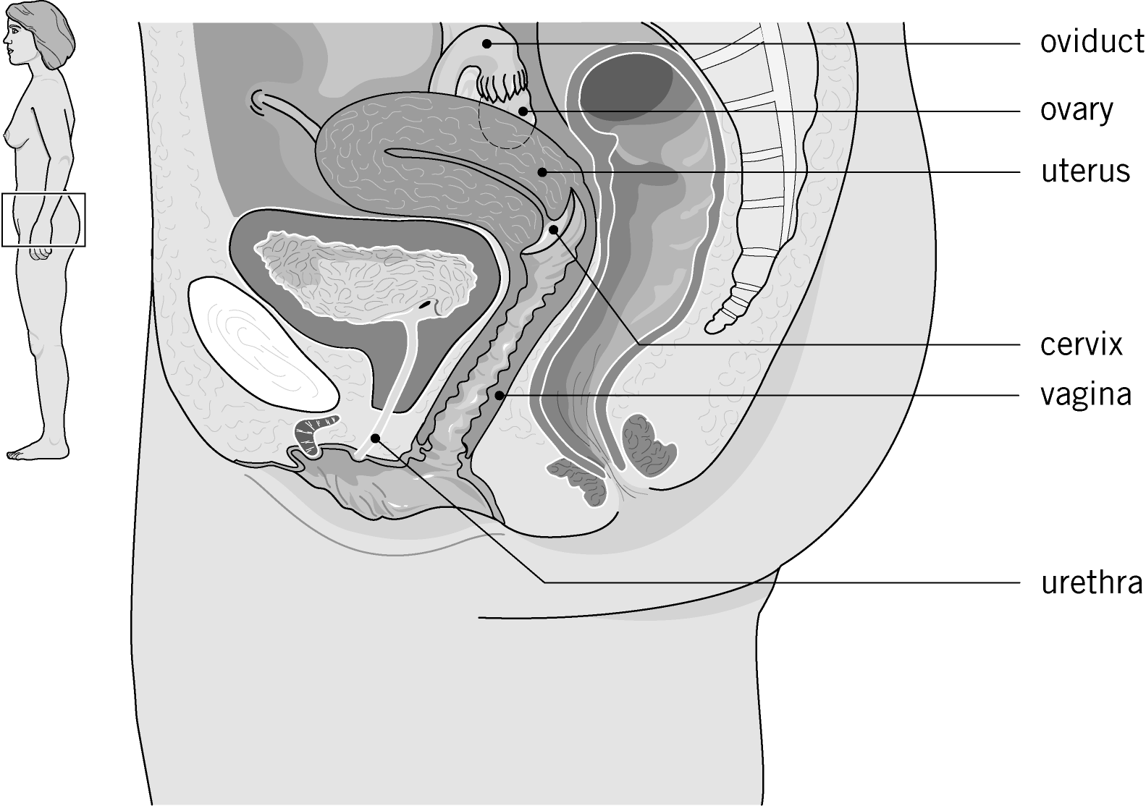

Female reproductive structure | Description of  structure | Function
ovaries | pair of small, oval-shaped glands, either side of the uterus | store and release eggs
oviduct | tube connecting ovary and the uterus | carries the egg to the uterus
uterus | hollow, pear-shaped organ | where a fetus/baby  develops until birth
cervix | ring of muscle at the entrance to the uterus | keeps the fetus/baby in place
vagina | muscular canal ending at the cervix | receives the sperm during sexual intercourse
urethra | tube from bladder | carries urine out of the body
Extension
1 a The lining is thick to hold the baby.
b Filled with blood vessels which can swell with blood and stiffen.
This allows the penis to be placed inside the vagina during sexual intercourse.
2 The temperature is a few degrees lower than the inside of the body. This is better for sperm production.
3 The lining is thick to hold the baby.
The cervix is a ring of muscle which keeps the baby in place in the uterus.
4 Sperm produced in the testes.
Stored in the testes.
When released they travel through the sperm duct.
Fluid is added from the glands which keeps the sperm healthy (and helps them swim).
Finally they pass through the centre of the penis in the urethra.
Support sheet
A support sheet is available with partly completed tables to help the students.

