Male and female reproductive systems
Setting the scene
Both the male and female reproductive systems have large numbers of structures in them that enable them to work. Each structure has its own function.
Aims
In this activity you will:
- learn the names and location of the main structures in both the male and female reproductive systems
- be able to describe the function of each of those parts.
You will be working scientifically to:
- present observations using appropriate methods.
Task 1: Male reproductive structures
Use the student book to label all of the structures in the male reproductive system shown below.
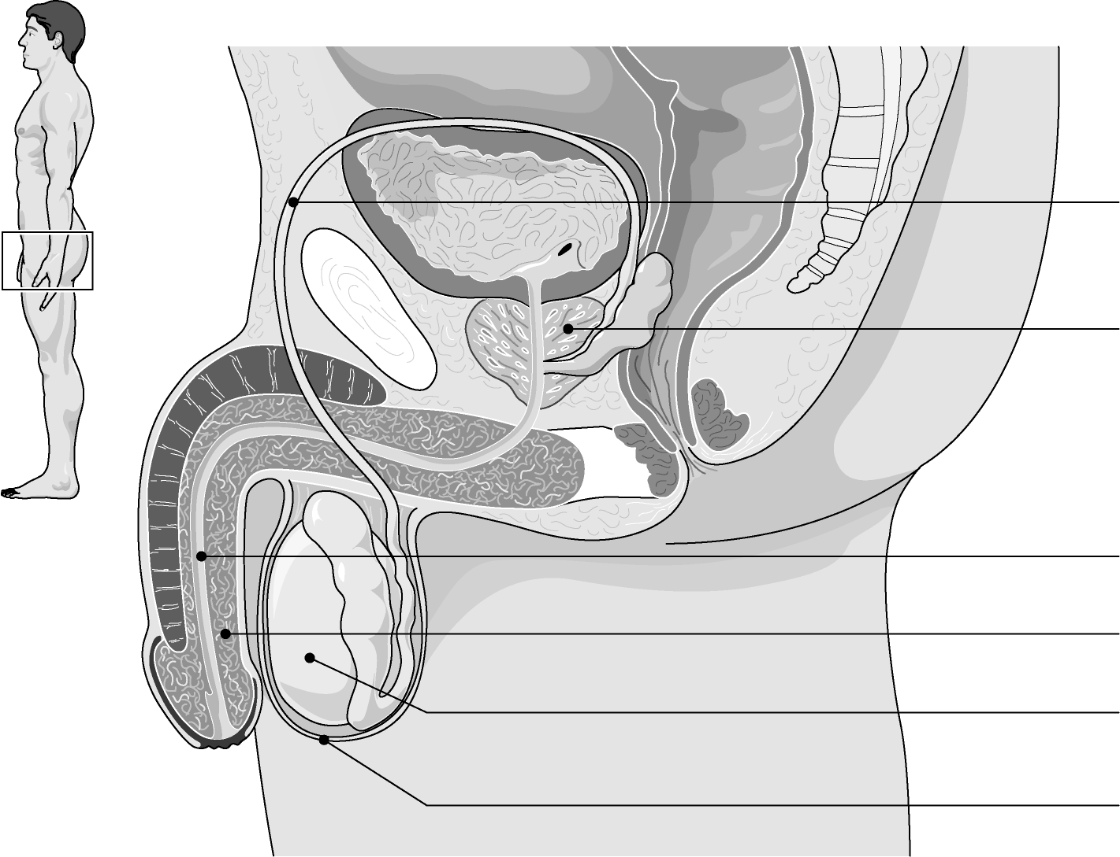

Then find the functions of each part.
Questions
Complete the following table.
Male reproductive structure | Description of  structure | Function
Task 2: Female reproductive structures
Use the student book to label all of the structures in the female reproductive system shown below.
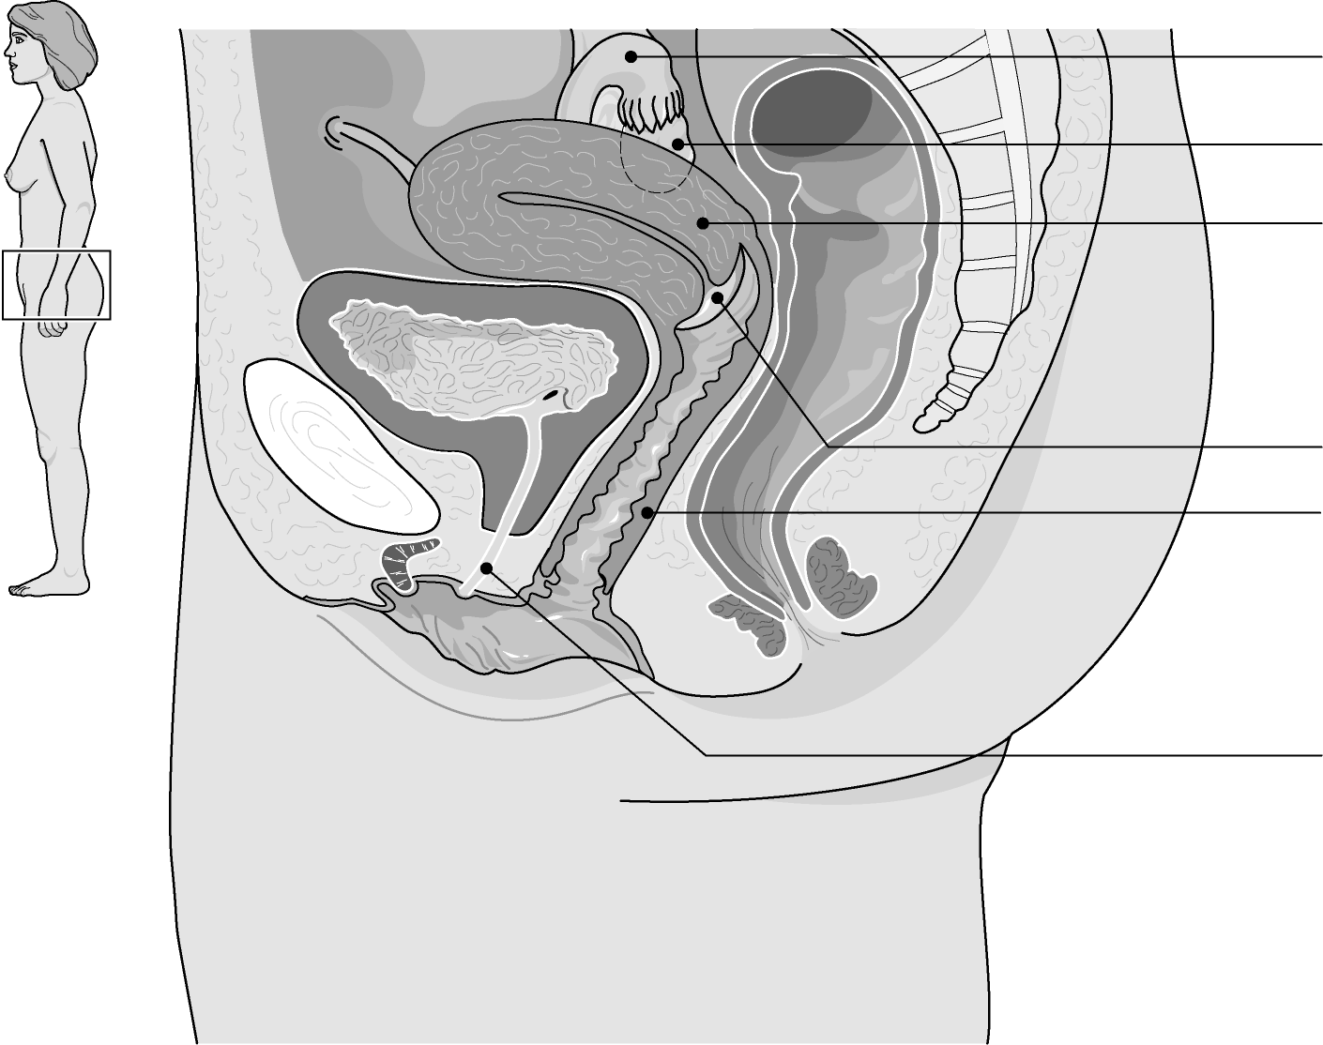

Then find the functions of each part.
Questions
Complete the following table.
Female reproductive structure | Description of  structure | Function
Extension
1 For each of the following, explain how their structure helps them to carry out their function fully:
a uterus

b penis

2 Explain why the testes are better being held in the scrotum than being held inside
the body.

3 Explain how some of the organs of the female reproductive system work together to
hold the baby during pregnancy.

4 Explain how a number of different structures work together to allow sperm to travel
from the testes to outside the body.

