Acids and alkalis
Setting the scene
Acids and alkalis are two ‘families’ of chemicals. Acids and alkalis are chemical opposites of one another. Some acids and alkalis are safe to use, handle, and even eat and drink. Many, however, are dangerous chemicals and have to be handled carefully.
Aims
In this activity, you will:
- consider how chemicals are labelled so that any hazards they present are clear
- consider how people using hazardous chemicals can keep themselves and others safe.
You will be working scientifically to:
- evaluate risks.
Task
1 Scientists use hazard symbols to label the risks associated with a chemical. New hazard symbols are being introduced so that every scientist uses the same hazard symbols.
Link the hazard symbols with their name and description.
Old  hazard  symbol |  | New hazard  symbol |  | Name |  | Description
1 | 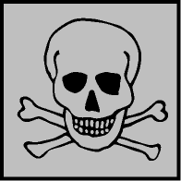 | 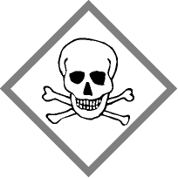 |  | Corrosive |  | This may dissolve or burn materials, including skin
2 | 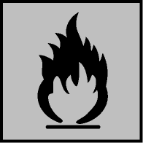 | 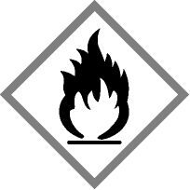 |  | Health hazard  (Harmful) |  | This includes irritants, harmful substances, and some low-hazard substances
3 |  | 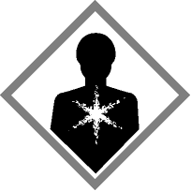 |  | Explosive |  | This contains dangerous organisms such as bacteria
4 |  | 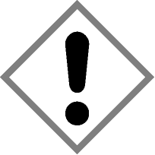 |  | Flammable |  | This can be poisonous and possibly deadly
5 | 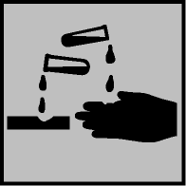 | 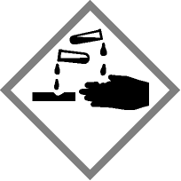 |  | Toxic |  | This may explode
6 | 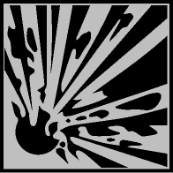 |  |  | Caution  (Irritant) |  | This can catch fire easily

2 A scientist wants to use some hydrochloric acid for an experiment. Hydrochloric acid is a strong acid, which is corrosive and an irritant. Which of the following safety precautions should he use? Tick the necessary precautions below.
Wear steel toe-capped shoes.
Wear eye protection.
Keep the lid on the acid when it is not in use.
Keep windows and doors open.
Only use proper laboratory glassware (e.g., beakers).
Wear a face mask.
Keep the temperature of the lab below 20 °C.
Wash any spillages off his skin with plenty of water.
Extension
1 For each precaution you have chosen in Question 2 explain why it is important.

