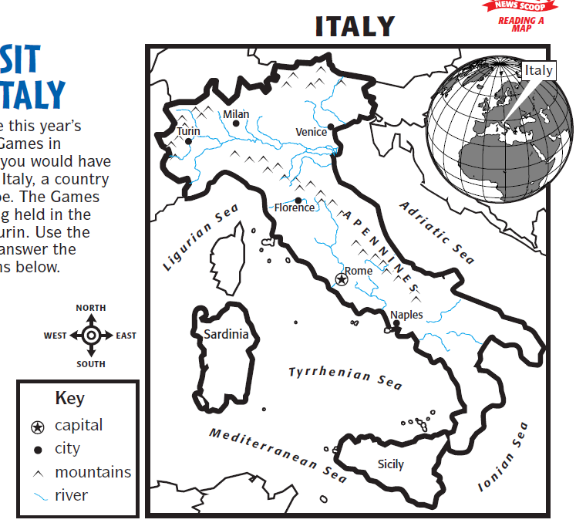
Name: ____________________________ Date: _______________

1. What is the capital of Italy? Rome

2. Find and circle Venice on the map.

3. What is Italy shaped like? A high heeled boot (kicking a ball)

4. What mountains run along the middle of Italy? The Apennines

5. If you lived in Rome what direction would travel to go to Turin?

North West

6. Which island is to the west of Italy? Sardinia

