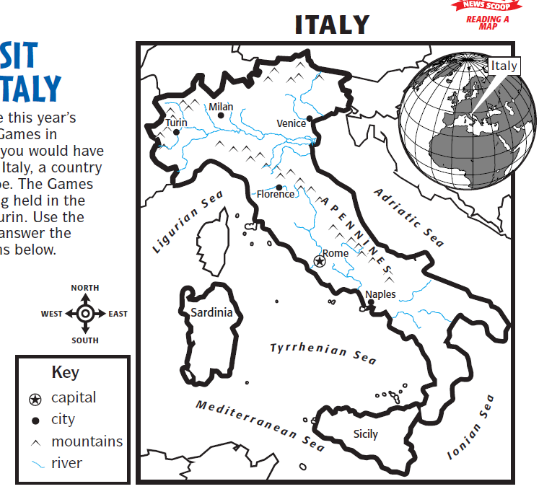
Name: ____________________________ Date: _______________

1. What is the capital of Italy? _________________

2. Find and circle Venice on the map.

3. What is Italy shaped like? _________________

4. What mountains run along the middle of Italy? ________________

5. If you lived in Rome what direction would travel to go to Turin?

_____________________________

6. Which island is to the west of Italy? ___________________

