Name:______________ Class:_________
THE HOLDERNESS COASTLINE:
A CASE STUDY
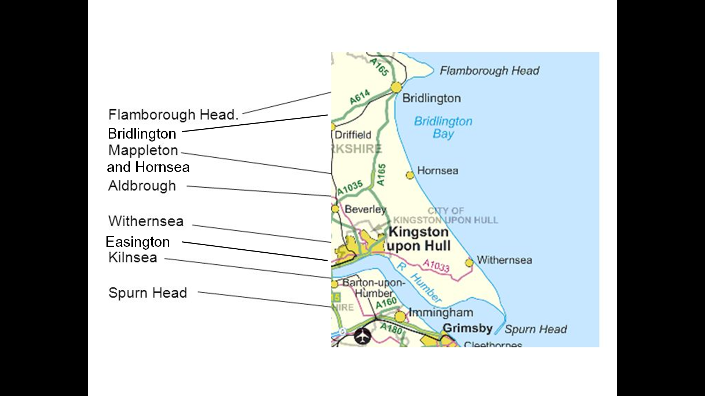
Introduction:
The Holderness Coastline is eroding more quickly than anywhere else in the whole of Europe! The East Riding of Yorkshire Council (ERYC) is responsible for looking after this coastline. Your task is to complete independent research using all of the information and resources provided (and the previous lessons) to find out about the different places along The Holderness Coastline and what the council is (or isn’t) doing.
The questions have coloured question marks next to them to let you know what level they are (developing, secure, secure+) so work to your level- and push yourself if you can!

WHY IS THE HOLDERNESS COASTLINE ERODING SO QUICKLY?
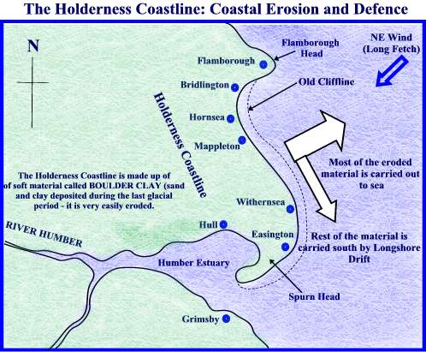
Use this image (and your book) to give as many reasons as you can to explain why The Holderness Coastline is eroding so quickly…

FLAMBOROUGH HEAD:
The features I can see are:
Look at the images of Flamborough head. This is a really good example of coastal erosion. What features can you identify in the images that have been created because of erosion?

Draw a diagram to show how headlands (like the ones at Flamborough) are eroded. Try to show how it goes from a crack to a cave, then arch, then stack and finally stump.

BRIDLINGTON:
Look closely at the two pictures of Bridlington. Which two forms of coastal defence have the council put here?
1)
2)
Why do you think the council chose these two forms of defence? (What are their strengths?)

The council would have had to think very carefully about which defences to pick. What are some reasons why the council might have been unsure whether the two methods they picked were the best ones? (What are their weaknesses?)

MAPPLETON AND HORNSEA
How much did the council spend on this area in 1991?
The council used rock to build groynes and rock armour. The imported rock they used was Scandinavian (which means it came from countries such as Norway, Sweden, Denmark, Finland or Iceland).
How could you use this information as evidence that, whilst rocks can look quite natural, using them to build groynes or armour is a method of hard engineering?

Grass growing on the cliffs

Big, sandy beach

How does the image above (and the labels) support the idea that the money the council spent on defending this area was worth it? (How has Mappleton and Hornsea benefitted?)

Give at least one reason why the council could have decided to protect this area:

ALDBROUGH
Look at the images of Aldbrough.
What has happened (and is still happening)?

Use an Ipad to watch the video.
Make notes below about what is being said:

If you were living in Aldbrough, why might you think the decisions made by the council to use coastal defences in the towns a bit further up the coast (Mappleton and Hornsea) was not a good choice?

WITHERNSEA
Look at the images of Withernsea
Which 3 coastal defences have the council used in Withernsea?
1)
2)
3)
In your opinion, did the council need to use all 3 defences?

EASINGTON
The council chose to use just rock amour here. Look very carefully at the images… Why do you think they chose to use just one method of defence, instead of 2 or 3 like they did in other places? Think about what the land is being used for. Why might they not think it is as important?

Evaluate whether rock armour is a useful defence method (strengths and weaknesses)

KILNSEA
Why has Kilnsea had to be rebuilt?

The first sea defences in Kilnsea were built in 1847. Look at the images. How many years later was one of them restored? Why did it have to be restored ?

How many yards of land were eroded from the coast of Kilnsea between 1847 and 1994? Look very closely at the image.

SPURN HEAD
Spurn Head is right at the south end of The Holderness coastline. A spit has formed here. Describe what a spit is.

Draw a diagram to show what how a spit is formed:

THE FUTURE
The Holderness Coastline is facing serious problems with erosion, even though the council are doing their best to protect it. Some people argue that managed retreat might be a better option. Read the information about managed retreat.
Evaluate whether managed retreat would be a good option for The Holderness Coastline.
Complete the table to help plan your answer:
Reasons why the council should use managed retreat | Reasons why the council shouldn’t use managed retreat (why should they continue to defend the coast) | What is your opinion?
Complete your answer below:
_____________________________________________________________________________________________________________________________________________________________________________________________________________________________________________________________________________________________________________________________________________________________________________________________________________________________________________________________________________________________________________________________________________________________________________________________________________________________________________________________________________________________________________________________________________________________________________________________________________________________________________________________________________________________________________________________________________________________________________________________________________________________________________________________________________________________________________________________________________________________________________________________________________________
Look at the information provided by the council about how they have chosen to defend the coastline. Use this information to answer the following questions:

- How long is The Holderness Coastline in total?
- How much of the coastline has the council (ERYC) paid to defend?
- How much of the coastline has defences that are being paid for privately (not by the council but by other people such as companies, landowners etc.
- How much of the coastline is not being defended at all?
Look closely at the image on the previous page, this is a record provided by the council of erosion rates since 1951. You need to use this image to help you answer the following question:
Analyse the choices made by the East Riding of Yorkshire Council.
In your answer you should include:
Introduction | -Why does the council have to make choices?  -Why can’t they defend the whole coastline?
Main body | Part 1:  How have the decisions made benefitted the coastline?  - Who has benefitted?  - Use evidence from the image you were asked to look at.  Part 2:  - How have the decisions made disadvantaged the coastline?  - Who has been disadvantaged?  - Use evidence (and statistics) from the image you were asked to look at
Conclusion | -What is your opinion?  - Do you think there could be a better solution to the problem?  - Or do you think the council are doing a good job?

_____________________________________________________________________________________________________________________________________________________________________________________________________________________________________________________________________________________________________________________________________________________________________________________________________________________________________________________________________________________________________________________________________________________________________________________________________________________________________________________________________________________________________________________________________________________________________________________________________________________________________________________________________________________________________________________________________________________________________________________________________________________________________________________________________________________________________________________________________________________________________________________________________________________________________________________________________________________________________________________________________________________________________________________________________________________________________________________________________________________________________________________________________________________________________________________________________________________________________________________________________________________________________________________________________________________________________________________________________________________________________________________________________________________________________________________________________________________________________________________________________________________________________________________________________________________________________________________________________________________________________________________________________________________________________________________________________________________________________________________________________________________________________________________________________________________________________________________________________________________________________________________________________________________________________________________________________________________________________________________________________________________________________________________________________________________________________________________________________________________________________________________________________________________________________________________________________________________________________________________________________________________________________________________________________________________________________________________________________________________________________________________________________________________________________________________________________________________________________________________________________________________________________________________________________________________________________________________________________________________________________________________________________________________________________________________________________________________________________________________________________________________________________________________________________________________________________________________________________________________________________________________________________________________________________________________________________________________________________________________________________________________________________________________________________________________________

