Name:__________________ Class:______
___
55
Year 6 Italy End of Topic Assessment
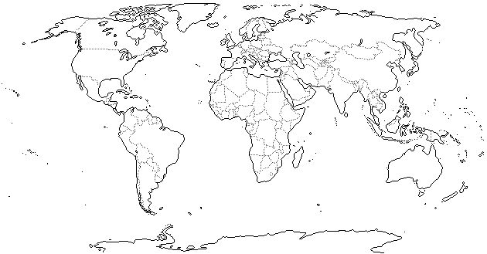
- Draw a circle around Italy on the map of the world below: (1 mark)
- In which continent is Italy? (1 mark) ___________________________

- Name the 4 countries which border Italy (4 marks) __________________________

- There are two different types of map, physical and political. Identify which type of map is shown below and give 4 things you usually find on this type of map:

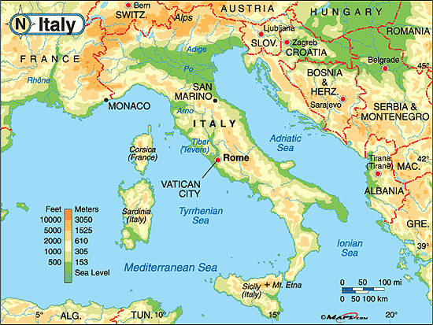
Type of map (1 mark): _____________
4 things this type of map usually shows (4 marks):
1)_________________________
2)_________________________
3)_________________________
4)_________________________

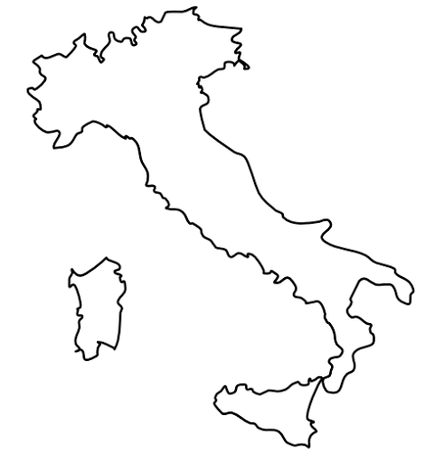
- There are 3 mountain ranges in Italy, The Alps, The Apennines and The Dolomites. Label them in the correct places on the map of Italy to the right: (3 marks)

- This is Ben, he has recently moved to Italy and wants to work in one of the mountain ranges. Identify one type of job that Ben could do in each mountain range, and describe why he is likely to get that sort of job there. (3 marks)
Mountain Range | Type of job Ben could do | Describe why that sort of job is available there
The Alps
The Dolomites
The Apennines

- The mountains have also been responsible for the creation of some amazing lakes in Italy. Use the diagrams below to help you to explain how the lakes were formed (remember- you should be using key terminology! The first one has been done for you) (5 marks)
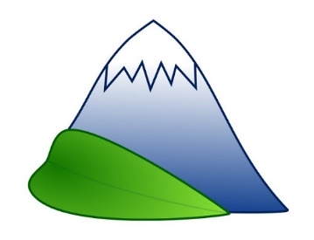  1) | The mountains have their own climate where it is very cold and often snowy.
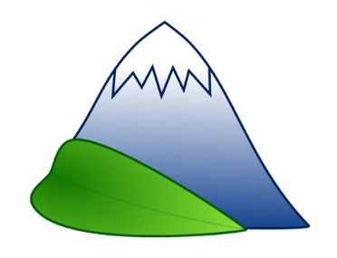
2)
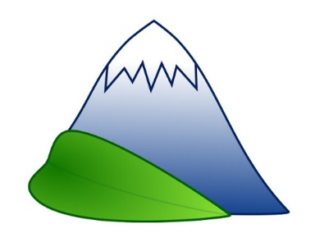
3)
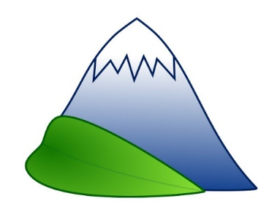
4)
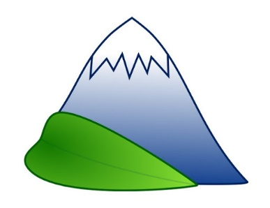
5)

- Due to the many mountain ranges, Italy also has volcanoes! Volcanoes can be active, dormant or extinct. Explain what those 3 terms mean (3 marks):
If a volcano is active it means__________________________________________
If a volcano is dormant it means ________________________________________
If a volcano is extinct it means _________________________________________

- When researching Italy’s volcanoes you recorded some primary (things that happened straight away) and secondary (things that happened a while after the eruption) effects of their eruptions. Pick one volcano and describe one primary and secondary effect. (3 marks)
Name of Volcano | Primary Effect | Secondary Effect

- Look at the climate graphs on the next page which show the different climates in north, mid and south Italy.

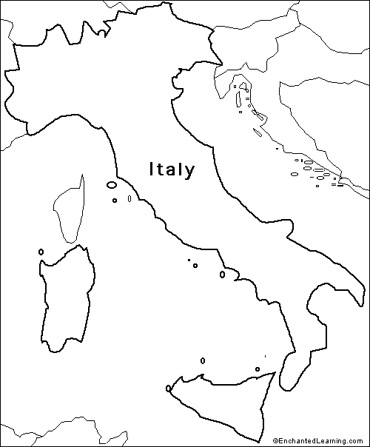
Analyse the information from the climate graphs, describe one difference and one similarity between the climate in different parts of Italy (4 marks)
By analysing the information from the climate graphs, I can see that _______________ and _______________ have a similar climate. It is similar because________________________________________________ _____________________________________________________________________.
I can also see that _____________ and ____________ have very different climates. They are different because ____________________________________________________ _____________________________________________________________________.

- In some ways, Italy and The UK are very similar, but in other ways they are very different! Compare Italy and the UK by describing 2 things that are similar about both countries and 2 things that are different. (Remember: you compared the following areas: Population, Mountains, Lakes, Rivers, Volcanoes and Coasts) (4 marks)
Something very similar about Italy and The UK is __________________. It is similar because _______________________________________________________________ _____________________________________________________________________.
Something very different about Italy and The UK is _________________. It is different because_______________________________________________________________ _____________________________________________________________________.
Italy is a developed country. We know this because the people who live there have a good quality of life. We can measure development using the Human Development Index (HDI). HDI is calculated by looking at 3 categories; living standard, health and education.
- What do we measure to find out about a country’s living standard? (1 mark)
___________________________________________________________________
- What do we measure to find out about a country’s health? (1 mark)
___________________________________________________________________
- What do we measure to find out about a country’s education? (1 mark)
___________________________________________________________________
- Is Italy more or less developed than the UK? Explain how you know this (what evidence is there?) (3 marks)
Italy is more / less (circle correct answer) developed than the UK. I know this because _________________________________________________________________________________________________________________________________________________________________________________________________________
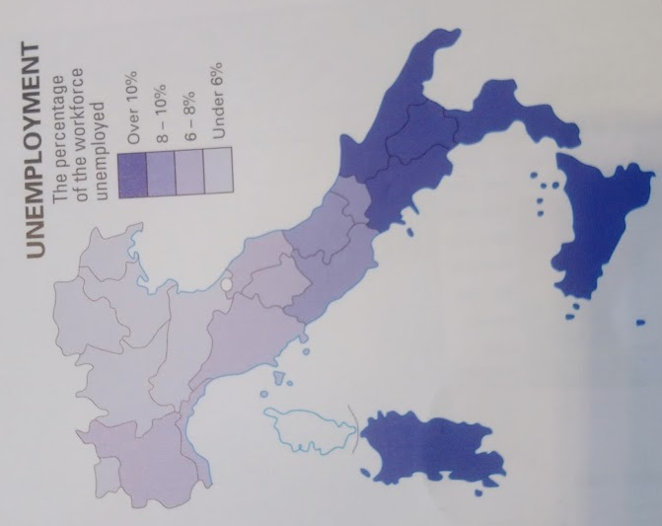
- Analyse the two maps below to help you compare whether North or South Italy is more developed and give two reasons why:
(3 marks)

By analysing the maps I can see that _______ Italy is more developed than ________ Italy.
One reason why I know this is because________________________________________ _____________________________________________________________________. Another reason I know this is because_________________________________________ _____________________________________________________________________.
- The jobs that people do can be split into 3 sectors; primary, secondary and tertiary. Describe each sector and give an example of a job in that sector. (6 marks)
Employment Sector | Description | Example of a job
Primary
Secondary
Tertiary

- The pie chart below shows how employment in Italy is spread across the three sectors. Colour the sections in three different colours and then complete the key to show which section is which (think about which section should be the biggest and smallest) (3 marks)

- Justify (give a reason) why developed countries, like Italy, have more people employed in a certain sector. (2 marks)
In developed countries, like Italy, more people are employed in the ______________ sector because ______________________________________________________________ _____________________________________________________________________.
20) Justify why in less developed countries, such as India, more people are employed in a different sector. (3 marks)
In less developed countries, such as India, more people are employed in the _____________ sector. This is because ____________________________________________________ _____________________________________________________________________.

