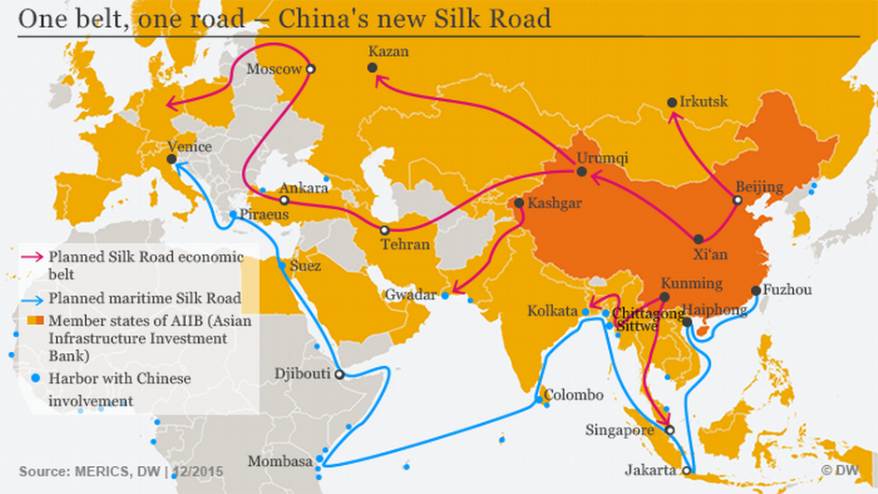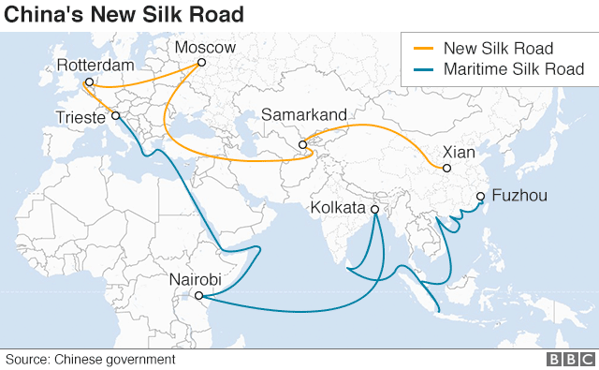

**These two maps are evidence that China’s economy will continue to grow and that China is helping to create a ‘global marketplace’ where we are all connected.**

The maps show China’s economy will continue to grow because:

They show China is helping to create a ‘global marketplace’ because: