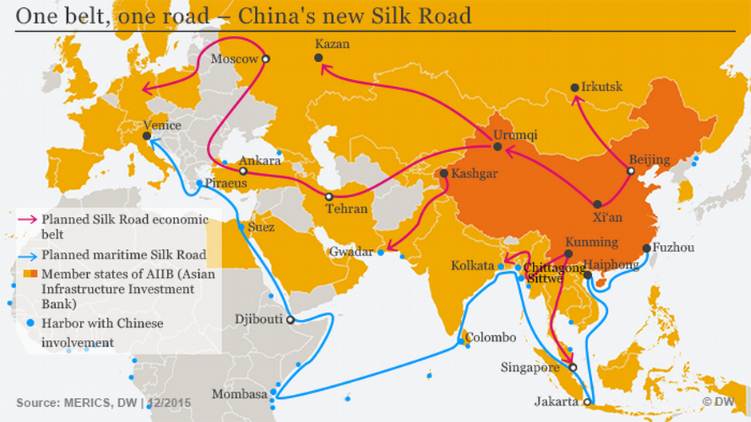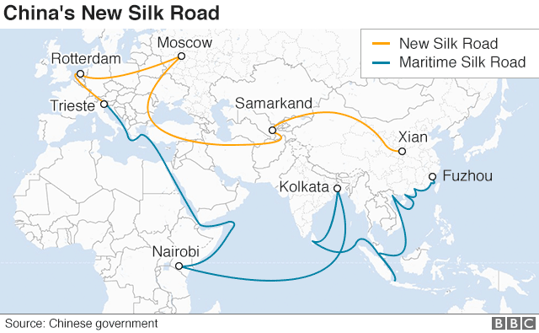

**These two maps are evidence that China’s economy will continue to grow and that China is helping to create a ‘global marketplace’ where we are all connected.**

The maps show China’s economy will continue to grow because:

The New Silk Road allows them to transport goods to more and more countries. The more countries China can export their goods to, the more money they can make. This will mean their economy will keep growing.

They show China is helping to create a ‘global marketplace’ because:

These maps show that China is creating land and sea routes to countries all over the world. In the past, China mainly traded with Europe, but the maps show that China can now trade with Asia and Africa too. This supports the idea that there is a global marketplace because countries all over the globe can buy from and sell to each other.