Project EAT
Introduction Page:
https://www.stem.org.uk/rxg4o9
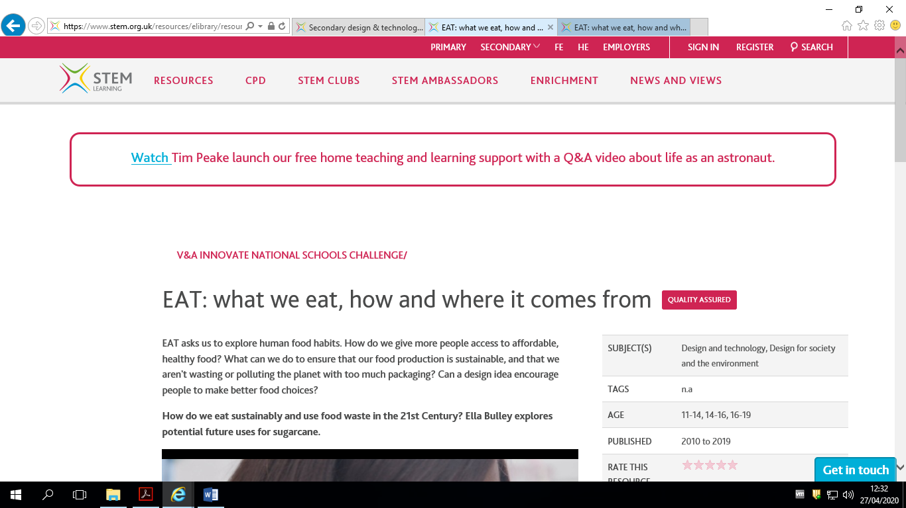
V&A Website Search URL:
https://collections.vam.ac.uk/