Investigation task:

- How does China compare to the UK in terms of HDI?
Use the evidence below to answer the following questions:
- In which country do people earn more money?_________________
- In which country do people live longer?________________
- In which country can more people read and write?______________
- So, which country is more developed (a better place to live)?__________
Evidence:
GDP per capita: The average amount of money people earn over a year
Life Expectancy: How long, on average, people live for
Literacy Rate: How many people can read and write (as a percent)
Italy: The UK:
GDP per capita | £7,090
Life Expectancy | 76
Literacy Rate | 96.8%
GDP per capita | £32,700
Life Expectancy | 80.17
Literacy Rate | 99%
Explanation:
When we compare China and The UK it is clear that China is less developed than the UK, even though it has a better economy. The evidence shows us that the quality of life is not as good in China. If we look at GDP per capita, which means ______________________________ _____________________________________, we can see that people in China only earn ___________ per year, whereas people in The UK earn ____________. This means people in the UK will have a better quality of life because __________________________________ _____________________________________________________________________.
If we look at the life expectancy, which means __________________________________, we can see that people in the UK on average live ____ years longer than people in China. Lastly, if we look at the literacy rate, which means ________________________________ _______________, we can see that the slightly less people in China can read and write (_____%). This is still quite a high number but it is not as good as the UK.

- What are the problems with China’s GDP per capita?
Look carefully at the graphs and then answer the questions:
Graph 1
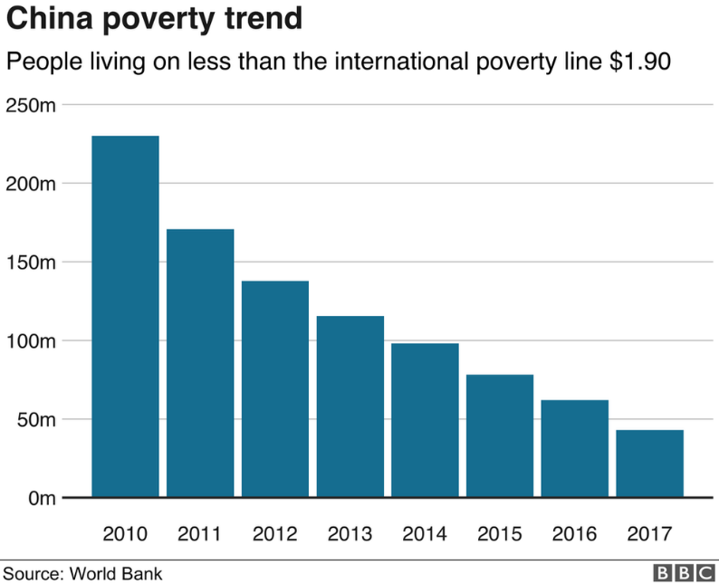
- What does ‘poverty’ mean?
_______________________
_______________________
_______________________

- What has been happening to the amount of people living in poverty since 2010?
_______________________
_______________________

- Roughly how many people in China were living in poverty in 2017? ________
Graph 2
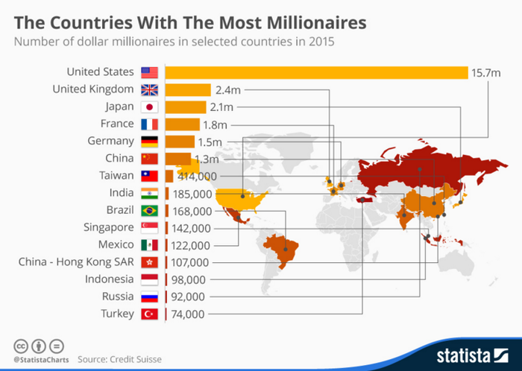

- In 2015, how many millionaires did China have?
_______________

Graph 3
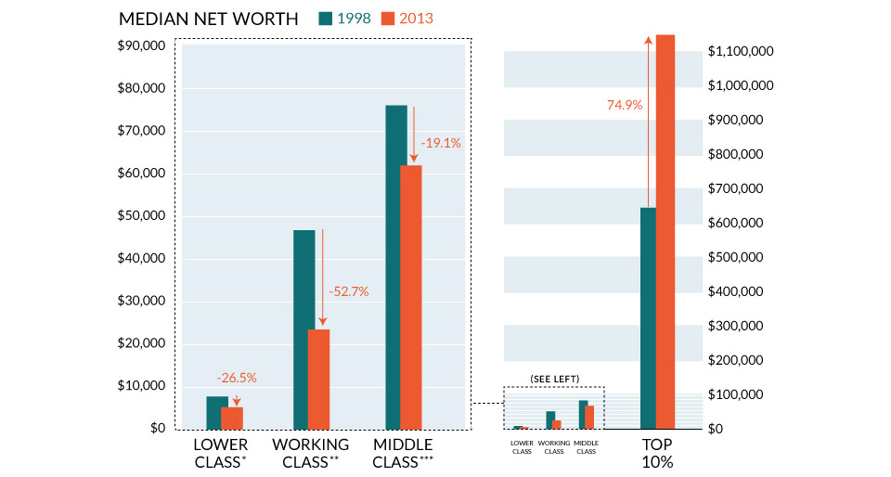
- In 2013 (the orange bars), roughly how much did the lower class in China earn? _____________
- In 2013 (the orange bars), roughly how much did the middle class in China earn? _____________
- In 2013 (the orange bars), roughly how much did the upper class (top 10%) in China earn? _____________
Explanation:
The evidence shows that the wealth (money) in China is not spread very fairly. Graph 1 shows that, whilst the amount of poverty in China is declining, there were still about __________ people living in poverty in 2017. This means all of those people’s suffer because __________ _____________________________________________________________________. On the other hand, graph 2 shows us that there are __________ people who are classed as millionaires in China. This means there is a huge difference between the rich and the poor people in China.
Graph 3 also supports this because it shows that lower class people in China earn very little money, around ____________. Whereas the upper class earn around ____________. This is extremely unfair because __________________________________________________ ______________________________________________________________________ _____________________________________________________________________.

- What are the problems with China’s healthcare?
Look carefully at the graphs and then answer the questions:
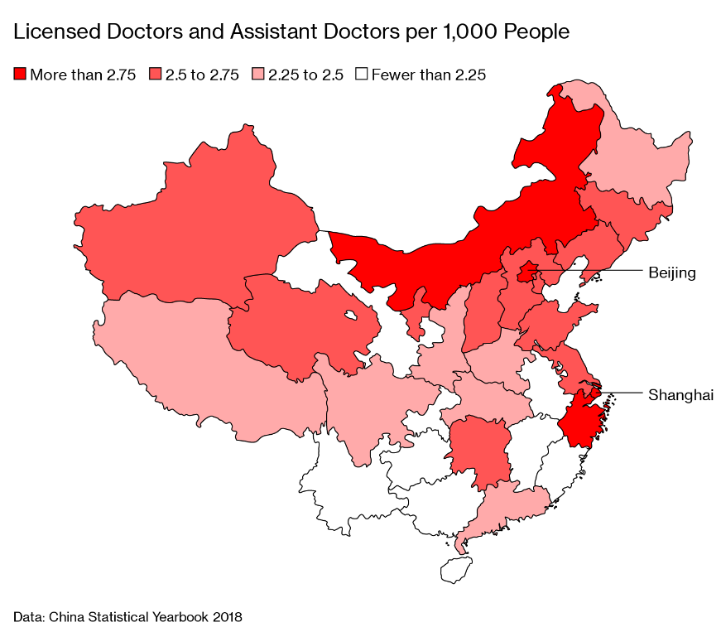
Graph 1
The more doctors there are the better as this means people can get treated more easily if they are unwell. The graph shows that the darker the colour, the more doctors, the lighter the colour, the less doctors there are.
- How many regions in China have more than 2.75 doctors per 1,000 people? ________
- How many regions in China have fewer than 2.25 doctors? __________
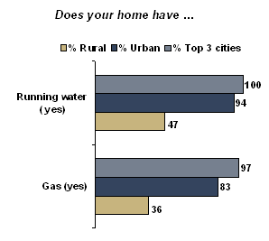
Graph 2
Rural means people who live in the countryside and urban means people who live in the city. People who live in rural China tend to be a lot poorer.
- What percent of people who live in Urban areas have running water?____________
- What percent of people living in Rural areas have running water?________
- Why do we need running water to stay healthy? _______________________ _______________________ _______________________
- What percentage of people living in Urban areas have gas in their home?________
- What percentage of people living in Rural areas have gas in their home? ________
- What do we use gas for that helps us to live and be healthy? _________________ _______________________________________________________________

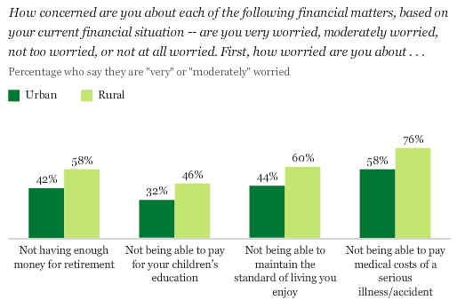
Graph 3

- What percentage of the people living in urban areas of China were worried about not being able to pay the medical costs of a serious illness/accident? _______
- How much more does that percentage increase for those living in rural areas? ______
- How many people living in rural areas of China worried that they do not have enough money to retire?_______
- If people don’t have enough money to retire, this means they have to keep on working. How could working when you are elderly affect your health? ___________________ ________________________________________________________________
Explanation:
The evidence shows that some people in China do not receive very good healthcare. Graph 1 shows us that there are only ____ regions which have more than 2.75 doctors per 1000 people, whereas there are _____ regions who have less that 2.25 doctors per 1000 people. This means there are lots more places where people will find it harder to see a doctor. This is a problem because _______________________________________________________ _____________________________________________________________________. There are two types of places people live in China, rural areas which are ________________ _______________ and urban areas which are ____________________________. People living in rural areas tend to have much less access to good quality healthcare. For example, graph 2 shows us that relatively few people living in rural areas have running water and gas in their homes. These two things are essential to stay healthy because __________________ ___________________________________________________________________________________________________________________________________________. Lastly, graph 3 shows us that lots of people in China are worried about not being able to afford healthcare if they need it. It also shows that lots of people in rural areas feel they do not have enough money to retire. This could affect their health because________________ _____________________________________________________________________.

- What are the problems with China’s education?
Look carefully at the graphs and then answer the questions:
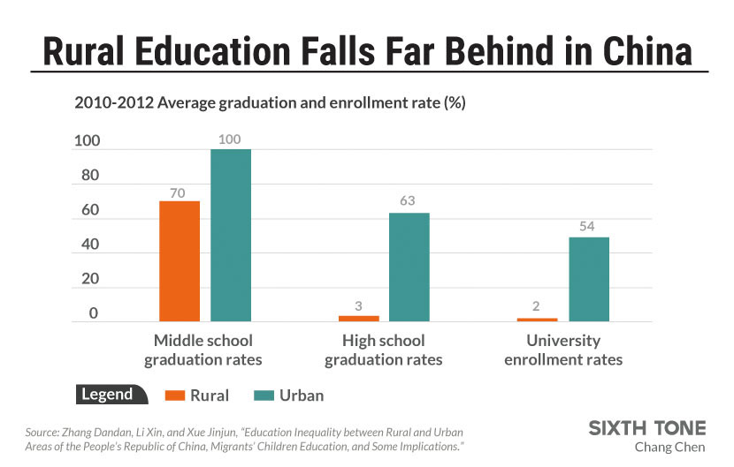
Graph 1

1) What percent of the children living in rural areas graduated from middle school? ___________
2) What percent of the children living in rural areas graduated from high school? ___________
3) What percent of the children living in rural areas enrolled in university?
4) What do you think children in rural areas (where it is poorer) might be doing instead of going to school?
____________________________________________________________________
5) How does this compare with the amount of education children in urban areas are experiencing? __________________________________________________________ _____________________________________________________________________.
Graph 2
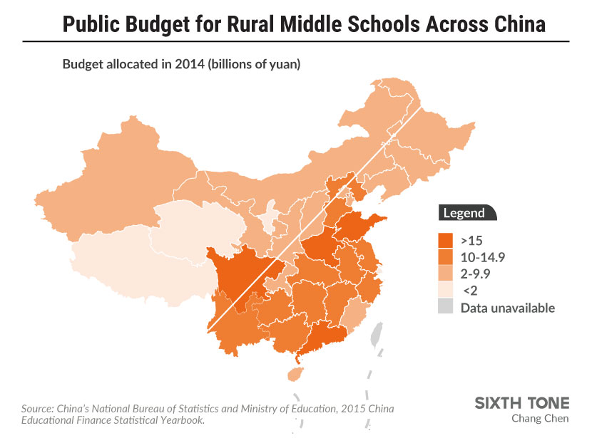
6) How many regions of China were given over 15 billion yuan (Chinese currency) to help their middle schools?_____________
7) How many regions of China were given under 10 billion yuan to help their middle schools? ________
8) Why is this unfair? __________________________ __________________________ __________________________ __________________________

Explanation:
The evidence shows that some people in China do not receive very education. Again, the people living in rural areas are worse off than those in urban areas. This can be seen in graph 1 because it shows that only ____% of people living in rural China graduate from high school, and only ____% enrol in university. This means that, after middle school, lots and lots of children stop going to school, this could be because _______________________________ _____________________________________________________________________. On the other hand, over 50% of people in urban China enrol in university. This will mean they will earn more money in the future because _____________________________________.
Graph 2 also shows that the money the government give to support middle school is not shared out fairly. There were only ____ regions which were given over 15 billion yuan, whereas the rest were given a lot less. This means those children going to school in the regions who get less money are not being treated fairly because ______________________ ______________________________________________________________________ _____________________________________________________________________.

