Investigation task:

- How does China compare to the UK in terms of HDI?
Use the evidence below to answer the following questions:
- In which country do people earn more money? The UK
- In which country do people live longer? The UK
- In which country can more people read and write? The UK
- So, which country is more developed (a better place to live)? The UK
Evidence:
GDP per capita: The average amount of money people earn over a year
Life Expectancy: How long, on average, people live for
Literacy Rate: How many people can read and write (as a percent)
Italy: The UK:
GDP per capita | £7,090
Life Expectancy | 76
Literacy Rate | 96.8%
GDP per capita | £32,700
Life Expectancy | 80.17
Literacy Rate | 99%
Explanation:
When we compare China and The UK it is clear that China is less developed than the UK, even though it has a better economy. The evidence shows us that the quality of life is not as good in China. If we look at GDP per capita, which means the average amount of money people earn over a year, we can see that people in China only earn £7,090 per year, whereas people in The UK earn £32,700. This means people in the UK will have a better quality of life because they get paid more money for the jobs they do so they have more money to spend on the things they want. This will improve their quality of life because they buy essential items as well as some more desirable/luxury items like cars, phones etc.
If we look at the life expectancy, which means how long, on average, people live for, we can see that people in the UK on average live 4.17 years longer than people in China. Lastly, if we look at the literacy rate, which means how many people can read and write, we can see that the slightly less people in China can read and write (2.2%). This is still quite a high number but it is not as good as the UK.

- What are the problems with China’s GDP per capita?
Look carefully at the graphs and then answer the questions:
Graph 1
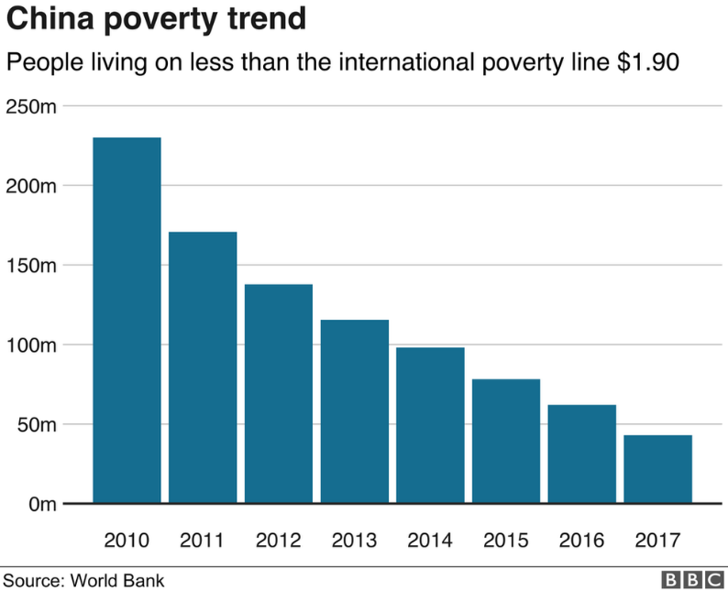
- What does ‘poverty’ mean?
Poverty means being extremely poor. The graph tells us the international poverty line is $1.90

- What has been happening to the amount of people living in poverty since 2010?
Since 2010, the amount of people living in China has dropped dramtically

- Roughly how many people in China were living in poverty in 2017? 45 million
Graph 2
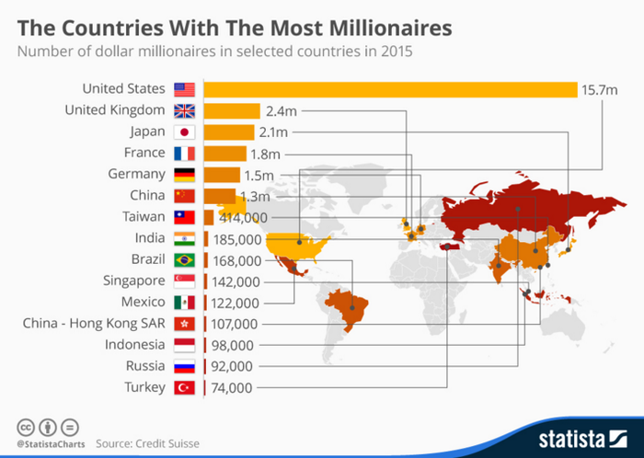

- In 2015, how many millionaires did China have?
1.3 million

Graph 3
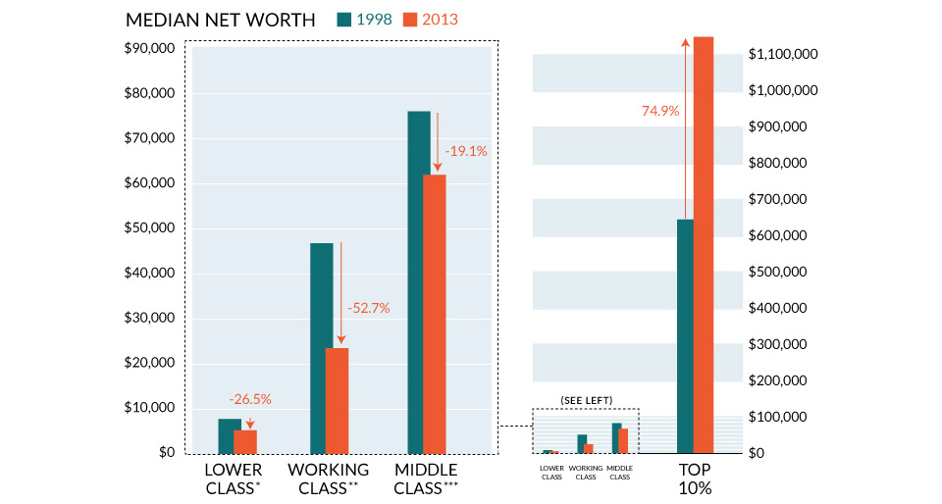
- In 2013 (the orange bars), roughly how much did the lower class in China earn?
Under $10,000 (around 6,000)
- In 2013 (the orange bars), roughly how much did the middle class in China earn? Just over $60,000 (around 61,000)
- In 2013 (the orange bars), roughly how much did the upper class (top 10%) in China earn? Over $1,100,000!
Explanation:
The evidence shows that the wealth (money) in China is not spread very fairly. Graph 1 shows that, whilst the amount of poverty in China is declining, there were still about 45 million people living in poverty in 2017. This means all of those people’s suffer because they have very little money to afford the essentials like food, water, clothing and shelter. On the other hand, graph 2 shows us that there are 1. 3 million people who are classed as millionaires in China. This means there is a huge difference between the rich and the poor people in China.
Graph 3 also supports this because it shows that lower class people in China earn very little money, around $6,000. Whereas the upper class can earn over $1,100,000. This is extremely unfair because it means that some people living in China have absolutely nothing and cannot afford a safe place to live with food and water, whereas other people in China have an enormous amount of money, meaning they could afford huge houses, luxurious cars and holidays etc. It means that the money in China is not shared fairly as the gap between rich and poor is huge.

- What are the problems with China’s healthcare?
Look carefully at the graphs and then answer the questions:
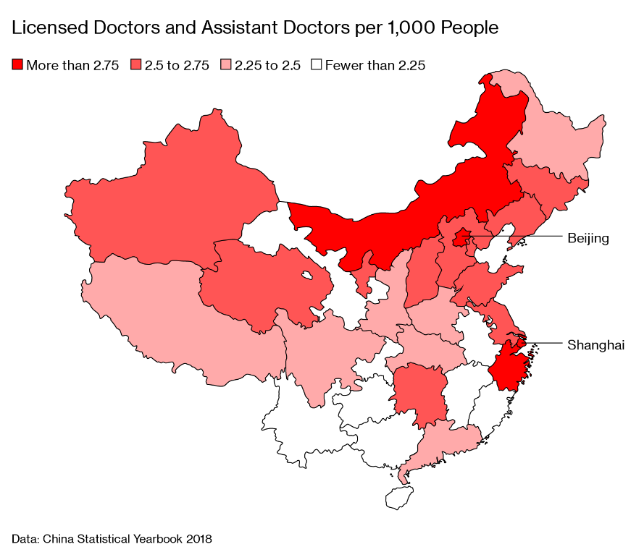
Graph 1
The more doctors there are the better as this means people can get treated more easily if they are unwell. The graph shows that the darker the colour, the more doctors, the lighter the colour, the less doctors there are.
- How many regions in China have more than 2.75 doctors per 1,000 people? 3
- How many regions in China have fewer than 2.25 doctors? 10
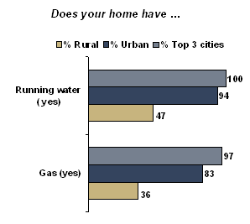
Graph 2
Rural means people who live in the countryside and urban means people who live in the city. People who live in rural China tend to be a lot poorer.
- What percent of people who live in Urban areas have running water? 100%
- What percent of people living in Rural areas have running water? 47%
- Why do we need running water to stay healthy? We need running water in order to stay clean- running water allows us to wash our hands, our clothes, our things etc. which will reduce the risk of spreading diseases and illnesses. We also need clean running water to drink in order to stay healthy.
- What percentage of people living in Urban areas have gas in their home? 97%
- What percentage of people living in Rural areas have gas in their home? 36%
- What do we use gas for that helps us to live and be healthy? We use gas to heat our homes, this keeps us well in the colder months. We also use gas to cook food which means we are not as likely to suffer from food poisoning.

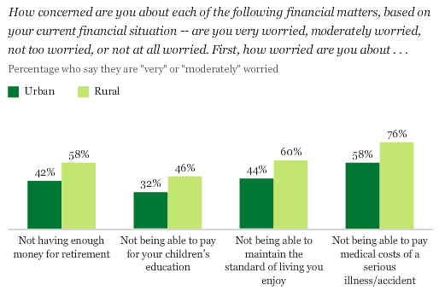
Graph 3

- What percentage of the people living in urban areas of China were worried about not being able to pay the medical costs of a serious illness/accident? 58%
- How much more does that percentage increase for those living in rural areas? 18%
- How many people living in rural areas of China worried that they do not have enough money to retire? 58%
- If people don’t have enough money to retire, this means they have to keep on working. How could working when you are elderly affect your health? People tend to struggle more with their health as they get older. If they were working this would be worse as they would not be able to rest as much if they were still working very hard. They could also suffer more injuries and pick up more illnesses from other people.
Explanation:
The evidence shows that some people in China do not receive very good healthcare. Graph 1 shows us that there are only 3 regions which have more than 2.75 doctors per 1000 people, whereas there are 10 regions who have less that 2.25 doctors per 1000 people. This means there are lots more places where people will find it harder to see a doctor. This is a problem because you are likely to get more ill, or even die, if you do not get the care you need from the doctor. There are two types of places people live in China, rural areas which are countryside and much poorer and urban areas which are the cities where people have more money. People living in rural areas tend to have much less access to good quality healthcare. For example, graph 2 shows us that relatively few people living in rural areas have running water and gas in their homes. These two things are essential to stay healthy because the running water allows us to be more hygienic as we can wash ourselves es and our things meaning diseases and illness is less likely to spread, and gas allows us to heat our homes and cook food. Lastly, graph 3 shows us that lots of people in China are worried about not being able to afford healthcare if they need it. It also shows that lots of people in rural areas feel they do not have enough money to retire. This could affect their health because they are forced to work for longer which could negatively affect their health.

- What are the problems with China’s education?
Look carefully at the graphs and then answer the questions:
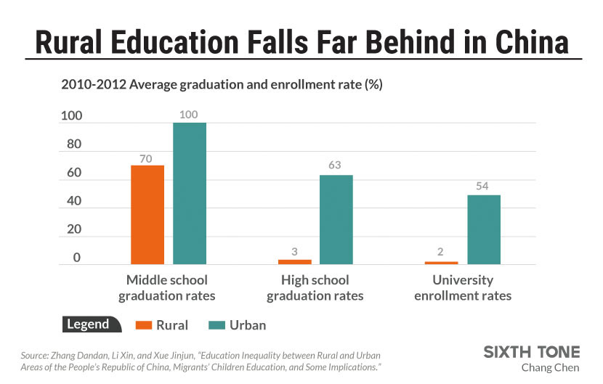
Graph 1

1) What percent of the children living in rural areas graduated from middle school? 70%
2) What percent of the children living in rural areas graduated from high school? 3%
3) What percent of the children living in rural areas enrolled in university? 2%
4) What do you think children in rural areas (where it is poorer) might be doing instead of going to school?
They are likely to be working from a young age to help provide money for their families
5) How does this compare with the amount of education children in urban areas are experiencing? Children in urban areas ALL graduated from middle school and over 50% went on to high school and university. This means they ate getting a much better standard of education which will mean they can get better opportunities and jobs in the future.
Graph 2
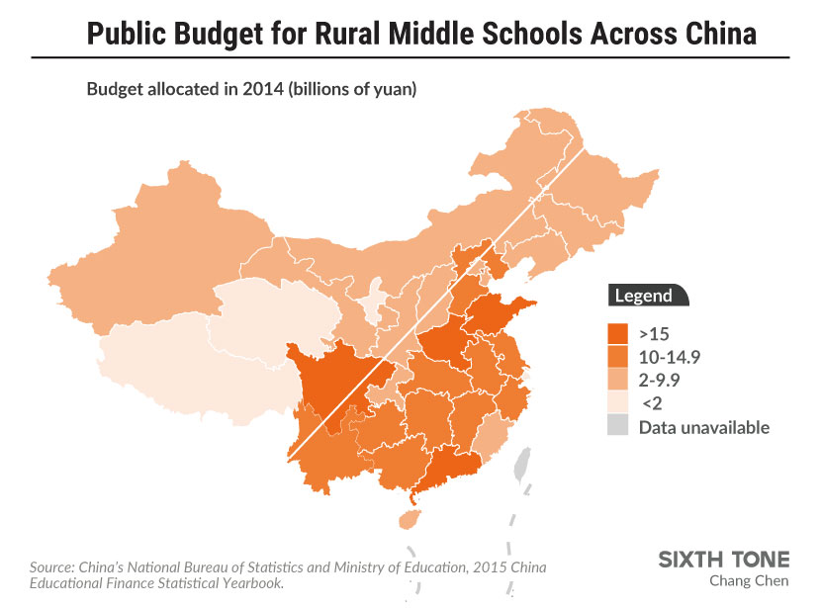
6) How many regions of China were given over 15 billion yuan (Chinese currency) to help their middle schools? 4
7) How many regions of China were given under 10 billion yuan to help their middle schools? 19
8) Why is this unfair? The government is not sharing the money equally meaning that schools in some areas will be much better than others. This means some students will have better access to things like computers, internet, books, trips etc.

Explanation:
The evidence shows that some people in China do not receive very education. Again, the people living in rural areas are worse off than those in urban areas. This can be seen in graph 1 because it shows that only 3% of people living in rural China graduate from high school, and only 2% enrol in university. This means that, after middle school, lots and lots of children stop going to school, this could be because they can’t afford to go to higher education, or perhaps they feel they need to work for a living so they can help their families. On the other hand, over 50% of people in urban China enrol in university. This will mean they will earn more money in the future because they will get better qualifications which means they can get jobs which have much larger salaries.
Graph 2 also shows that the money the government give to support middle school is not shared out fairly. There were only 3 regions which were given over 15 billion yuan, whereas the rest were given a lot less. This means those children going to school in the regions who get less money are not being treated fairly because they are not being given the same opportunities to learn and progress as those children who go to the more funded schools. This could mean they leave school without reaching their potential and without getting the qualifications they need/deserve.

