6/5 Maths w/c 1st June 2020

2. We are learning how to draw a line graph.

Have a look at the two graphs below. Both graphs are showing (or trying to show) the same data. Graph A is a poorly-drawn graph. It shows many of the mistakes that can be made. Now look at Graph B. Compare the two graphs. Make a note of all the differences you can spot. Can you explain why Graph B is better?

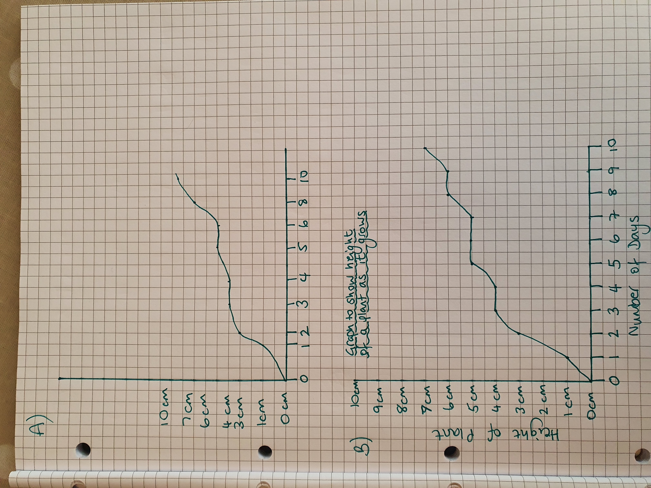

Now fill in the blanks using the words in the box below.

All graphs need a ________. This is so we know what the graph is about. It should be at the top of the graph so it is easy to see.

Along the bottom is the x-axis. Up the side is the _______.

It is important that the number on the y-axis go up in ________ steps.

Both axes should be __________ so we know what information they are showing.

equal | y-axis | title | labelled

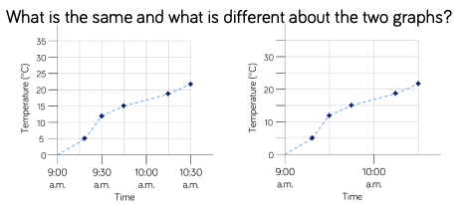

Both of these graphs have been drawn correctly. But they are still different. Answer the questions below:
- What is on the x-axis of these two graphs?
- What is on the y-axis?
- What size are the steps for temperature on the left graph (i.e. how much does it go up by each time?)
- What size are the steps for temperature on the other graph?
- Do you think one would be easier to read than the other? Can you say why?
- Do we know what object is having its temperature measured? Where could we put that information?

