6/5 Maths w/c 1st June 2020

2. We are learning how to draw a line graph - answers

Have a look at the two graphs below. Both graphs are showing (or trying to show) the same data. Graph A is a poorly-drawn graph. It shows many of the mistakes that can be made. Now look at Graph B. Compare the two graphs. Make a note of all the differences you can spot. Can you explain why Graph B is better?

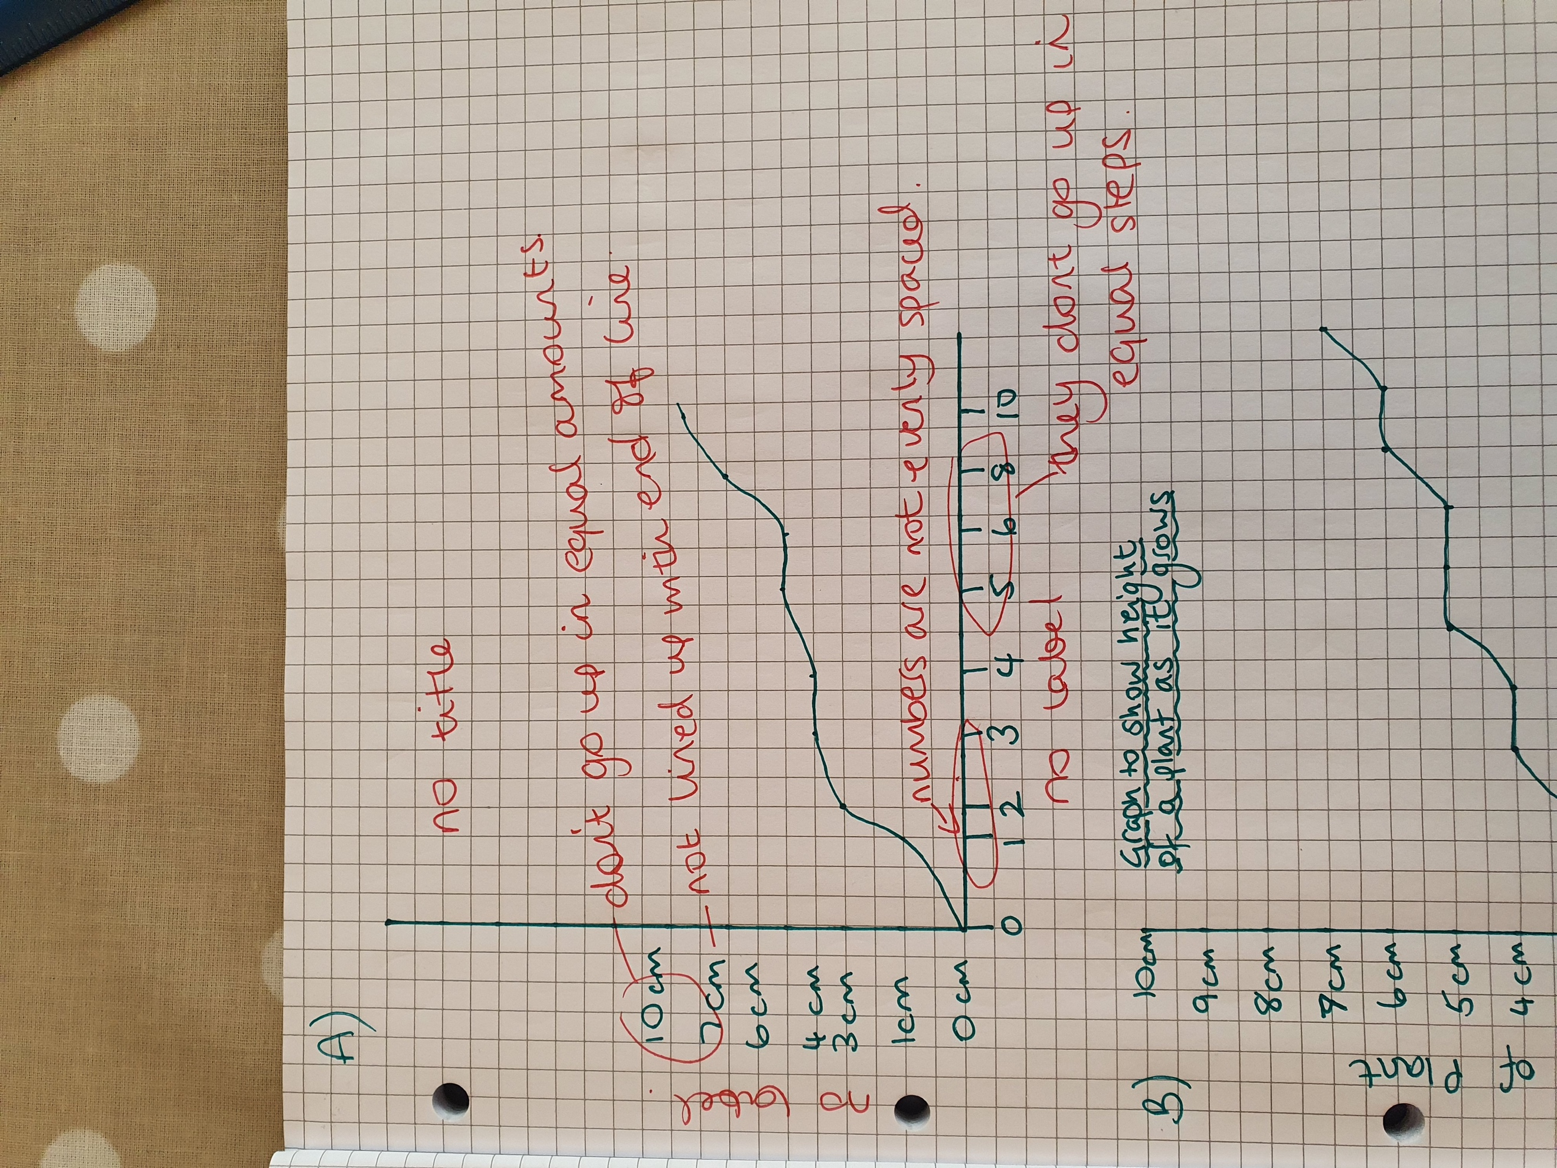

Now fill in the blanks using the words in the box below.

All graphs need a title. This is so we know what the graph is about. It should be at the top of the graph so it is easy to see.

Along the bottom is the x-axis. Up the side is the y-axis.

It is important that the number on the y-axis go up in equal steps.

Both axes should be labelled so we know what information they are showing.

equal | y-axis | title | labelled

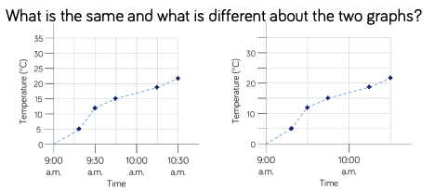

Both of these graphs have been drawn correctly. But they are still different. Answer the questions below:
- What is on the x-axis of these two graphs? Time
- What is on the y-axis? Temperature
- What size are the steps for temperature on the left graph (i.e. how much does it go up by each time?) It goes up by 5 each time
- What size are the steps for temperature on the other graph? It goes up in ten each time
- Do you think one would be easier to read than the other? Can you say why?
- Do we know what object is having its temperature measured? Where could we put that information? We don’t know what it having its temperature measured. That sort of information would go in the title for the graph.

