**Spider Maze**

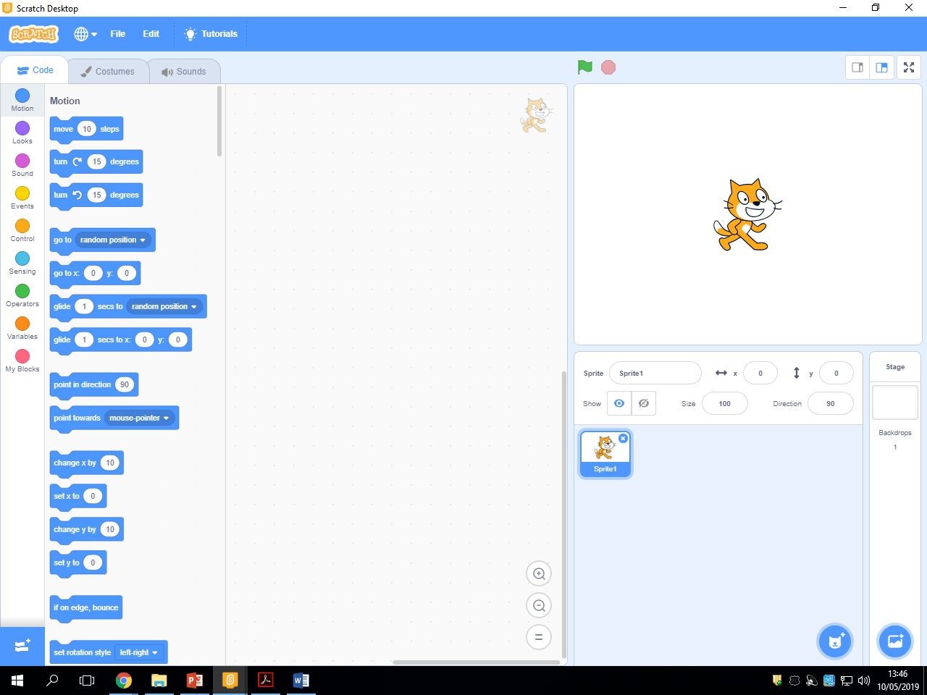**Creating a Sprite**

Delete cat sprite by clicking on the small ‘x’

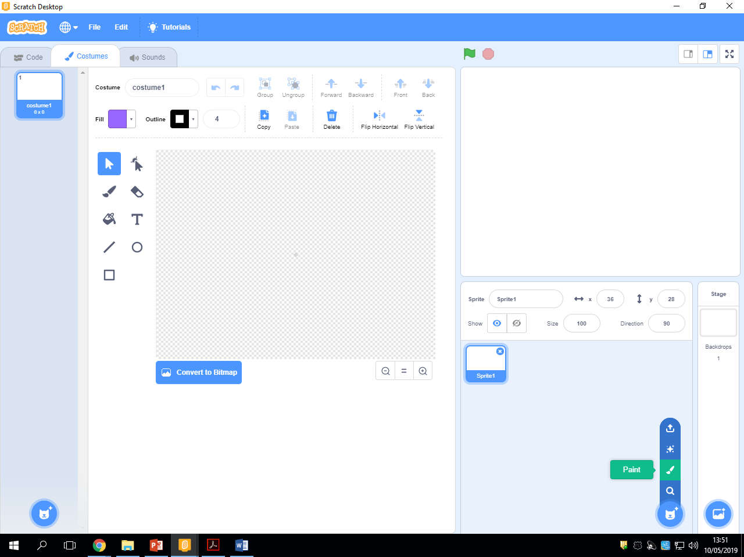

Hover over the cat icon and click on paint.

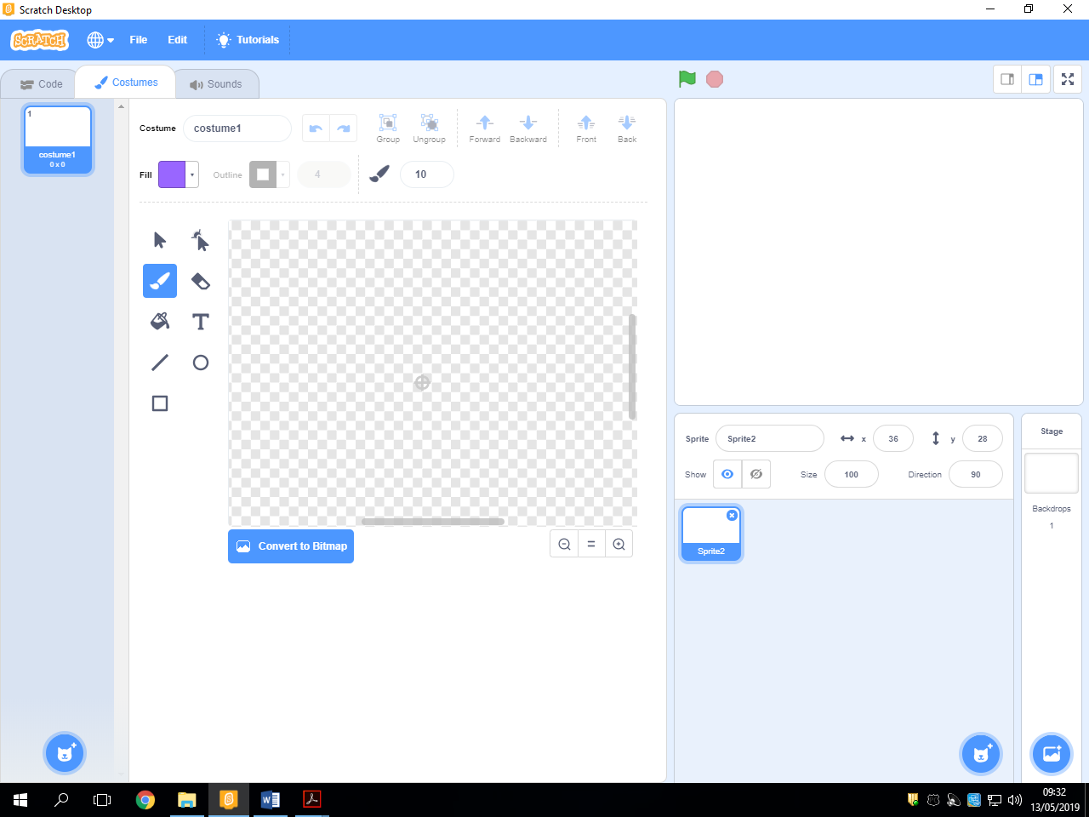

Select a colour for your spider.

Select a suitable brush size.

Zoom in so you can clearly see this crosshair. This will be the centre of your spider.

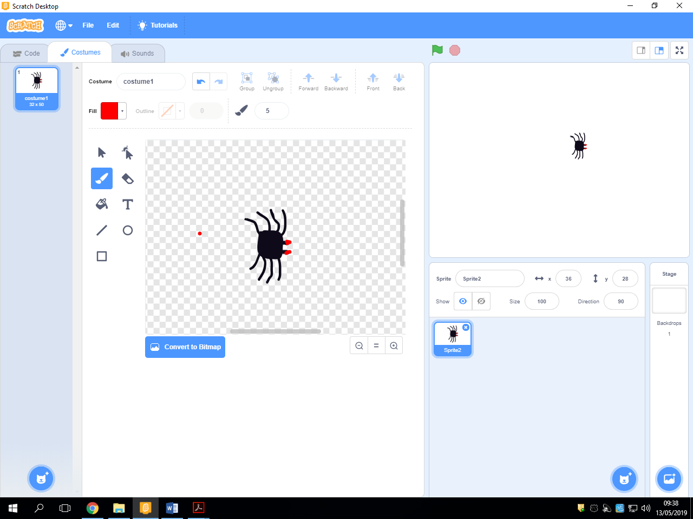

Rename ‘costume1’ to ‘spider1’

Draw a basic spider with legs and eyes. Make sure the eyes face right.

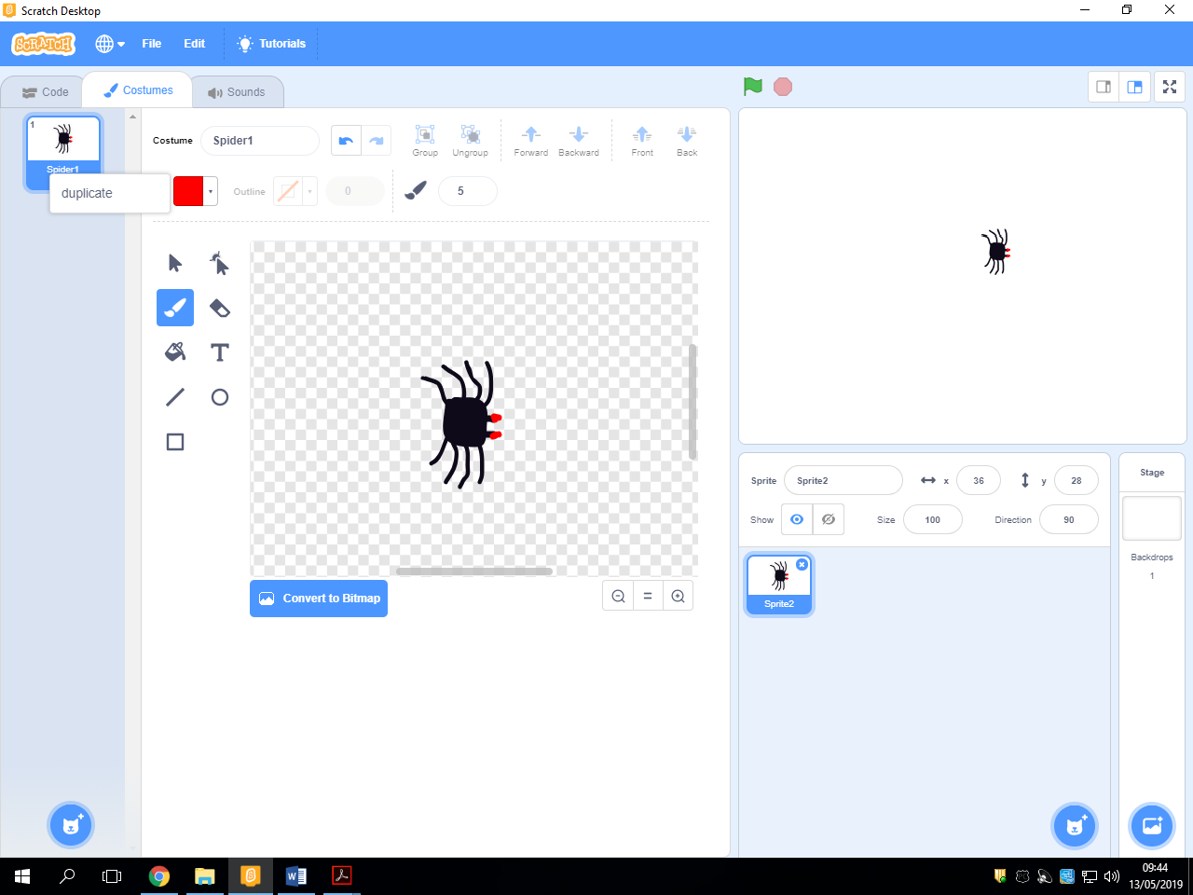

Right click on ‘spider1’ and click on duplicate.

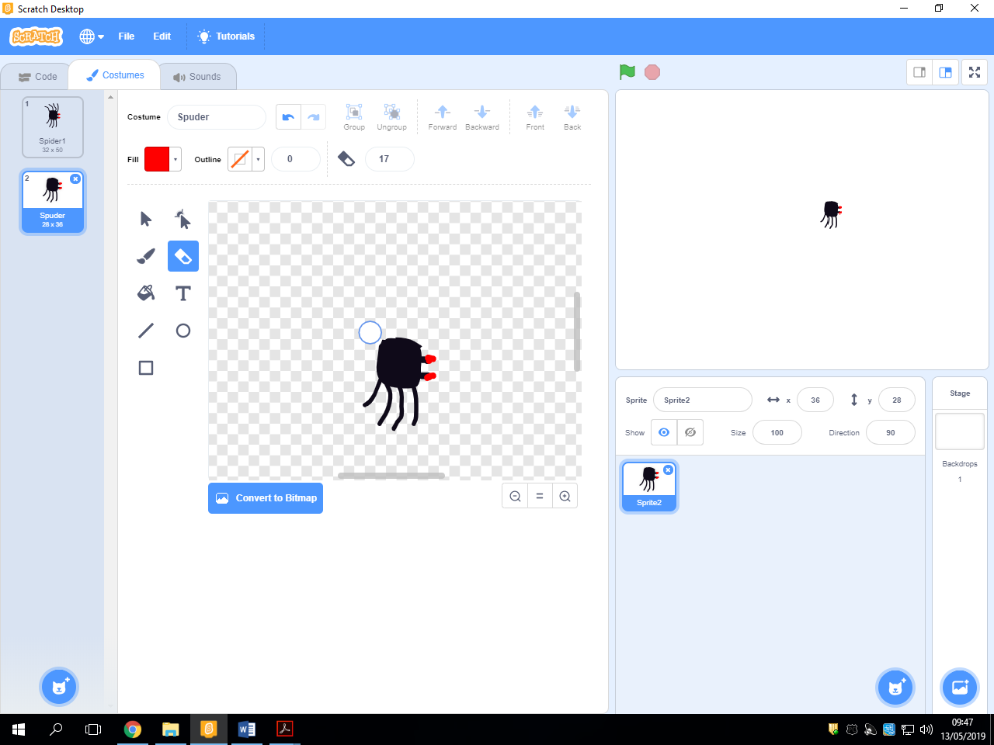

Using the rubber, delete the legs and redraw them in a different position.

**Making the sprite look like it is moving forever.**

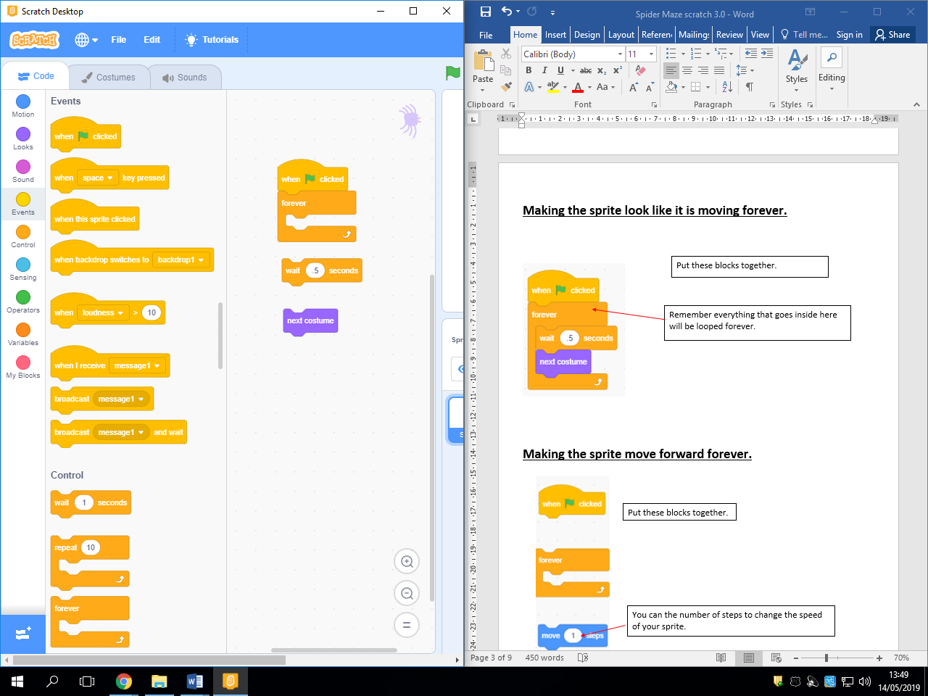

Put these blocks together.

Remember everything that goes inside here will be looped forever.

**Making the sprite move forward forever.**

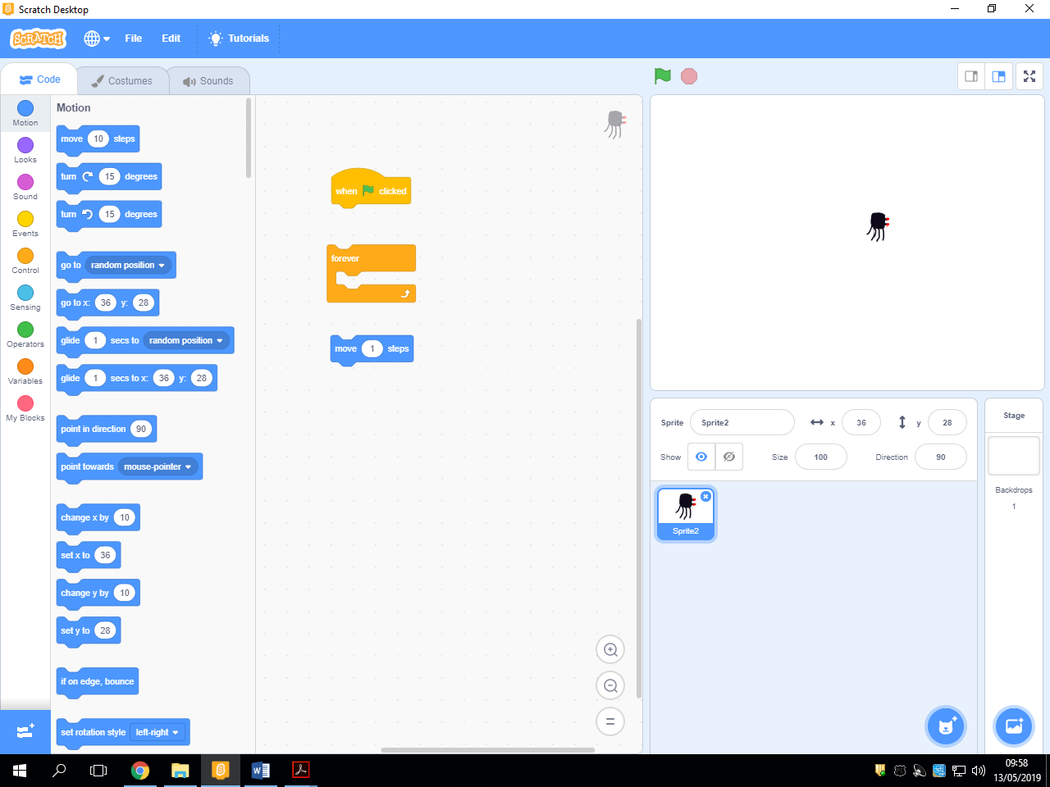

Put these blocks together.

You can the number of steps to change the speed of your sprite.

**Creating a right steering block.**

There are two different ways you can do this.

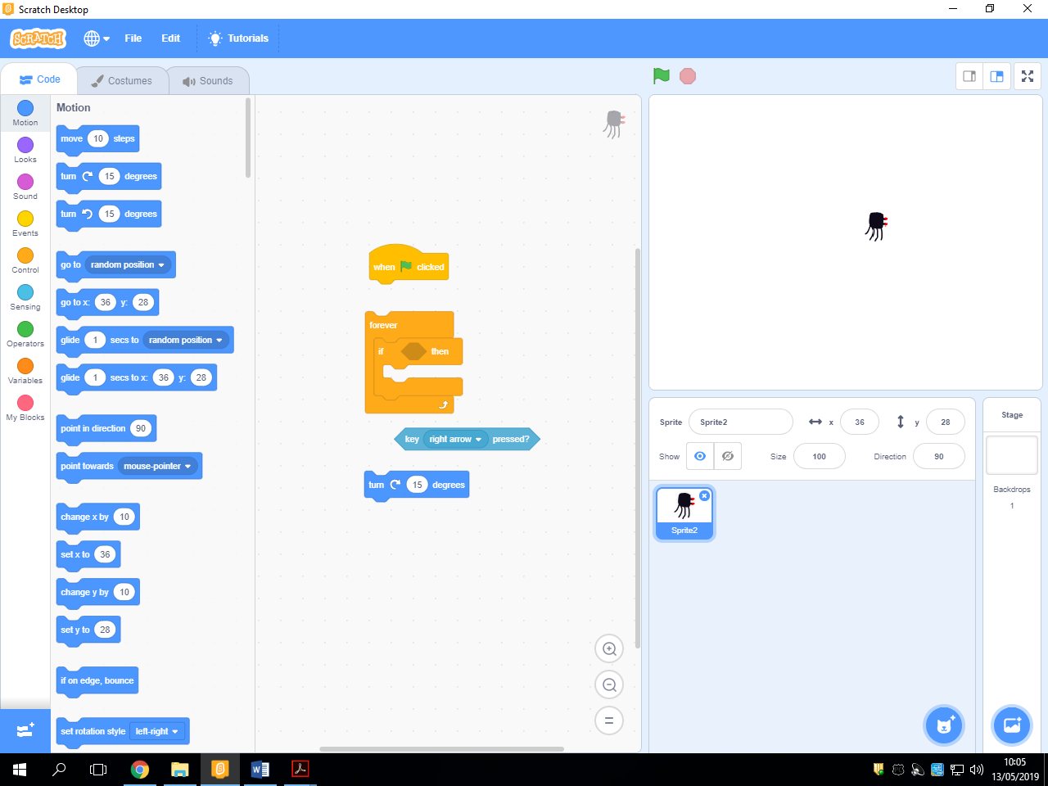**Number 1:**

Put these blocks together.

**Number 2:**

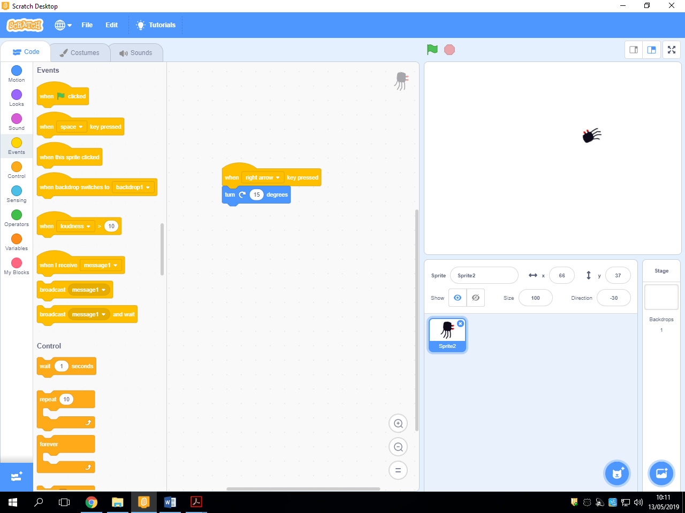

You can change this number to change the speed your sprite turns.

**Creating a left steering block.**

There are two different ways you can do this.

**Number 1:**

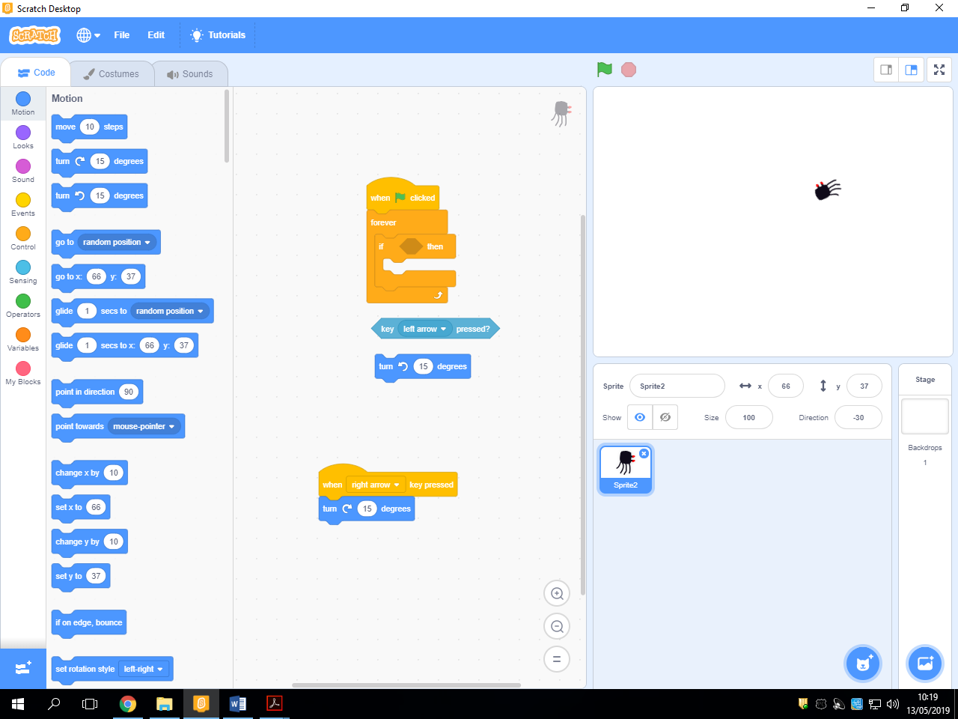

Put these blocks together.

**Number 2:**

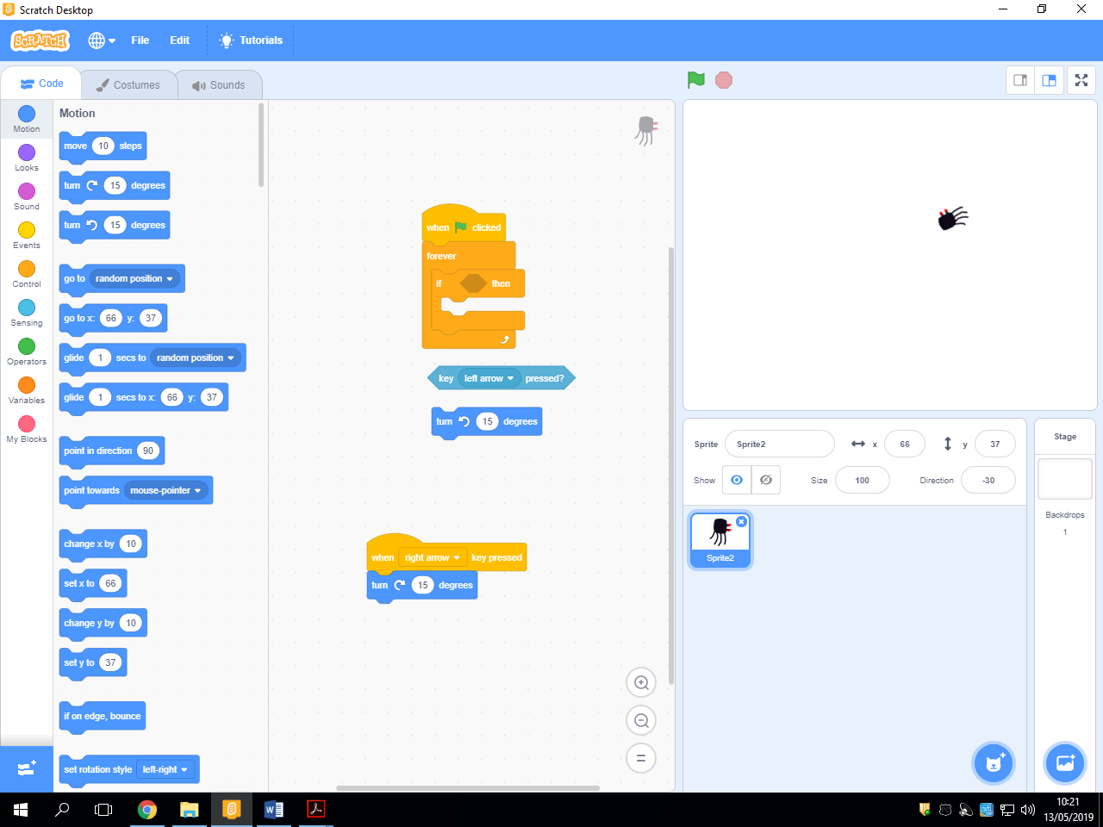

You can change this number to change the speed your sprite turns.

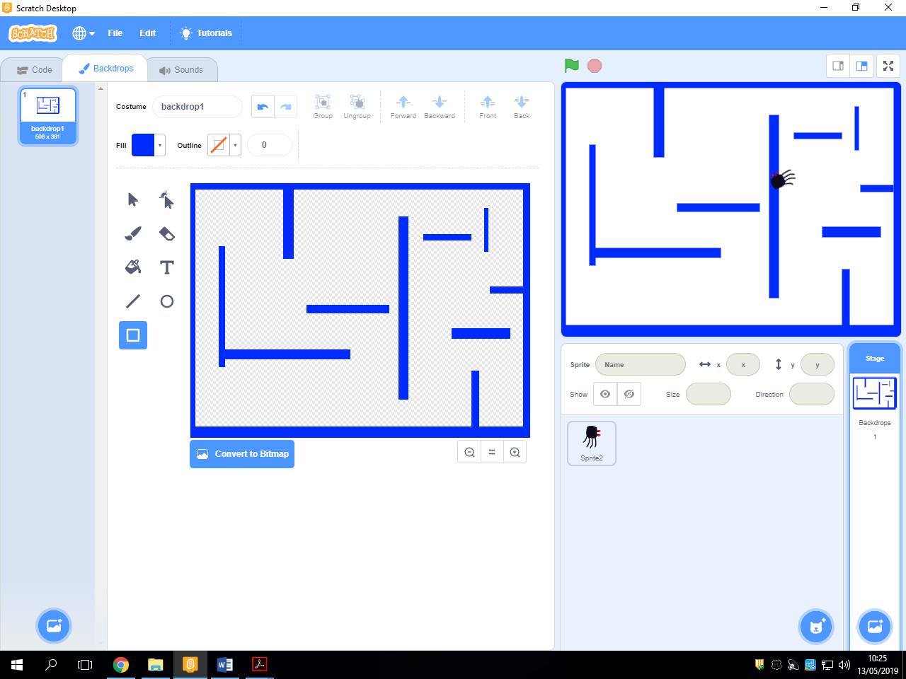**Creating a backdrop.**

Click on ‘backdrop1’ and make sure you are on the backdrops tab.

Rename ‘backdrop1’ to ‘maze1’

Click this button to make sure you are fully zoomed out.

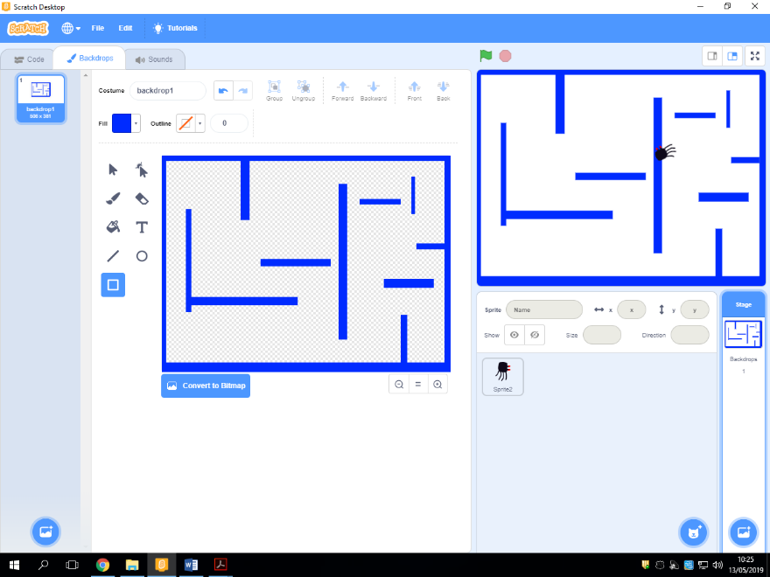

You can use the shape tool to design the inside of your maze. (Remember to leave enough space so that your spider can get through)

Using the shape tools, draw a maze in a different colour than you used for your spider.

**Electrifying the maze.**

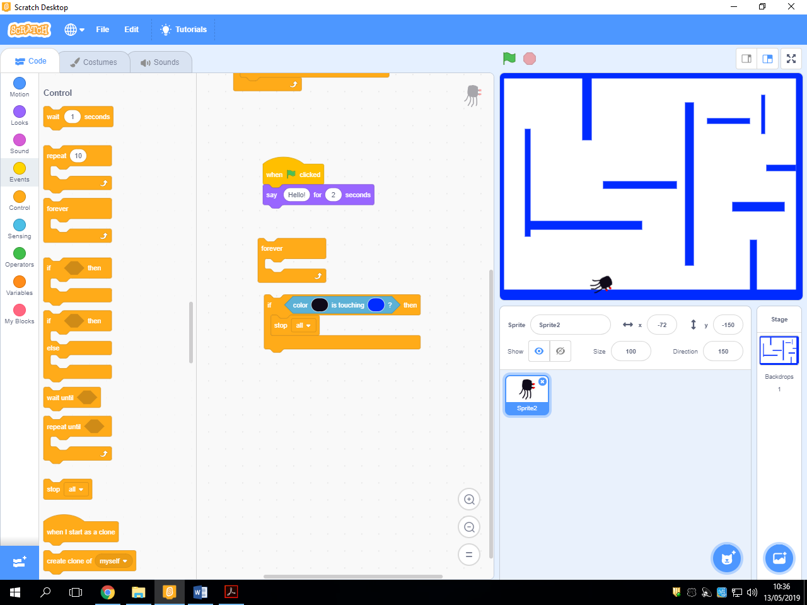

Put these blocks together on the code tab of your spider.

Colour of your spider.

Colour of your maze.

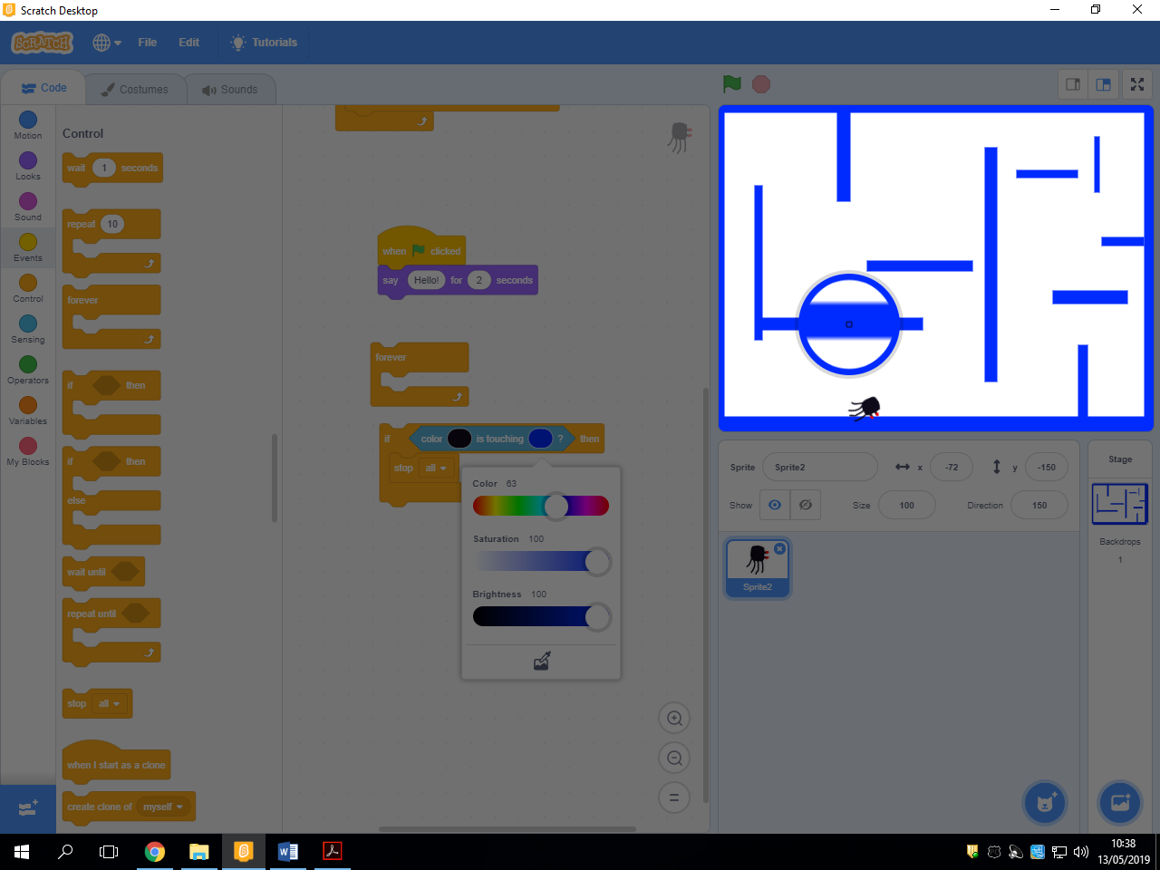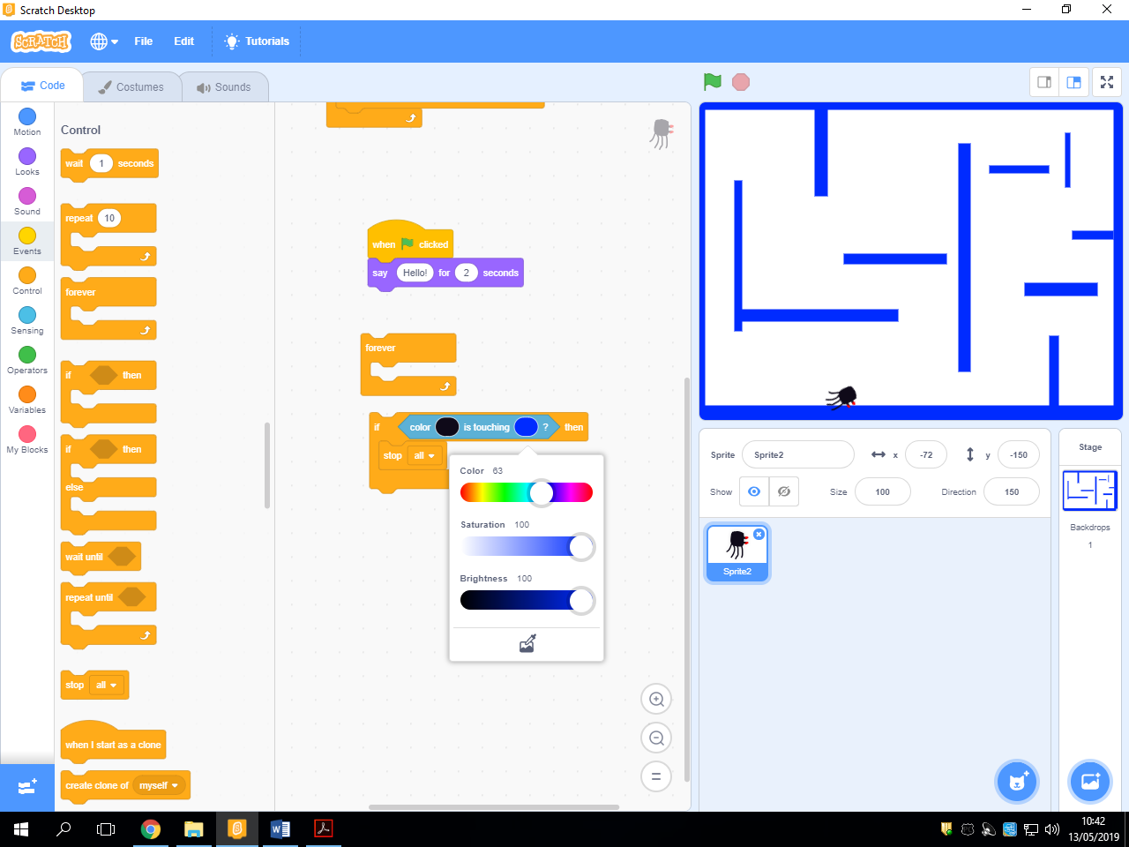

To select a colour for your game, click on the coloured circle and click on the colour-matching button. Then find the colour on your game.

**Positioning objects.**

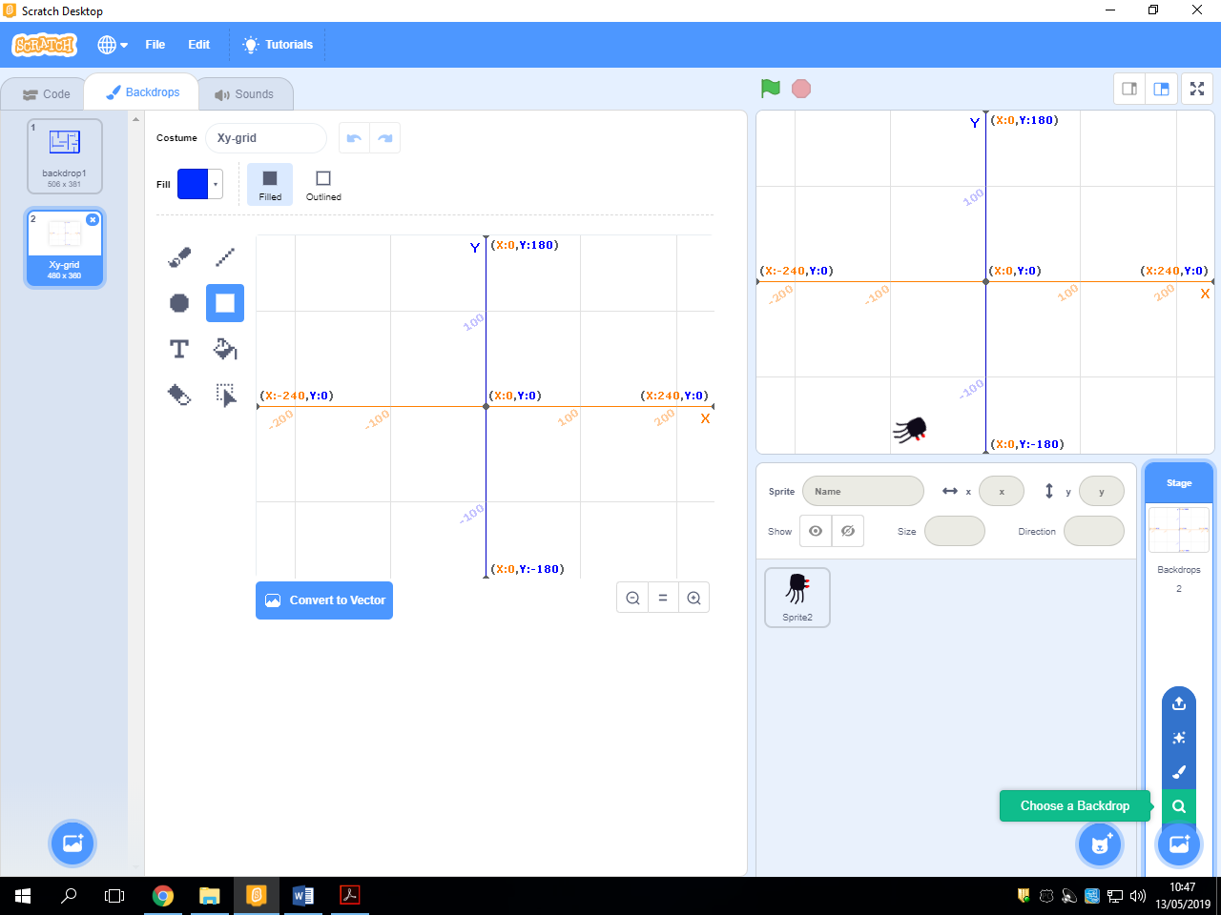

Hover over the backdrop icon and select ‘Choose a Backdrop’

Scroll down and chose ‘xy-grid’. Don’t worry, you won’t lose your maze.

**Resetting a sprite start position and direction.**

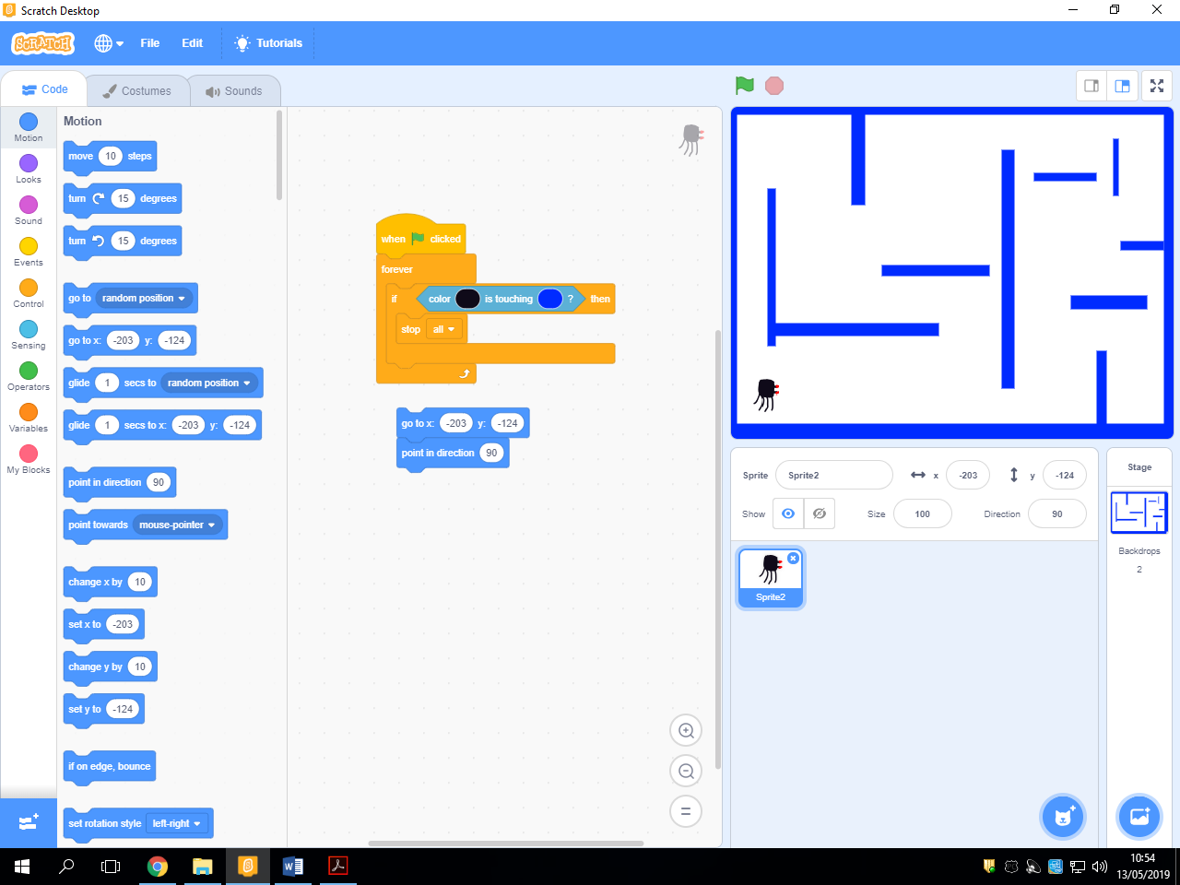

You can even use these numbers for help.

Remember to change these numbers to suit your game.

Use the xy grid for help.

Can you try to add these blocks to your electrifying the maze script?

**Adding a target.**

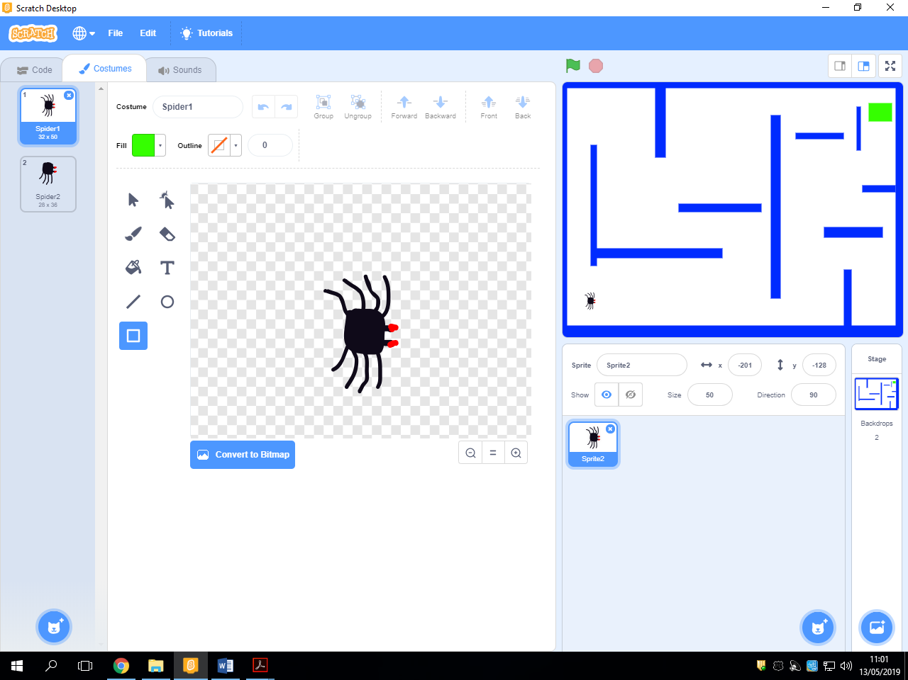

Go back onto your maze and add a target for your spider to reach.

If your spider is too big or smaller, click on your sprite and change the size.

**Challenge**

Using the ideas introduced, create a game so that when your spider touches the target a message appears to say well done and your spider goes back to its starting position.

For an extra challenge, create another backdrop and have the game switch to it when your spider touches the target.