Fertilisation and implantation
Setting the scene
The process of making a baby involves a number of key steps. First, gametes need to be made by the mother and father. Then sperm from the male needs to be transferred into the female and meet the egg cell in fertilisation. Finally, the fertilised egg needs to implant in the uterus wall.
Aims
In this activity you will:
- study each of the key steps in how a baby is formed
- develop an understanding of how the baby is formed at the beginning.
Task 1: The size of sperm and egg cells
Look at the following diagrams of the sperm and egg cells.
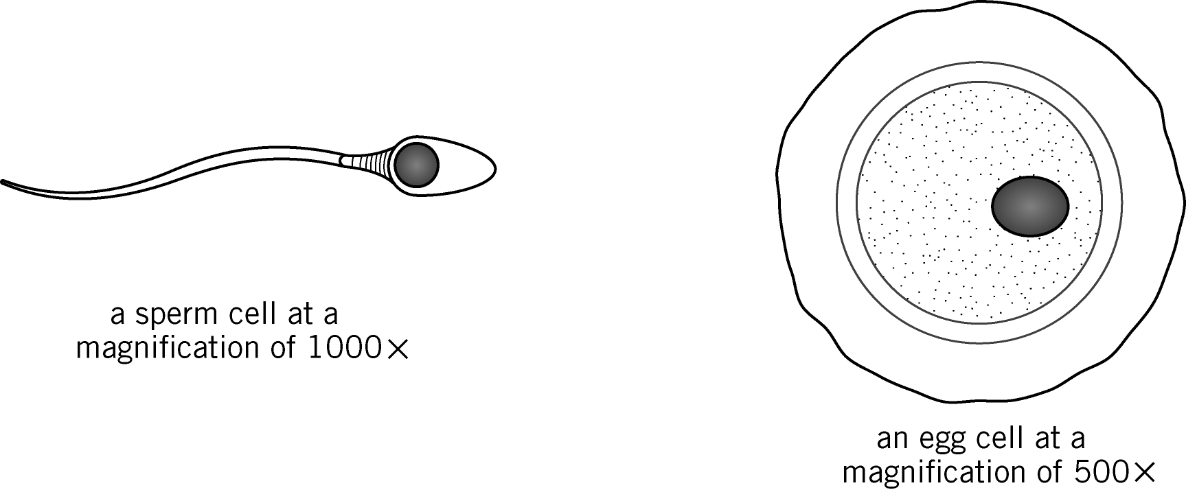

Questions
1 State where the sperm cells are made.

2 State where the egg cells are made.

3 Measure the length of the sperm and the width of the egg from the diagram above, in millimetres. Now use these measurements to complete the table below.
Cell | Size of cell in  picture (mm) | Magnification | picture size  magnification
egg
sperm
4 Calculate how many times bigger the egg cell is than the sperm cell.
Actual size =

Task 2: Sexual intercourse
Complete the sentences by connecting each statement with the correct ending.

During intercourse, the man’s penis…
The woman’s vagina…
Moving the penis in the vagina…
Semen is released…
Each ejaculation contains…
…500 million sperm.
…out of the penis.
…becomes stiff and erect.
…becomes relaxed and moist.
…causes the man to ejaculate.

Task 3: Fertilisation and implantation (optional)
Watch the film clip which shows fertilisation and cleavage of the embryo cell.
1 State what happens to the egg and sperm cells at fertilisation.

2 Describe what happens at implantation.

Extension
1 Calculate the actual width of the sperm cell.

2 State if the film covered everything you know about fertilisation and implantation. If not, suggest one way of improving this film.

Homework
Your task is to produce a story board for a new film for Key Stage 3 that gives a complete account of fertilisation and implantation.
Complete the story board to indicate the images you want to show and any text or dialogue you feel you need. You may use as many sequences as you wish.

