Medieval Doom painting
Source analysis activity
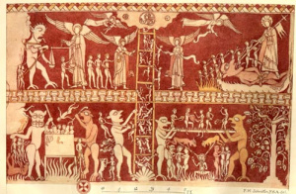

Task 1- Look at the doom painting. What can you see happening in it? Try to think of 3 things.
Task 2- Cut out the doom painting and stick it in the middle of a piece of paper. Around it, add the labels below that describe what is happening in the painting. You can add more if you can.
Task 3- The ladder on this source represents a place called purgartory, that the church taught was between heaven and hell. Using a dictionary and/ or the internet to help you, find out what purgatory means. This web page might help: https://www.bbc.co.uk/bitesize/guides/zyrrpbk/revision/3 Stretch question: why do you think the church gave people hope by teaching about purgatory?
Angels helping people up the ladder. The ladder represents purgatory.
St Michael weighing peoples souls to see if they deserve to go to heaven

Sinners being pulled off the ladder as they try to get into heaven
Christ Crushing a devil in heaven
Murderers being stewed in a pot of boiling water by devils
Dishonest tradesmen being forced to sit on a spiked bar

