7/4 Maths w/c 11th May 2020

1. We are learning to use a protractor to measure angles.

A protractor is a measuring tool – a bit like a ruler – except a protractor helps us to measure angles. It looks something like this:

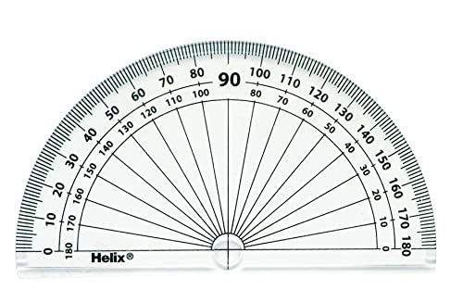
This is a very important part of the protractor. On some of them, there will be a little cross (like this one). Some protractors might have a hole instead. This is important for lining up with the angle – on all protractors, the cross or hole will be in the middle of the line that runs along the straight edge.

Step 1
When you have an angle to measure, line up the cross or hole with the point of the angle (the mathematical name for this point is the ‘vertex’). Like this:

This is the ‘point’ or ‘vertex’

Step 2

Also make sure that one of the lines goes through the zero on the protractor.
Like here

There are two zeros on most protractors – one at either side. It doesn’t matter which zero you use – but you must make sure that you count from that same zero when measuring. See below.

This zero is on the outside set of numbers (nearest to the curved edge of the protractor). If you line up with this zero, you must use the outside numbers to measure. | This zero is on the inside set of numbers (nearest to the middle of the protractor). If you line up with this zero, you must use the inside numbers to measure.

This zero is on the outside set of numbers (nearest to the edge of the protractor). If you line up with this zero, you must use the outside numbers to measure.

Step 3

Now you have one line going through the zero. Follow the numbers round the edge of the protractor until you get to the other line. See what number the other line is on and that is the size of the angle.

For more help, there is a powerpoint presentation for this lesson and you could also try watching this: https://www.khanacademy.org/math/basic-geo/basic-geo-angle/measure-angles/v/using-a-protractor

Try this activity for some practice.
https://www.bbc.co.uk/bitesize/guides/zrck7ty/revision/4

After this, work through the task sheet for this lesson.

