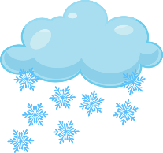  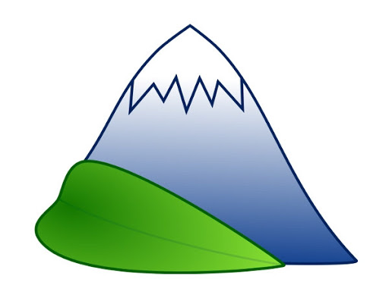  1)  Analyse how Italy’s lakes have been formed | The top of mountains have their own climate where it cold and often snowy
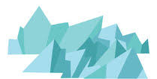  2) | The snow piles on top of each other and the stuff at the bottom turns into ice! This is called a glacier.
3) | As the glacier (ice) is so heavy, it very slowly moves down the mountain
4) | The climate at the bottom of the mountain is much warmer than at the top of the mountain which means the glacier (ice) melts…
5) | When the glacier (ice) melts, a lake is formed at the bottom of the mountain.

