**Angles on a straight line**

**Find the missing angle in each of these diagrams**

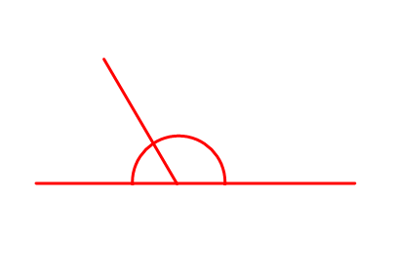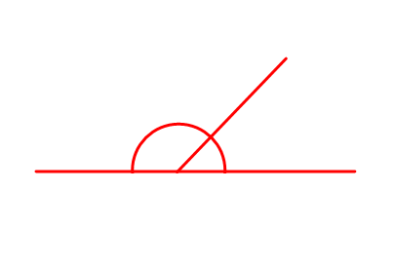******RED** – Start with me

300

1400

500

100

1300

1500



600

1100

1200

400

200

Found these easy so far? Why not move onto **orange**?

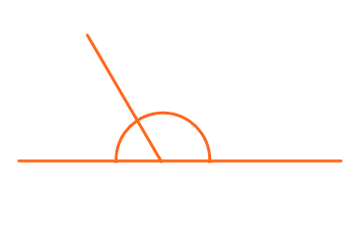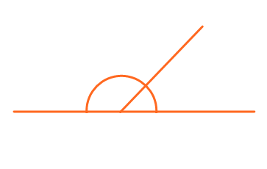**Orange** – Move onto me

150

350

550



250

1550

1250





450

1350

1750

1050

1650