7/4 Maths w/c 27th April 2020

3. We are learning to understand how different fractions can be equal to each other.

Fractions that are equal to each other are also called ‘equivalent fractions’.

Watch the video on this page https://www.bbc.co.uk/bitesize/topics/zsxhfg8/articles/zwjwgdm
Try the activities.

Look at this number line. What can you see?

$$\frac{1}{1}$$
$$\frac{1}{2}$$ |  |  |  |  |  | $$\frac{1}{2}$$
$$\frac{1}{3}$$ |  |  |  | $$\frac{1}{3}$$ |  |  |  | $$\frac{1}{3}$$
$$\frac{1}{4}$$ |  |  | $$\frac{1}{4}$$ |  |  | $$\frac{1}{4}$$ |  |  | $$\frac{1}{4}$$
$$\frac{1}{5}$$ |  | $$\frac{1}{5}$$ |  |  | $$\frac{1}{5}$$ |  | $$\frac{1}{5}$$ |  |  | $$\frac{1}{5}$$
$$\frac{1}{6}$$ | $$\frac{1}{6}$$ |  |  | $$\frac{1}{6}$$ |  | $$\frac{1}{6}$$ |  | $$\frac{1}{6}$$ |  |  | $$\frac{1}{6}$$
0 1

This shows us that $\frac{1}{1}$ , $\frac{2}{2}$ , $\frac{3}{3}$ , $\frac{4}{4}$ , $\frac{5}{5}$ and $\frac{6}{6}$ are all equal to each other. We have already learnt this from our last lessons when we were using fractions where the top and bottom number were the same to replace the number 1.

These are not the only fractions that are equal to each other though. Here is the box again with some parts shaded in.

$$\frac{1}{1}$$
$$\frac{1}{2}$$ |  |  |  |  |  | $$\frac{1}{2}$$
$$\frac{1}{3}$$ |  |  |  | $$\frac{1}{3}$$ |  |  |  | $$\frac{1}{3}$$
$$\frac{1}{4}$$ |  |  | $$\frac{1}{4}$$ |  |  | $$\frac{1}{4}$$ |  |  | $$\frac{1}{4}$$
$$\frac{1}{5}$$ |  | $$\frac{1}{5}$$ |  |  | $$\frac{1}{5}$$ |  | $$\frac{1}{5}$$ |  |  | $$\frac{1}{5}$$
$$\frac{1}{6}$$ | $$\frac{1}{6}$$ |  |  | $$\frac{1}{6}$$ |  | $$\frac{1}{6}$$ |  | $$\frac{1}{6}$$ |  |  | $$\frac{1}{6}$$

Which fractions are the same as ½? There are two – write them here.

Can you explain why we can’t have a thirds fraction or a fifths fraction that is equal to ½ ?

Here is the number line again with different shading. What fractions are equal to each other?

$$\frac{1}{1}$$
$$\frac{1}{2}$$ |  |  |  |  |  | $$\frac{1}{2}$$
$$\frac{1}{3}$$ |  |  |  | $$\frac{1}{3}$$ |  |  |  | $$\frac{1}{3}$$
$$\frac{1}{4}$$ |  |  | $$\frac{1}{4}$$ |  |  | $$\frac{1}{4}$$ |  |  | $$\frac{1}{4}$$
$$\frac{1}{5}$$ |  | $$\frac{1}{5}$$ |  |  | $$\frac{1}{5}$$ |  | $$\frac{1}{5}$$ |  |  | $$\frac{1}{5}$$
$$\frac{1}{6}$$ | $$\frac{1}{6}$$ |  |  | $$\frac{1}{6}$$ |  | $$\frac{1}{6}$$ |  | $$\frac{1}{6}$$ |  |  | $$\frac{1}{6}$$
Use the number lines to try and complete this table.

$$\frac{1}{2}$$ | is equal to | $$\frac{}{4}$$ | and | $$\frac{}{6}$$
$$\frac{1}{3}$$ | is equal to | $$\frac{}{6}$$
$$\frac{2}{3}$$ | is equal to | $$\frac{}{6}$$

Using the fraction wall sheet and a ruler, try to find other fractions that are equal to the ones below. There might be more than one answer.

$$\frac{1}{2}$$
$$\frac{1}{3}$$
$$\frac{1}{4}$$
$$\frac{1}{5}$$
$$\frac{1}{6}$$
$$\frac{4}{6}$$
$$\frac{3}{12}$$

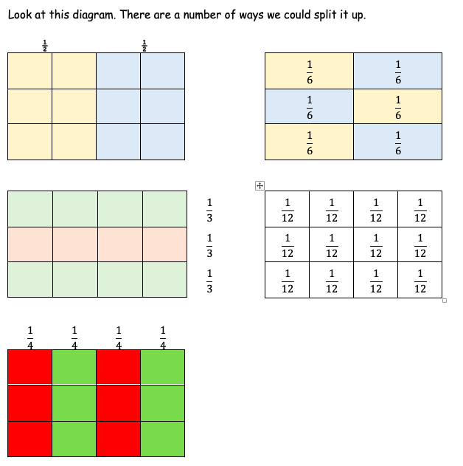
Here is the box again with part of it shaded. How many different fractions can we use to describe the shaded part? | What about in this one? How many fractions can you use to describe the shaded part?
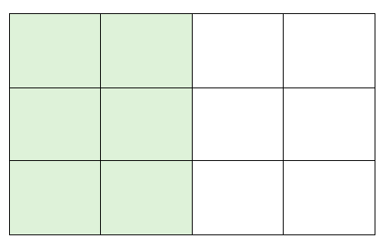 | 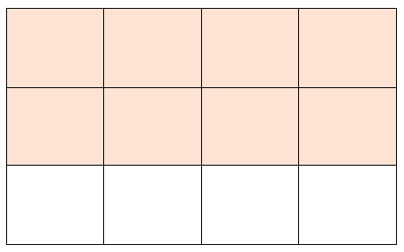
Answers: | Answers:

