Patterns, groups, and periods in the Periodic Table
Setting the scene
The Periodic Table shows all the chemical elements. They are shown in groups and periods. Groups and periods can show patterns in their behaviour.
Aims
In this activity you will:
- label a Periodic Table
- use the Periodic Table to answer questions on the properties of elements.
You will be working scientifically to:
- interpret observations and data to identify patterns and draw conclusions
- explain data
- understand and use International Union of Pure and Applied Chemistry (IUPAC) terminology.
Task
1 Using different coloured highlighter pens or different types of shading, colour in each
of the following groups and give them the heading shown:
- Group 1 ‘The alkali metals’
- Group 2 ‘The alkaline earth metals’
- Group 7 ‘The halogens’
- Group 0 ‘The noble gases’

2 Use a dark pen to draw a line in the following position:
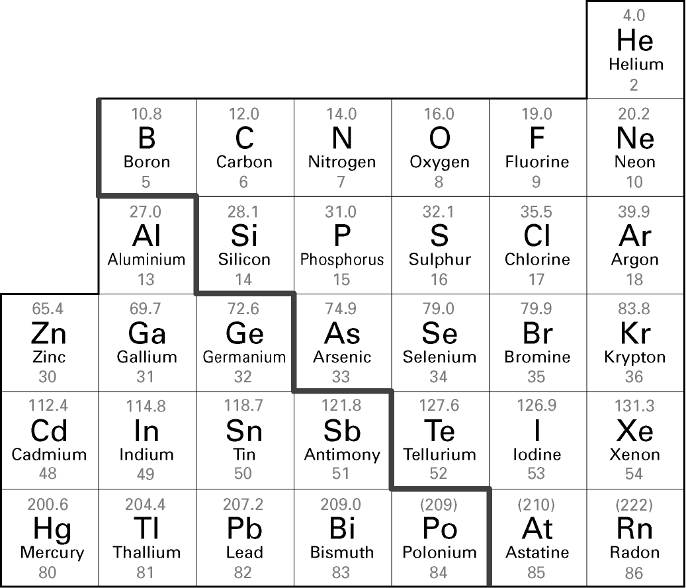

3 The line you have just drawn divides the Periodic Table into metals and non-metals.
Add the following labels in large, clear writing in the positions given:
- ‘Metals’ to the left of the stepped line
- ‘Non-metals’ to the right of the stepped line
4 Draw an arrow to the stepped line and add the following label:
‘Metalloids are found either side of this stepped line.’
Questions
1 All the elements in the Periodic Table have two numbers next to them. The bigger of the two numbers is called the atomic mass. Use your Periodic Table to decide which of the following statements are true. Tick all the statements that are true.
The atomic mass increases as you move across a period.
The atomic mass decreases as you move across a period.
The atomic mass increases as you move down a group.
The atomic mass decreases as you move down a group.
The atomic mass increases by one as you move across a period.
The atomic mass increases by one as you move down a group.
2 The first three elements in Group 2 are beryllium, magnesium, and calcium. They all react with nitrogen to make a substance called a nitride. Predict the product of the reaction between strontium and nitrogen. Explain your answer.

Extension
1 Dmitri Mendeleev was a chemist who made predictions about elements that had not
yet been discovered. One of the elements he made predictions about was gallium.
He originally called gallium ‘eka-aluminium’. Look at the Periodic Table and suggest
why he may have given the undiscovered element this name.

2 Aluminium has a density of 2.70 g/cm³. Boron has a density of 2.08 g/cm³.
Predict the density of gallium. Explain your answer.

3 Classify the properties discussed in Question 2 and Extension Question 2 as chemical
or physical properties. Explain your answer.

