Y8 topic: The Transatlantic slave trade
Lesson 1- capture in Africa
Learning objective: to understand how West African people got captured and enslaved in their homeland and how traumatising this could be.
Resources: powerpoint 1, task sheet 1.
- Remind yourself of the 3 places that were connected by the slave trade triangle. Watch this video if you can’t remember: https://www.bbc.co.uk/bitesize/clips/zkctvcw
- Read the information on the powerpoint and watch the video on slide 13 that shows how traumatic capture could be.
- Read the extracts from Olaudah Equiano’s (former slave who wrote a story about his life).
- Look at the example of an acrostic poem. Now create your own acrostic poem to describe the capture of a slave. This can be in the 1st or third person. See task sheet 1 for guidance.
Lesson 2- capture in Africa: diary entry
Resources: powerpoint 2, ideas prompts for diary entry, starter sentences to support diary entry
Throughout this topic pupils will take on a West African character and create a diary that shows how their life changed because of the slave trade (some pupils have already done this). If they haven’t, they should create a profile for their character using the internet and devise a West African name (https://www.behindthename.com/names/usage/western-african, consider their character’s gender, age and family members. Every time pupils learn a new aspect of the slave trade, they will complete a diary entry about what happened to their character. This diary can be done by hand (examples below of how to create a diary) or online. Pupils can add images from google to their diary entries at any time. They are also encouraged to create them in an ‘old’ style e.g. cursive fonts, staining white paper with damp (and used!) teabags. Apologies to those pupils who started this at school and did not get to take their diaries home. Hopefully it shouldn’t take too long to recreate the profile, and you can do this on a word document if you prefer.
Example:

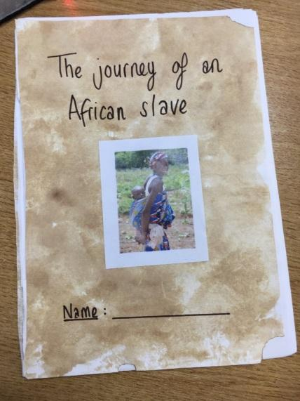
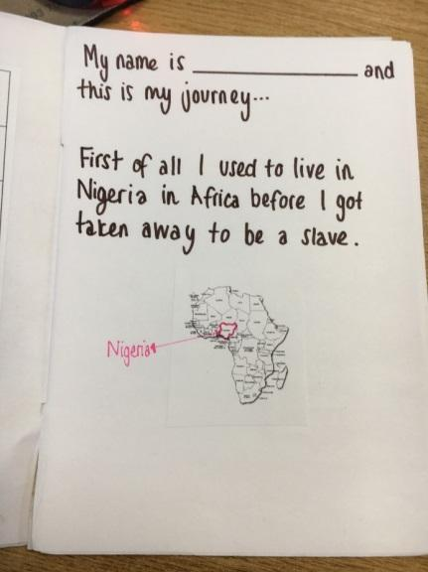
Pupils can get 6 pieces of plain paper and fold them in half together to create their diary. It could have a front cover with a picture of their character (this could be drawn or printed off and on the front page a bit of a profile about their character with basic info.

Task: front the point of view of your character, create a diary entry about how your character got captured using the information from last lesson. Use the success criteria on powerpoint 2 to help you. There is also a diary writing frame if you need help starting your paragraphs off. About 3-5 paragraphs is expected.
Although your character’s experience of the slave trade will be completely unique, you should try to link in the facts from last lesson as much as possible.

