7/4 Maths w/c 20th April 2020

5. We are learning to take one fraction away from another - ANSWERS

Now you try. Shade in the starting number and then cross out the number you are taking away as above. Count the shaded parts that are left. Write the answer as a fraction underneath.

$$\frac{1}{4}$$ | $$\frac{1}{4}$$ | $$\frac{1}{4}$$ | $$\frac{1}{4}$$
0 1

a) $\frac{3}{4}$ – $\frac{1}{4}$ = $\frac{2}{4}$

$$\frac{1}{3}$$ | $$\frac{1}{3}$$ | $$\frac{1}{3}$$
0 1
b) $\frac{3}{3}$ - $\frac{2}{3}$ = $\frac{1}{3}$

$$\frac{1}{10}$$ | $$\frac{1}{10}$$ | $$\frac{1}{10}$$ | $$\frac{1}{10}$$ | $$\frac{1}{10}$$ | $$\frac{1}{10}$$ | $$\frac{1}{10}$$ | $$\frac{1}{10}$$ | $$\frac{1}{10}$$ | $$\frac{1}{10}$$
0 1

c) $\frac{9}{10}$ - $\frac{4}{10}$ = $\frac{5}{10}$

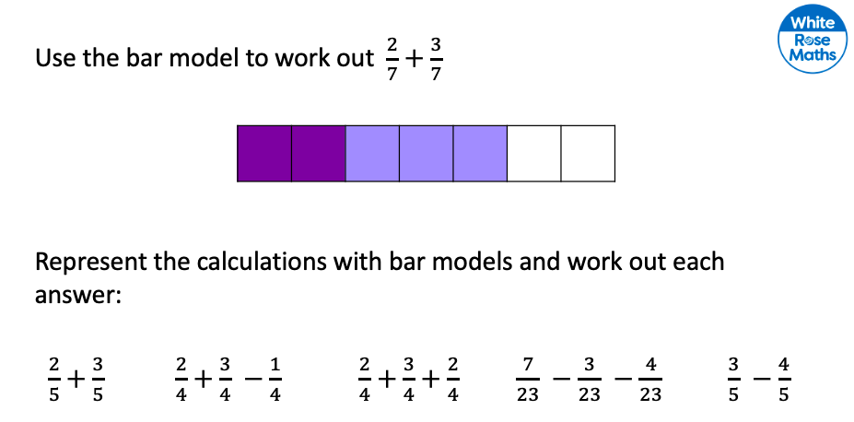

 |  |  |  |  | =$\frac{5}{5}$ |  |  |  |  | = $\frac{4}{4}$ |  |  |  |  | = $\frac{7}{4}$

= 0

= -$\frac{1}{5}$

