7/4 Maths w/c 20th April 2020

1. We are learning to identify fractions on pictures and diagrams. - ANSWERS

1. What would the fraction be if I was to take 3 slices of cake? $\frac{3}{4}$

I can cut my flapjack into 3 equal parts.

2. What would one of these pieces be as a fraction? - $\frac{1}{3}$
3. Colour in $\frac{1}{3}$ of the flapjack.

What would 2 pieces be as a fraction? - $\frac{2}{3}$

This line shows 1 split up into four equal parts. The line shows ¼ shaded in.
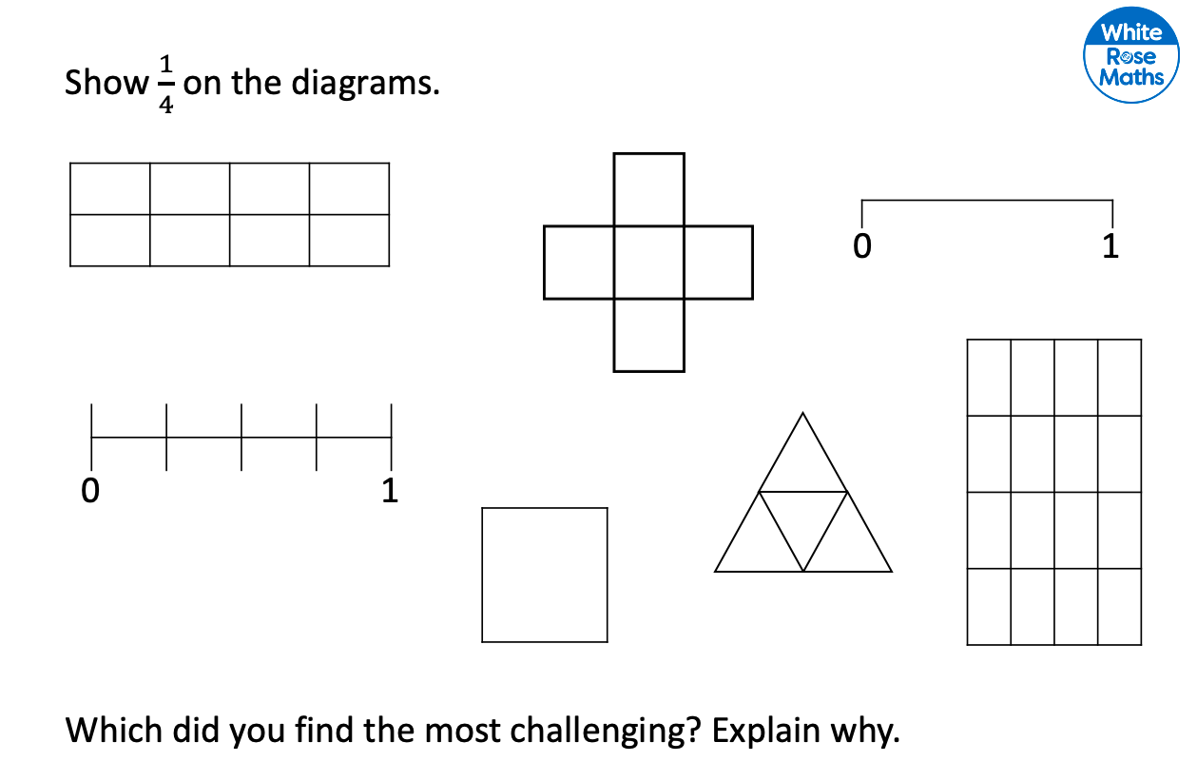

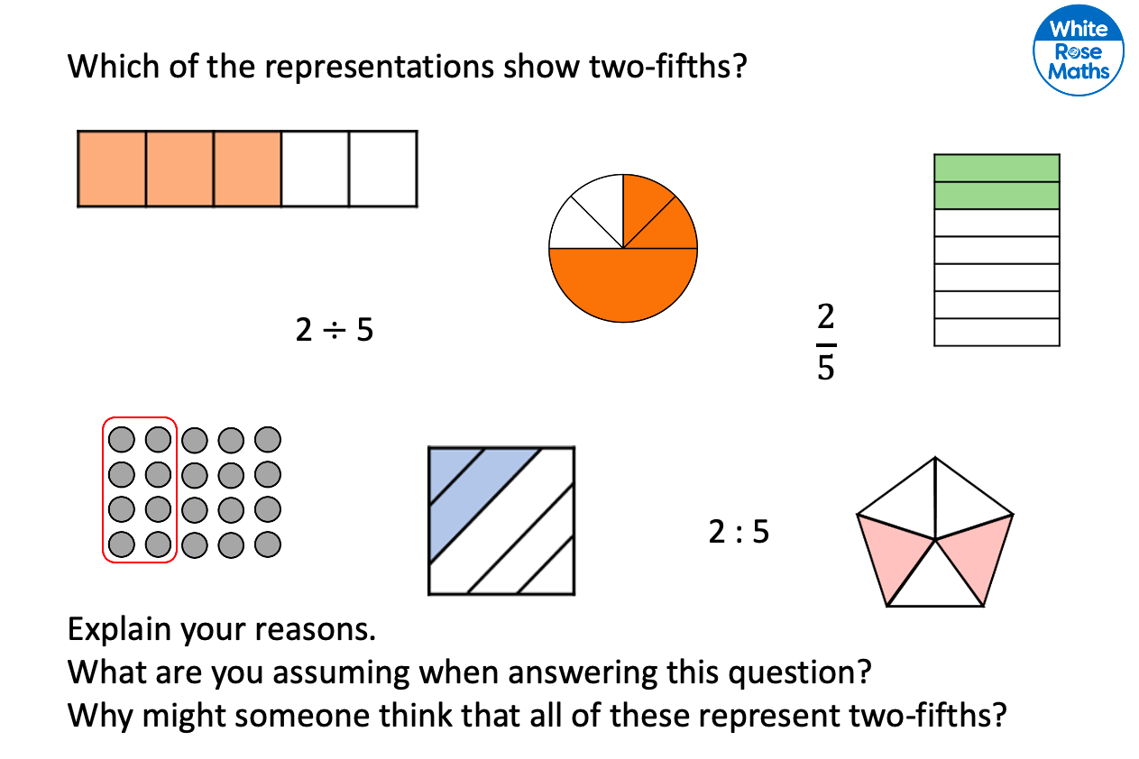
EXTRA CHALLENGE:
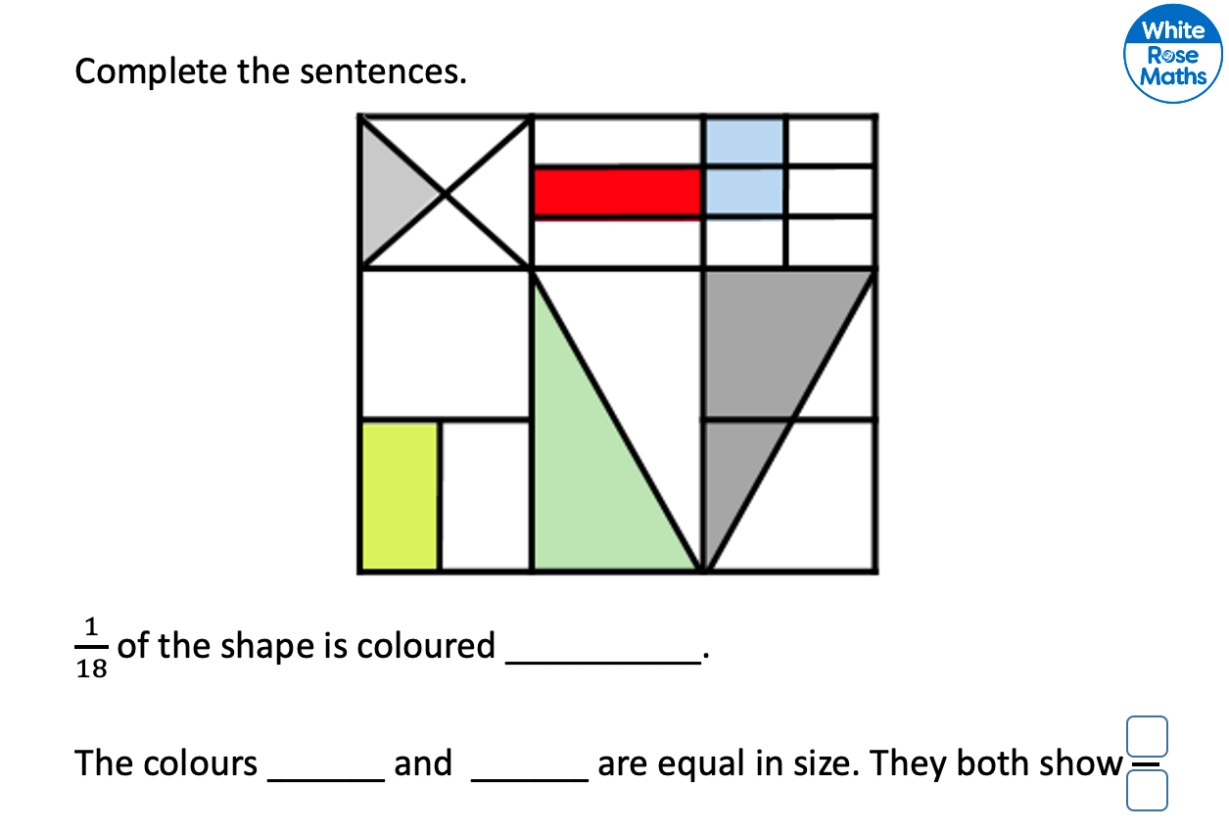
$\frac{1}{9}$ or $\frac{2}{18}$

For more practice, complete the Stained Glass fractions activity sheet.

