7/4 Maths w/c 20th April 2020

1. We are learning to identify fractions on pictures and diagrams.

We can show fractions to talk about parts of a whole – for example slices of a cake or pupils in a class. We can also use them to talk about part of a shape or an amount.

Imagine that this circle is a cake.

We can cut this cake into four equal parts. When working with fractions, it is very important to remember that the parts must be equal – the same size.

Each one of these parts is ¼ of the whole cake. The number of the bottom is 4 because the cake was split into four equal parts. The number on the top is one because we are taking about one of those parts.

If I was to take two slices of cake, the fraction would be $\frac{2}{4}$ . Again, the four is because the cake is cut into four pieces and the 2 because we are taking 2 of those pieces.

1. What would the fraction be if I was to take 3 slices of cake?

Next we have flapjacks!

I can cut my flapjack into 3 equal parts.

2. What would one of these pieces be as a fraction?
3. Colour in $\frac{1}{3}$ of the flapjack.

What would 2 pieces be as a fraction?

We can also use a number line to show a fraction of a number.

0 1

This line shows 1 split up into four equal parts. The line shows ¼ shaded in.

Watch this video for more of an explanation on fractions and number lines. https://www.khanacademy.org/math/arithmetic/fraction-arithmetic/arith-review-fractions-on-the-number-line/v/fractions-on-a-number-line

This flapjack is cut into 6 parts. Can I still shade in $\frac{1}{3}$ ?

Yes – because I can make three equal groups – here I have shaded one of the three groups.

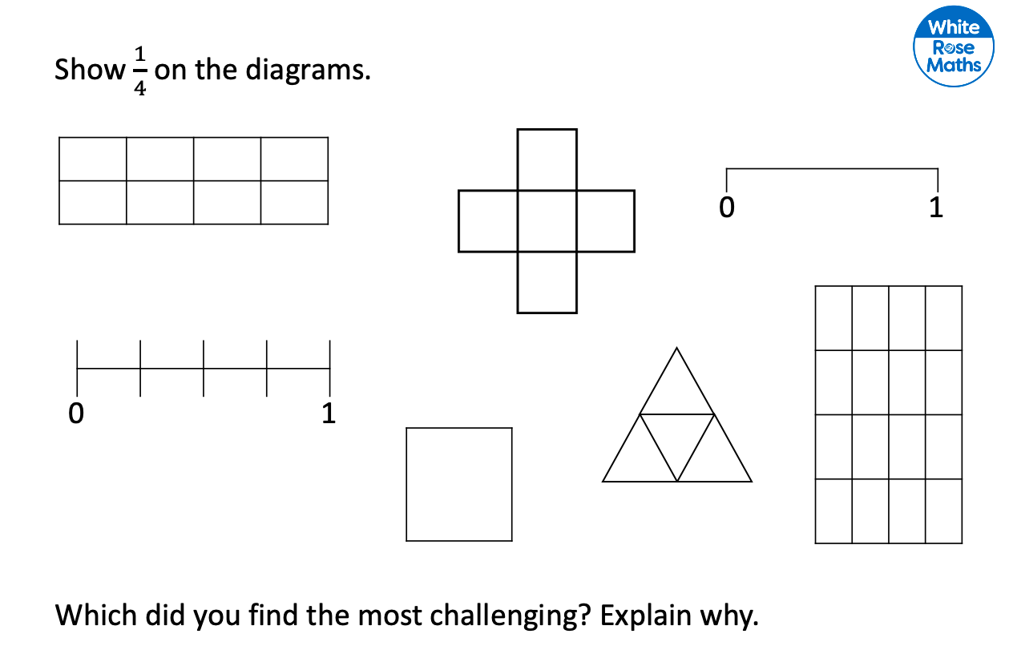

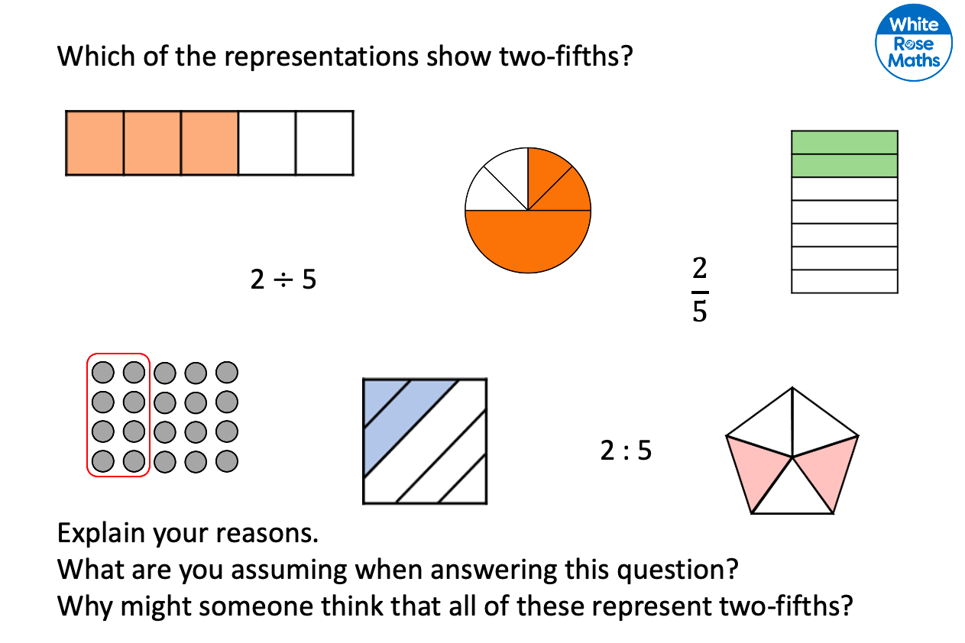
EXTRA CHALLENGE:
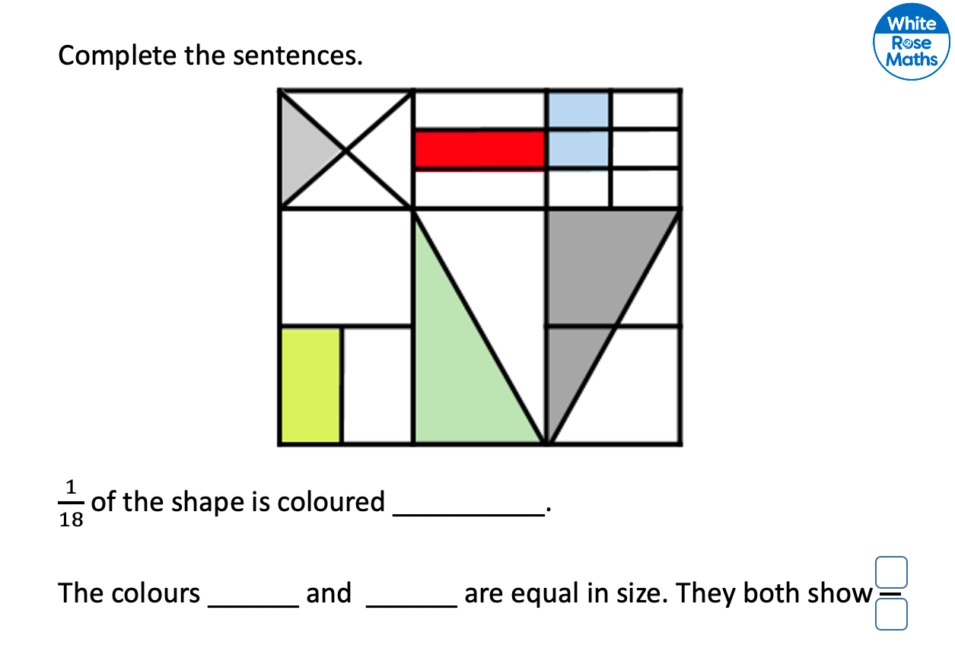

For more practice, complete the Stained Glass fractions activity sheet.

