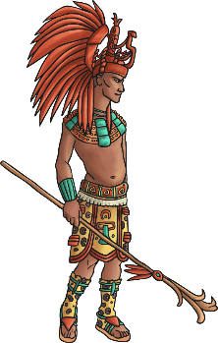
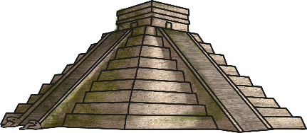
Year 6 Home learning history- lesson 2
Maya Civilisation- how was Maya civilisation discovered?
Learning objective: To explore where and when the remains of the Mayan civilisation were discovered.

Resources: Mayan slides 1 PDF document (information), worksheet 1, worksheet 2, photo cards, supportive diary writing frame (these do not need to be printed- only if you wish).

- Recap: What do you already know about the Mayans? Draw a quick spider diagram without looking at last lesson’s note at first, and then use your notes to add some facts.

- Go through the information on the slides, answering the questions on paper as they come up.

- Look at the picture cards of the Mayan ruins. On worksheet 1, write six words to describe how the Spanish explorers would have felt when they found the ruined cities, and then write six questions they would like to find the answer to in the boxes around the picture of a Mayan pyramid. If you prefer or do not have access to a printer, you can do this on plain/ lined paper.

- On worksheet 2, write a diary entry as though you are a 16th century Spanish explorer coming across the Mayan ruins for the first time. You need to describe what you can see; how you feel about this amazing discovery and any questions you have about what you are seeing. If you prefer or do not have access to a printer, you can do this on plain/ lined paper. There is a supportive writing frame available to help pupils structure their diary if they need it.

- Summary: imagine the discovery of the Mayan cities is the top news story on this evening’s news. What would your attention-grabbing headline be for the news report?

