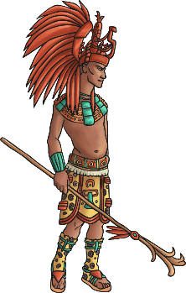
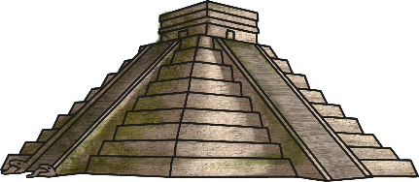
Year 6 Home learning history- lesson 1
Maya Civilisation
- You are starting a new topic in history today, and it is all about the Mayans. On a piece of paper, write down anything you already know, or think you know, about the Mayans. Don’t do any research yet!

- In another coloured pen, write down some questions you would like to find out about the Mayans. You should leave at least 5 lines in between each question you write down, and underline the question like a subtitle. Secure pupils should aim for 5, and secure+ pupils should aim for 10. Remember, good questions are open questions (this means that they need a detailed answer rather than a simple ‘yes or no’ answer) and they could be begin with: who, what, where, when, why, how?
e.g. Where did the Mayans come from?

- Read through the lesson 1 PowerPoint which has an overview of the Mayans. In a third colour, answer any of your questions you have found the answer to. How many of your own enquiry questions did you manage to answer?

- If you found any extra facts about the Mayans that you did not ask a question about, you can record these underneath your questions.

- Summary: Summarise Maya Civilisation in 5 key words at the bottom of your work.

- Extra study: some extra information and videos can be found here: https://www.bbc.co.uk/bitesize/topics/zq6svcw/articles/zqv6msg

