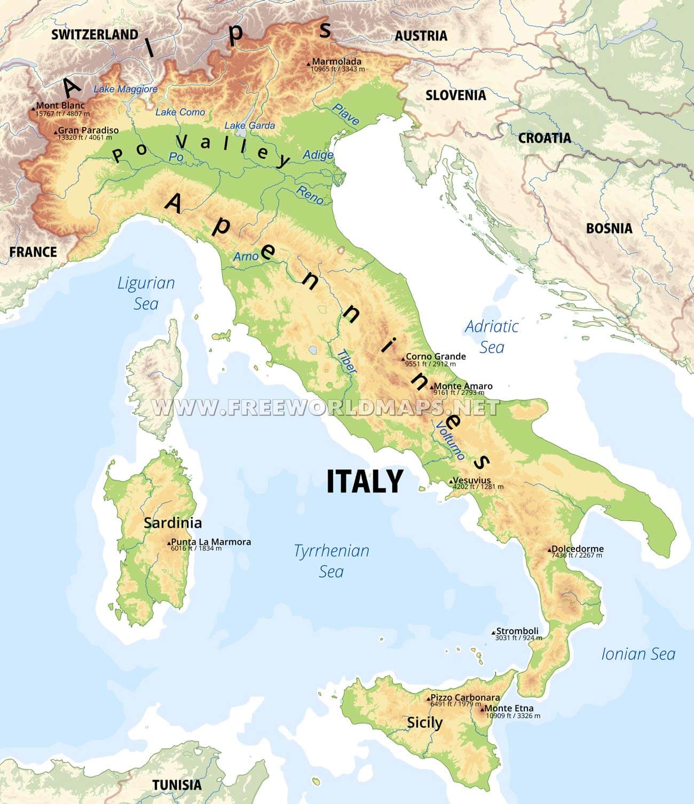
A physical map of Italy

I can see that a physical map shows you information such as:
Natural features like the height of the land, mountain ranges, the names of mountains and the names of rivers, lakes and seas. Using the physical map, can you do the following tasks?
- Name two mountain ranges in Italy: Alps and Apennines
- Name one river in Italy: Po, Tiber, Arno, Reno, Adige, Piave, Volturno
- Name two seas surrounding Italy: Ligurian Sea, Tyrrhenian Sea, Ionian Sea and Adriatic Sea
- Name one mountain in Italy: Mount Etna, Mount Blanc (or there was also Marmalada, Gran Paradiso, Vesuvius, Punta la Marmora, Dolcedormi, Stromboli, Pizzo Carbonara)
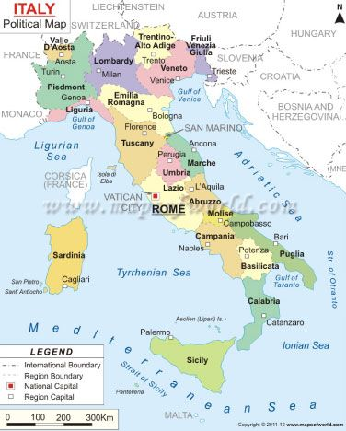
A political map of Italy

I can see a political map gives you useful information like Human features such as the names and locations of countries, regions and cities (including the capital city)
Name 3 regions of Italy: any of the bold words inside the colourful sections on the map above

- Name one of Italy’s islands
Sardinia or Sicily
- Name 3 countries which border Italy: France, Switzerland, Austria and Slovenia

