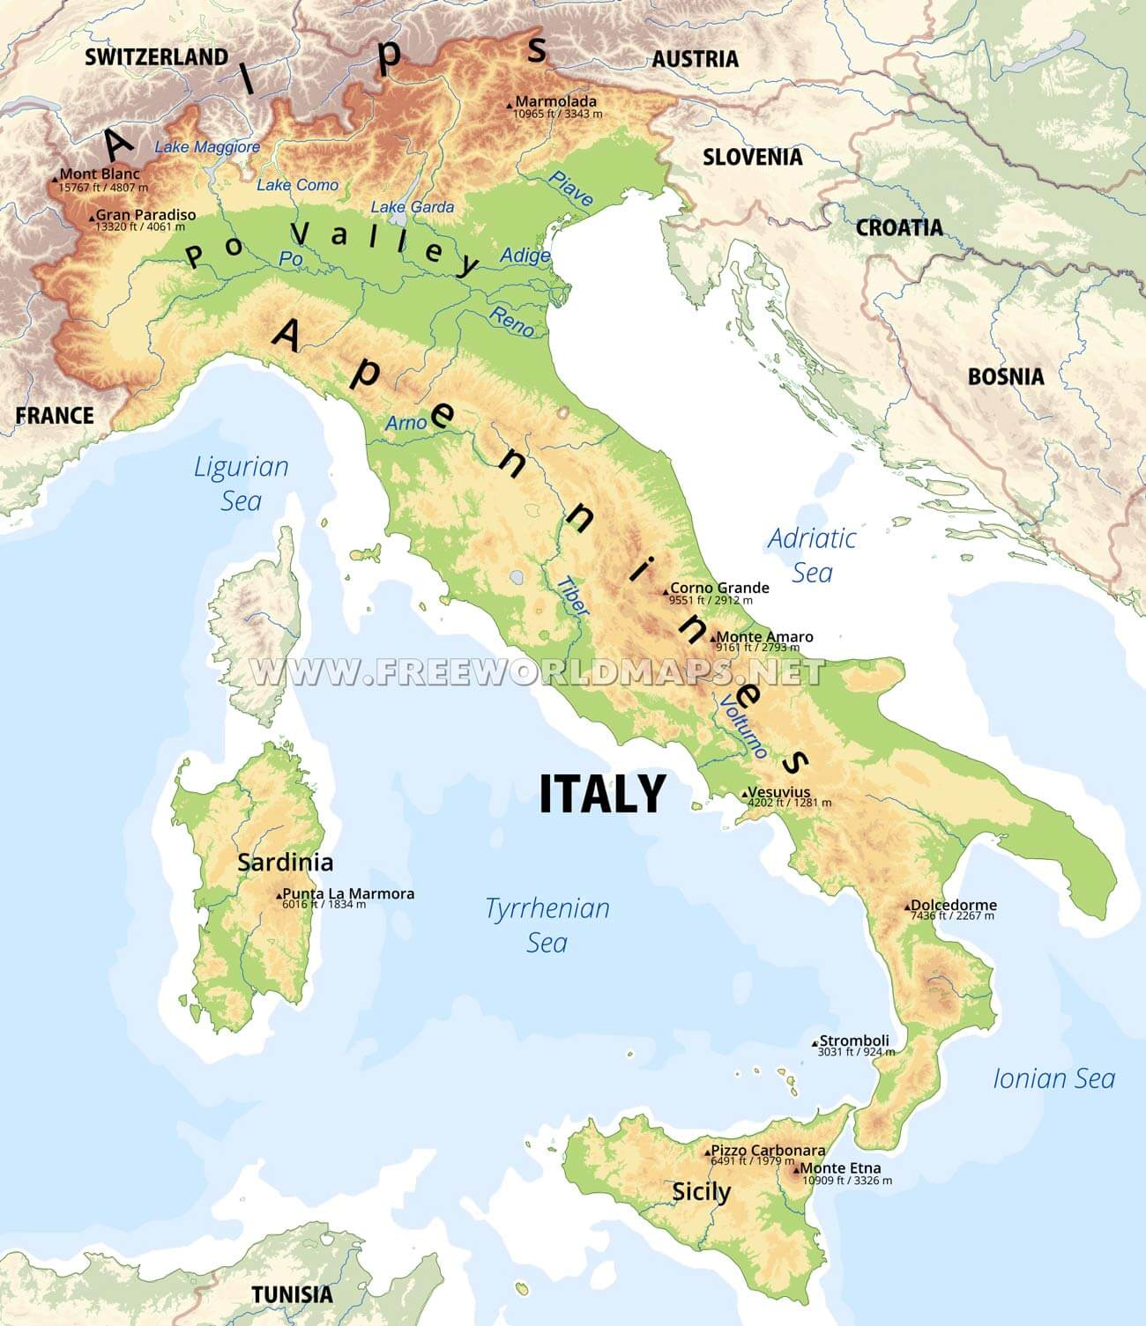
A physical map of Italy

I can see that a physical map shows you information such as: ________________________________________________________________________________________________
Using the physical map, can you do the following tasks?
- Name two mountain ranges in Italy

- Name one river in Italy

- Name two seas surrounding Italy

- Name one mountain in Italy
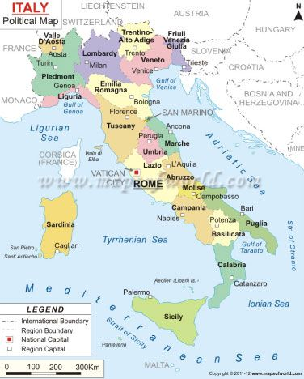
A political map of Italy

I can see a political map gives you useful information like ________________________________________________________________________________________________
- Name 3 regions of Italy

- Name one of Italy’s islands

- Name 3 countries which border Italy

