Researching Italy

1. What is Italy’s current population (to the nearest million)?
60.55 million (anything between 60-61 million is fine)

2. Which is the largest of Italy’s islands?
Sicily
3. List Italy’s 3 longest rivers
Po, Adige, tiber
4. What is the tallest mountain in Italy?
Bianco or Mont Blanc (The White Mountain)
5. Italy is special as it has two whole countries inside it! Which two countries are entirely surrounded by Italy?
San Marino and Vatican City
6. Which city is home to the luxury Italian car maker Ferrari?
Maranello
7. In which city would you find Leonardo da Vinci’s painting ‘The Last Supper’? Add an image of the painting!
Milan
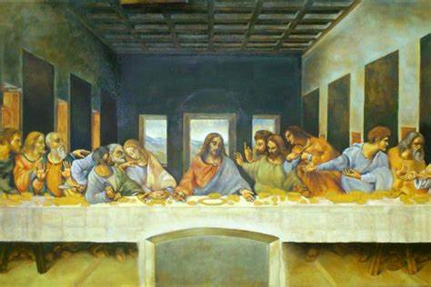
8. What is the name of Italy’s Prime Minister?
Giuseppe Conte
9. Which Italian leader gave his name to a flat sandwich biscuit filled with currants?
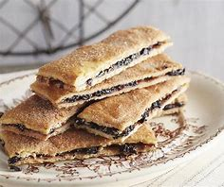
Garibaldi
10. How many official regions are there at present in Italy?
20

11. Who is the Italian Pope? Add an image of him!
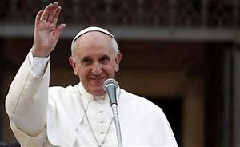
Pope Francis
12. What are the 3 main (largest) cities (in terms of population)?
Rome, Milan and Naples
13. Find out 3 items of food and 2 drinks Italy is famous for
e.g. pizza, pasta, olive oil, parmesan cheese, parma ham, tirmisu, gelato
wine, limoncello, but anything will do as long as it’s Italian!
14. Find out about one ski resort in Italy and one beach resort. Add some images of both.
Ski Resorts such as:
- Cortina d'Ampezzo
- Val Gardena
- Breuil-Cervinia and Valtournenche
- Sestriere and Val Chisone
- Courmayeur
- Alta Badia
- Madonna di Campiglio
- Livigno
- Bormio
- Val di Fassa
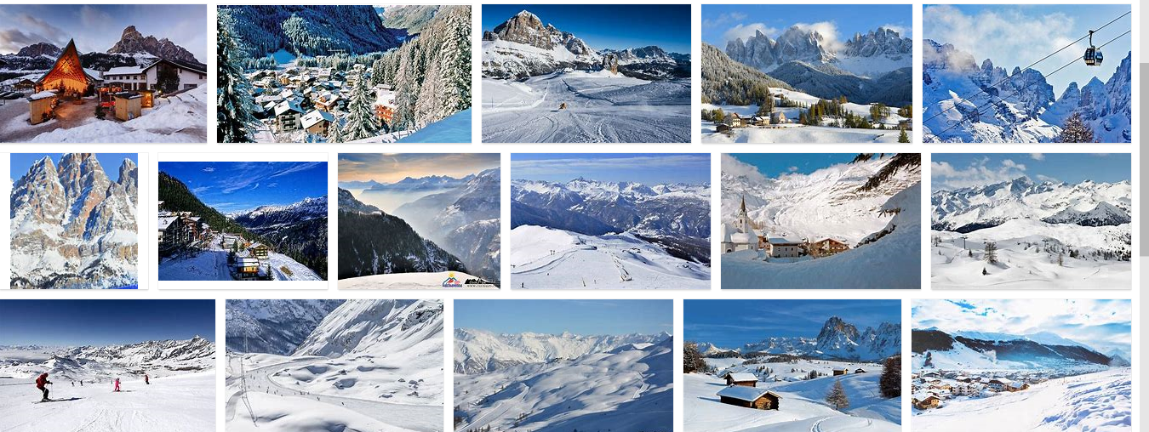

Beach resorts such as:
- Capri and the Amalfi Coast
- Il Riccio
- Lo Scolgio de Sirene
- Pupetto, Positano
- Da Adolfo, Positano
- Riccione, Emilia-Romagna
- Frontone, Ponza
- Venice Lido
- Forte dei Marmi, Tuscany
- Posta Vecchia, Ladispoli

